Club Championship

Match Play Format

July 8 thru August 25, 2024

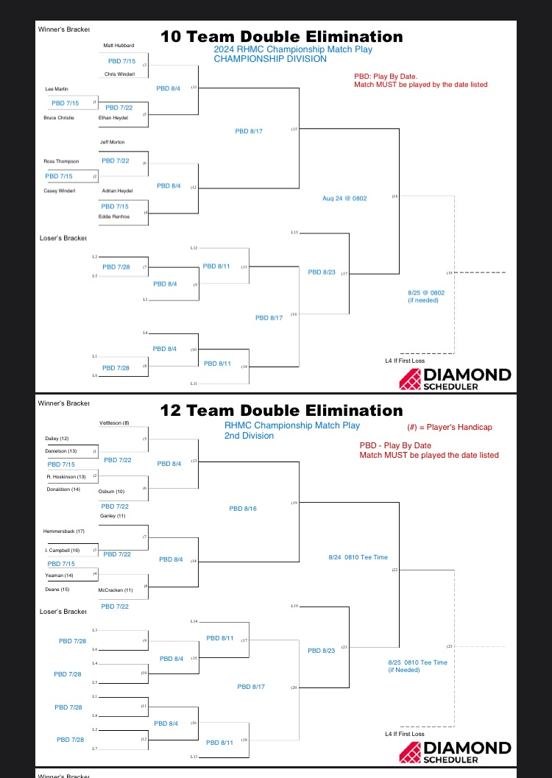

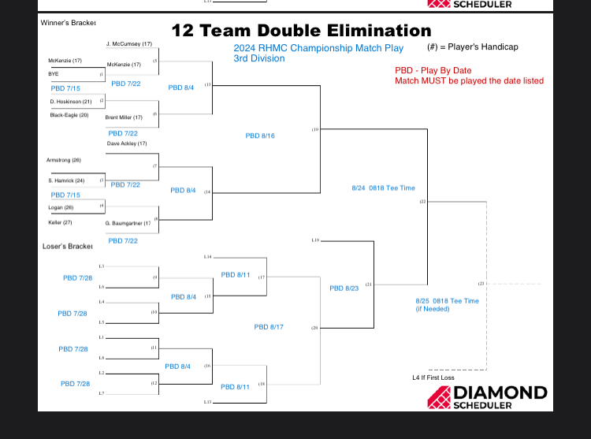

* **Double Elimination**: Brackets are set.
* Each round will have **PLAY-BY DATES** listed on the bracket sheets. Players failing to complete their match in time will be DISQUALIFIED.
* Players arrange matches with assigned opponent; report results to the Pro Shop.
* All preliminary rounds shall be completed prior to August 23rd.
* Final matches for each division scheduled for   
  Saturday August 24th and Sunday August 25th
* Championship Division: No Handicap Applied

Handicap Divisions: Handicaps are in parentheses following the players name. Handicaps are set for the duration of the competition.