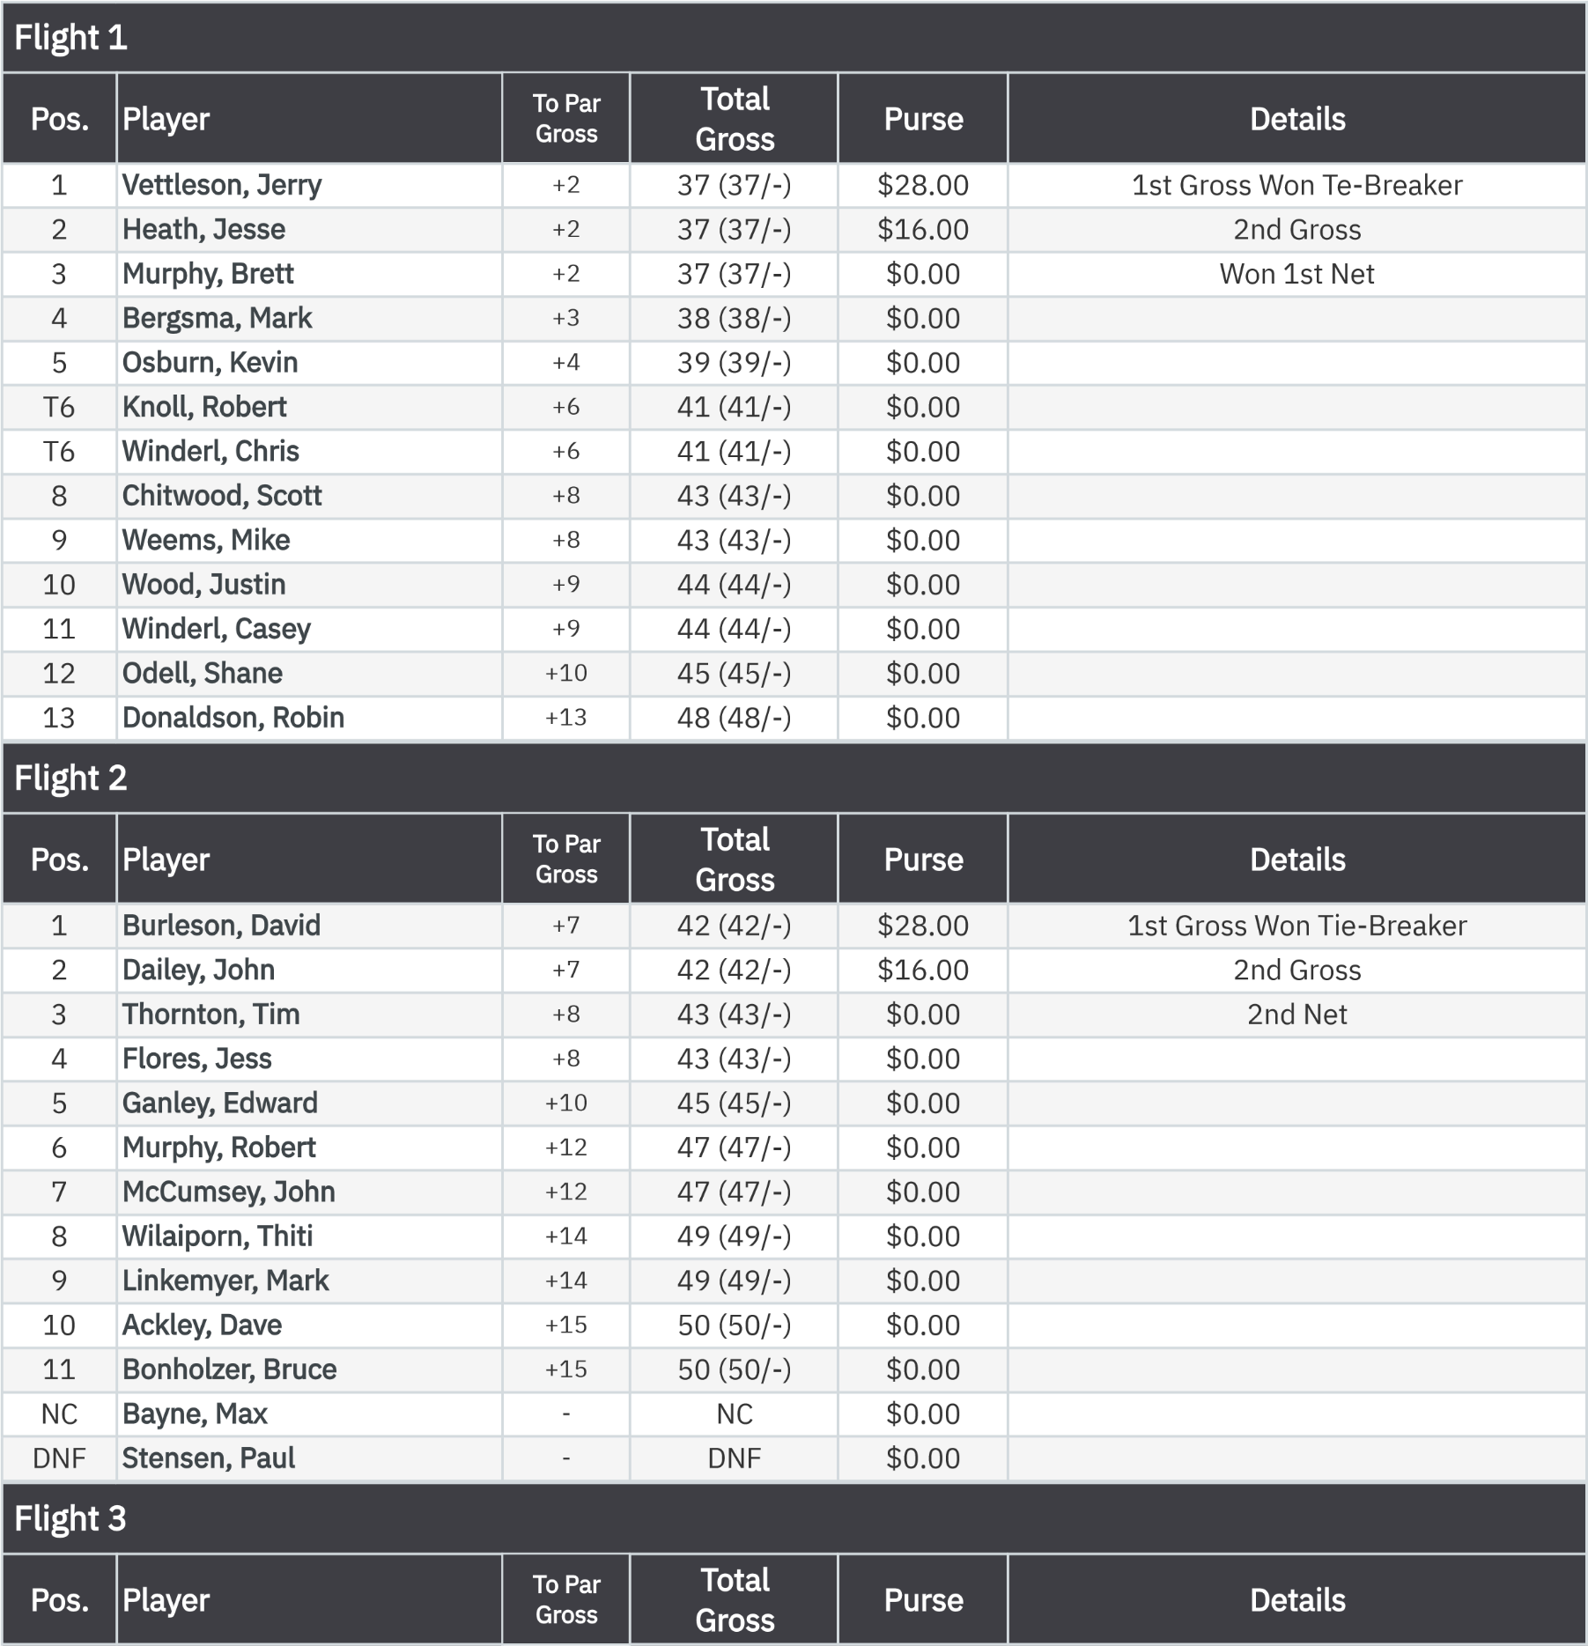
Stroke Play Front Nine (Gross)

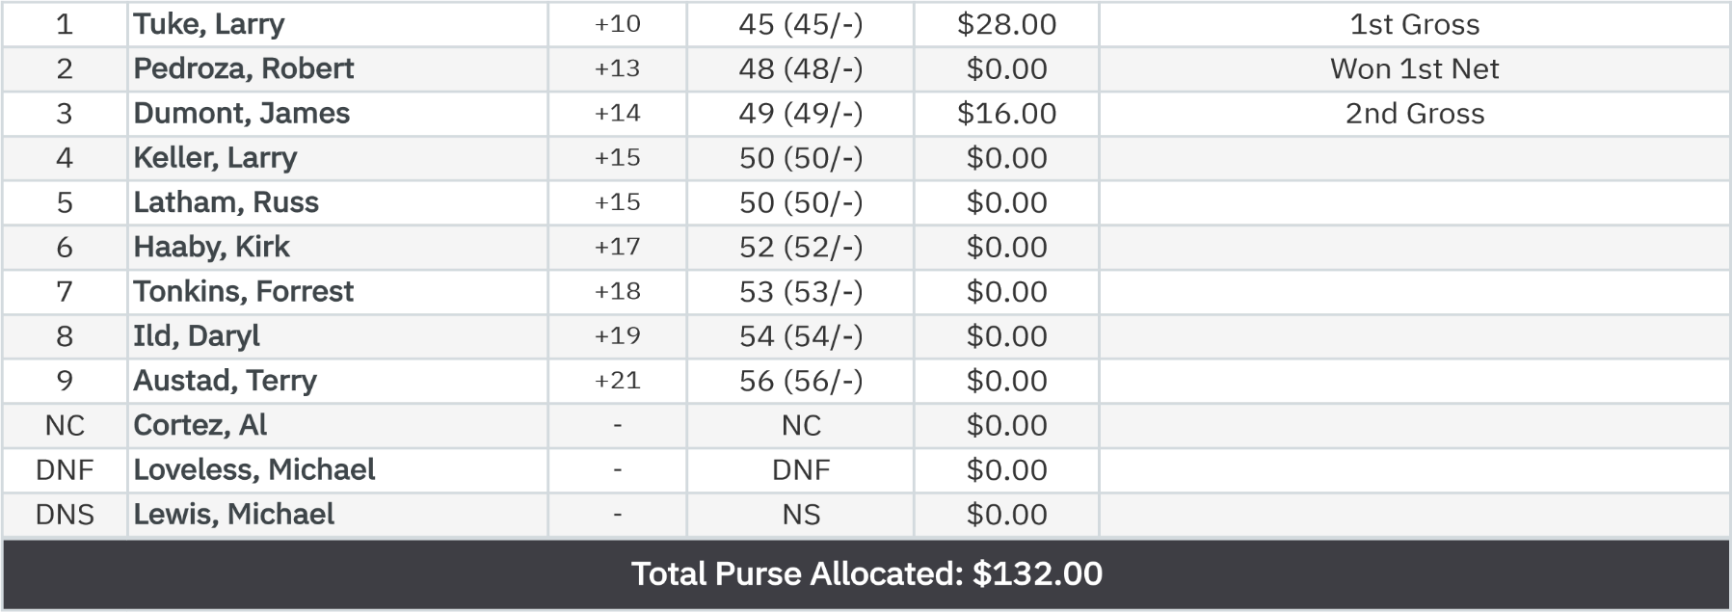

Stroke Play Front Nine (Net)
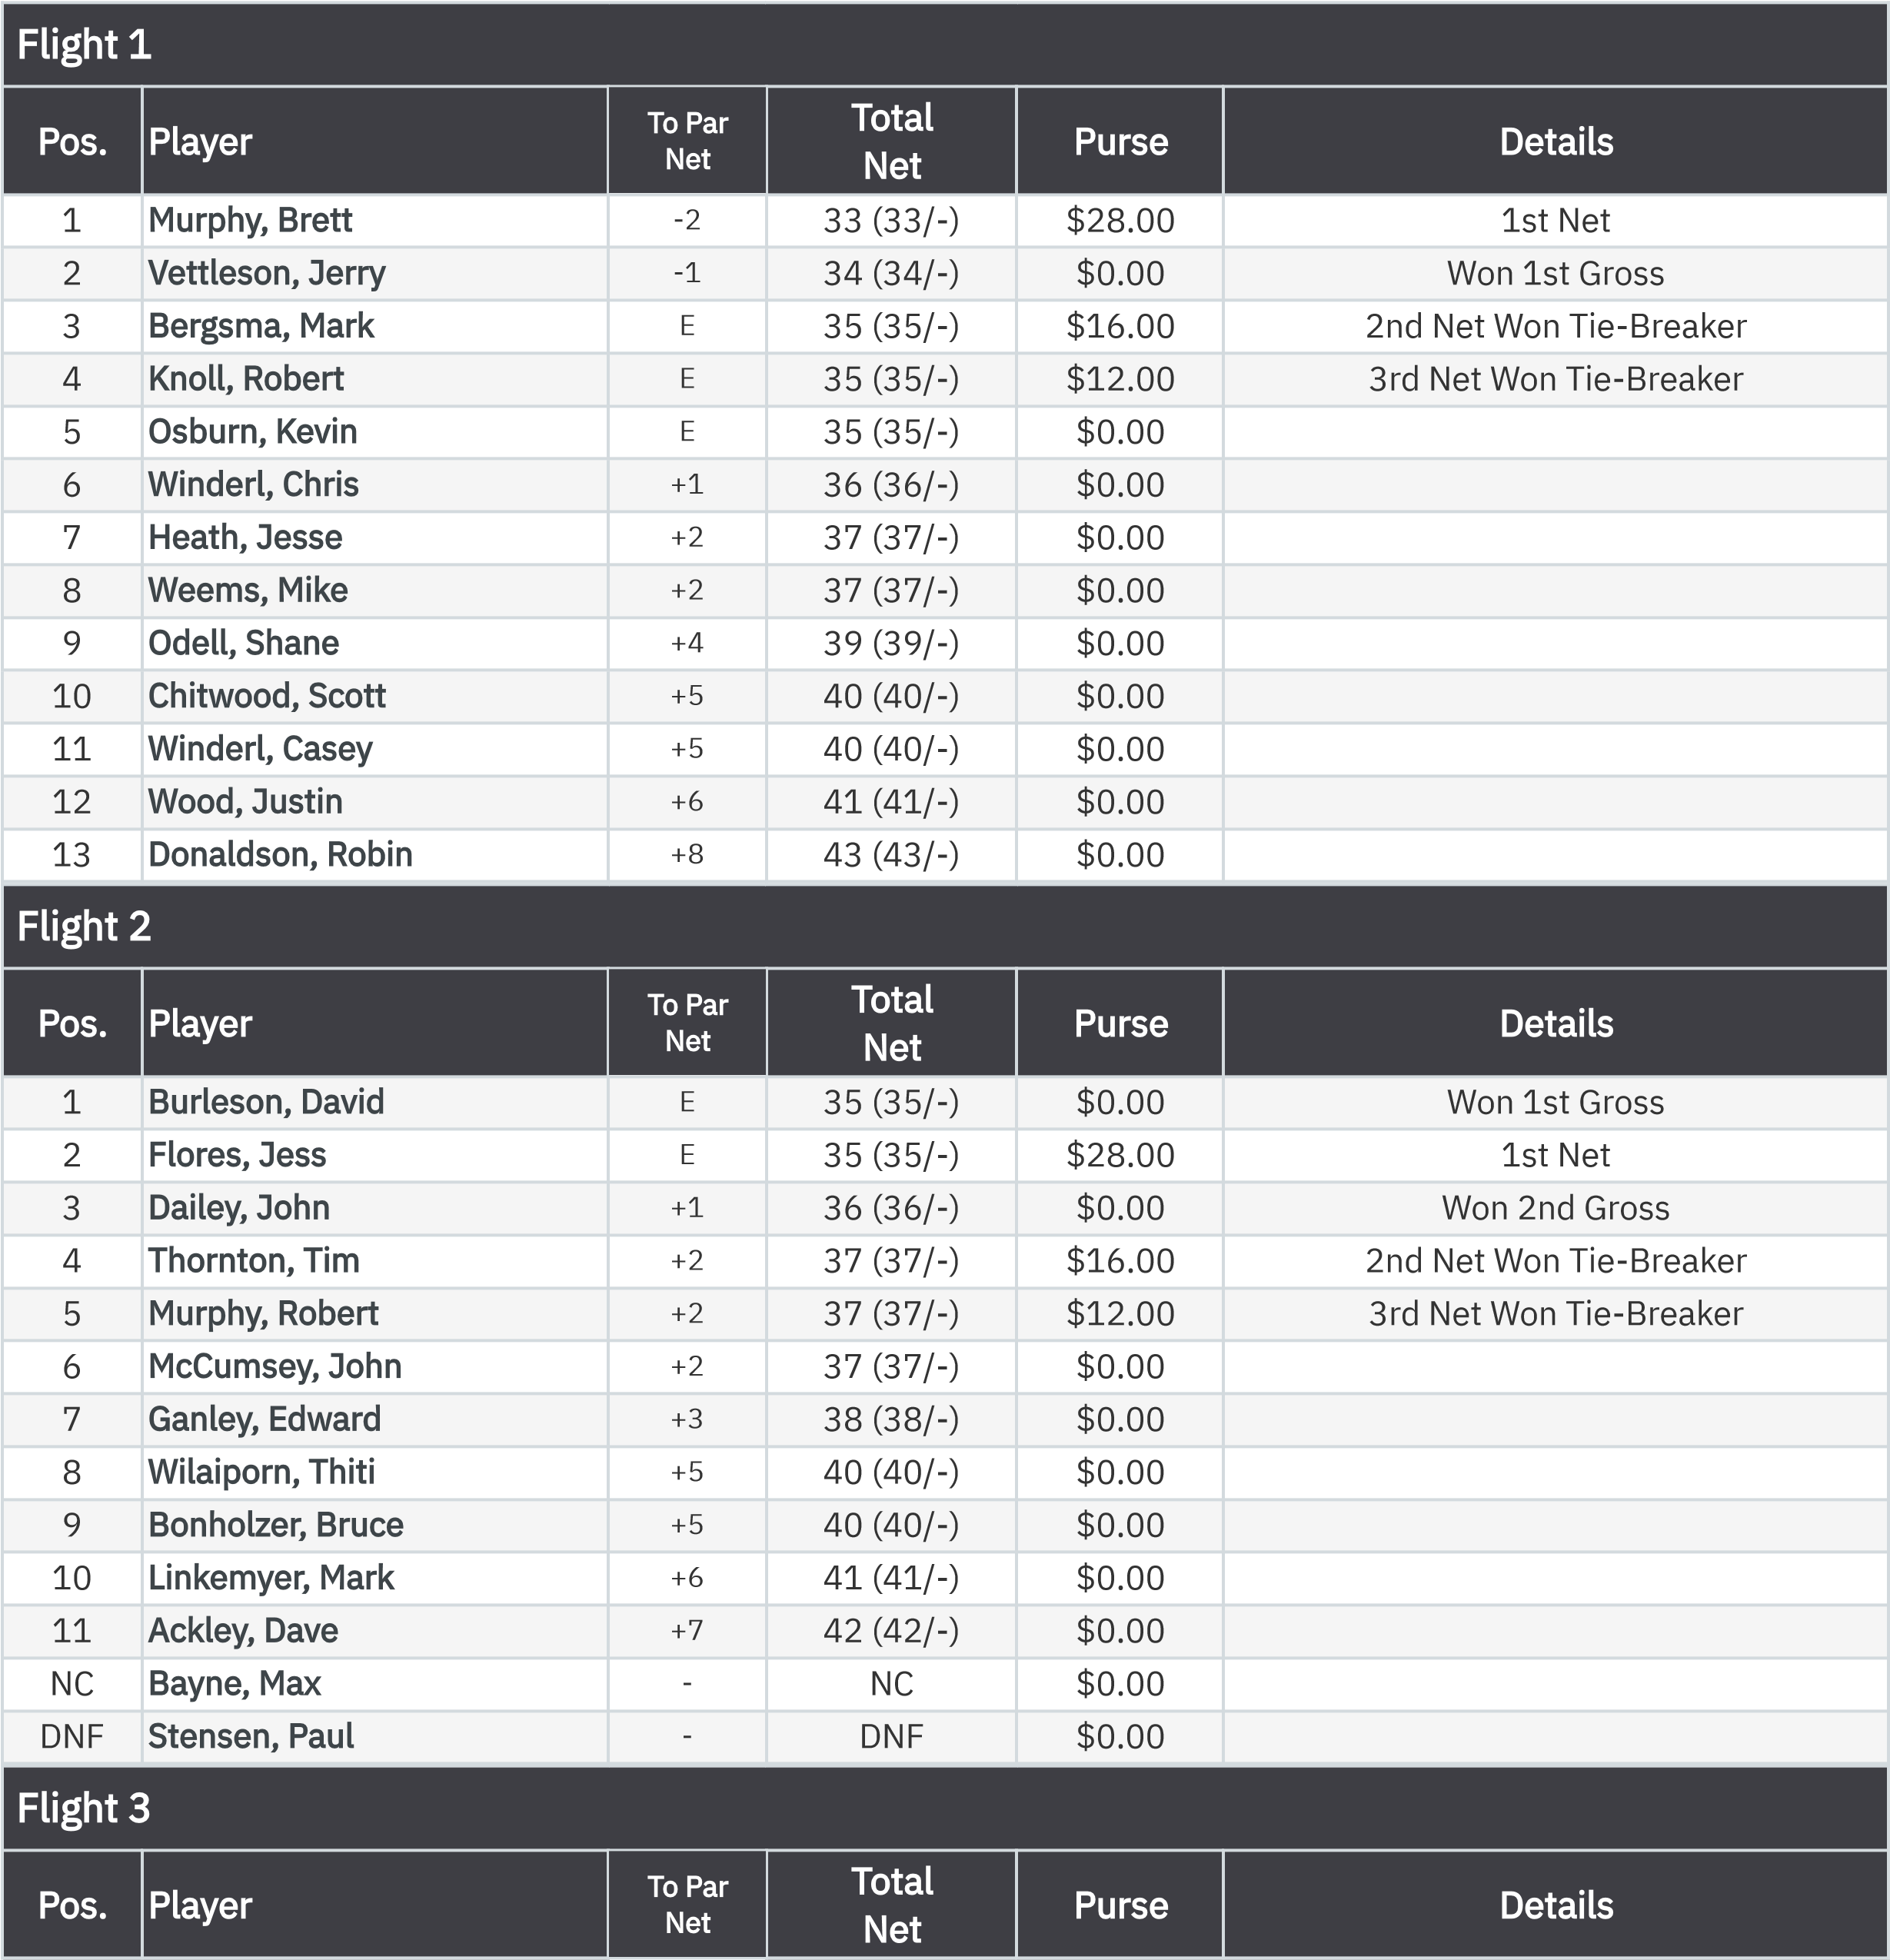
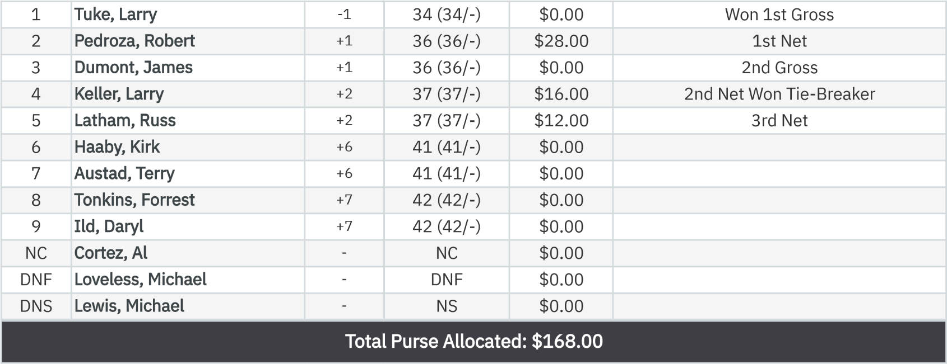

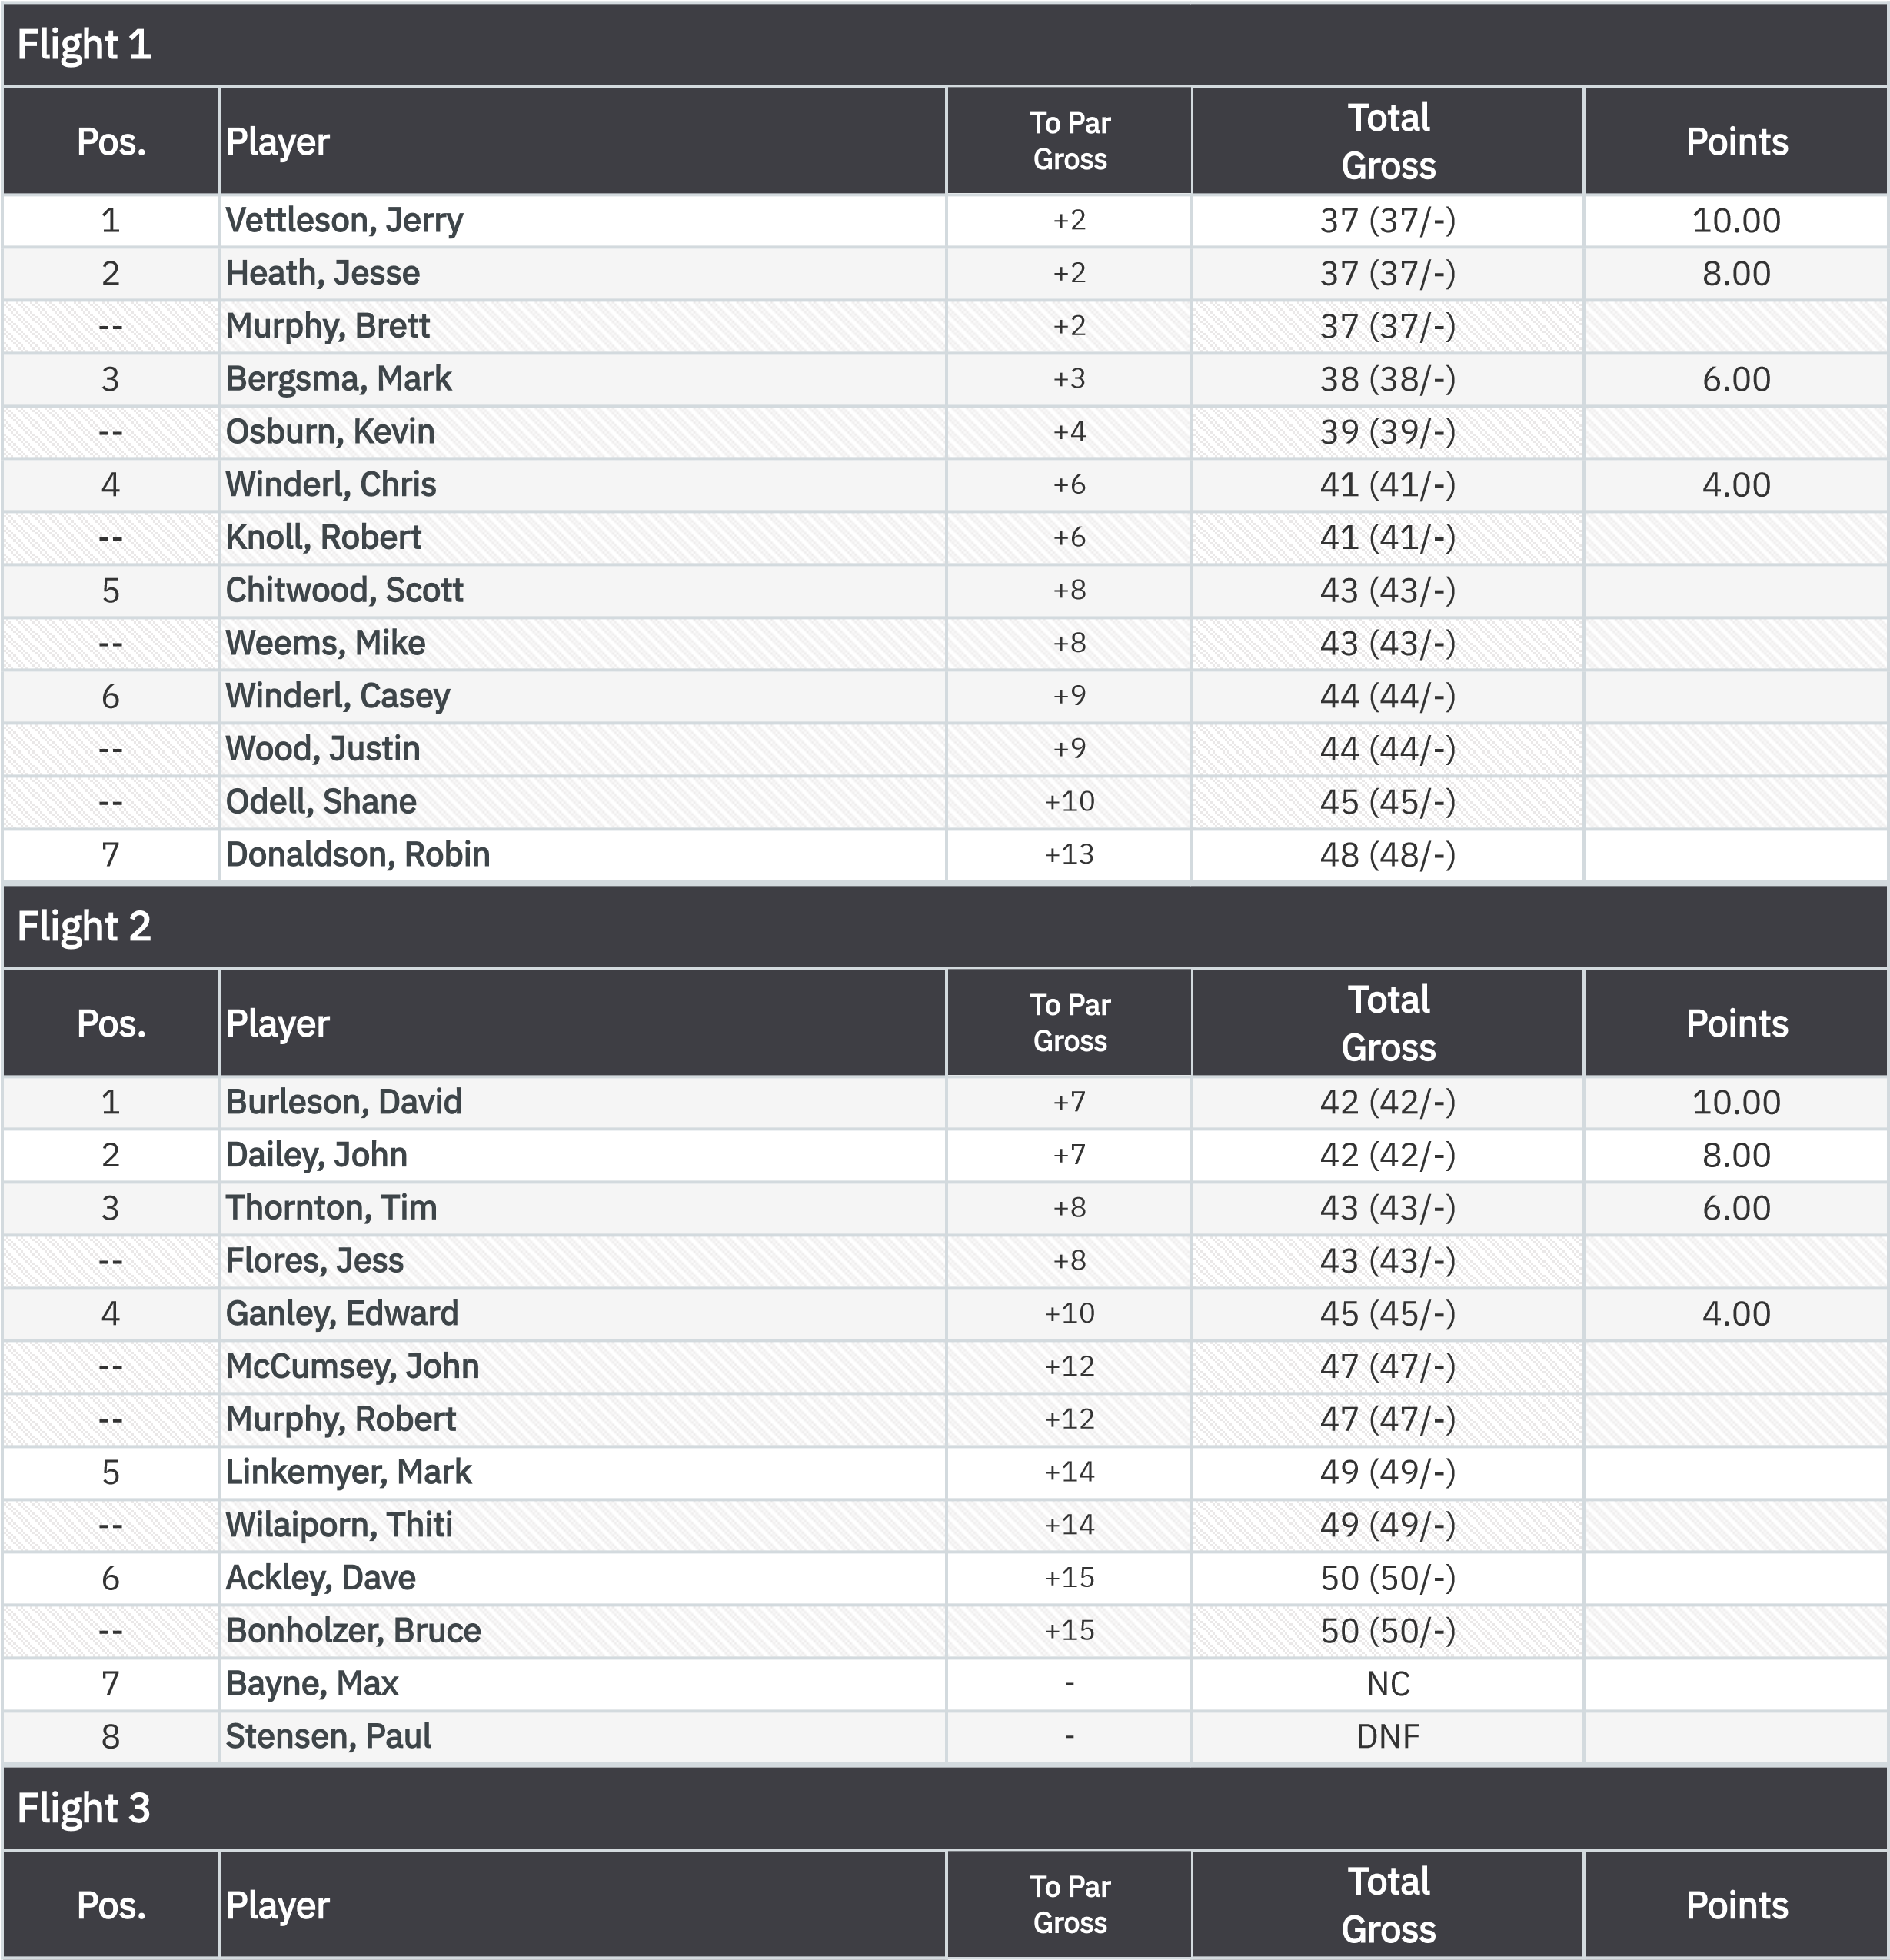
Gross VP Cup Points Front Nine (Gross Bias)

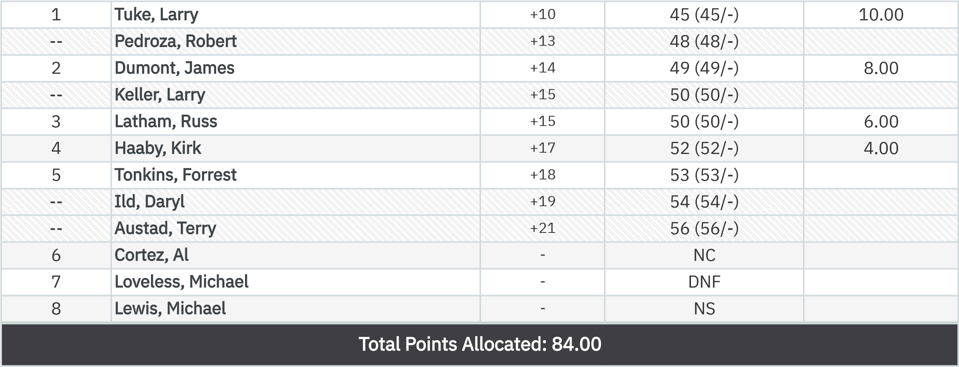

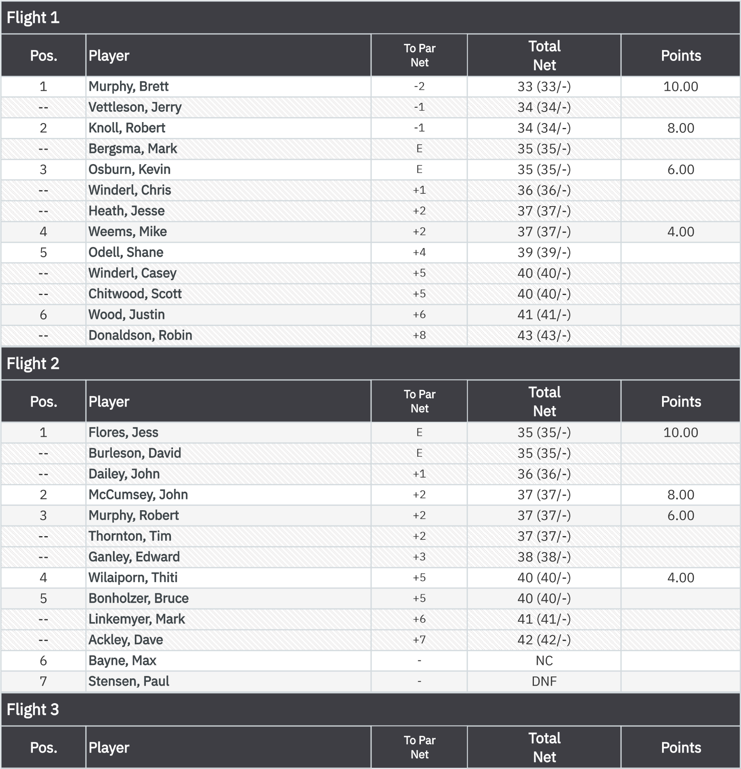
Net VP Cup Points Front Nine (Gross Bias)

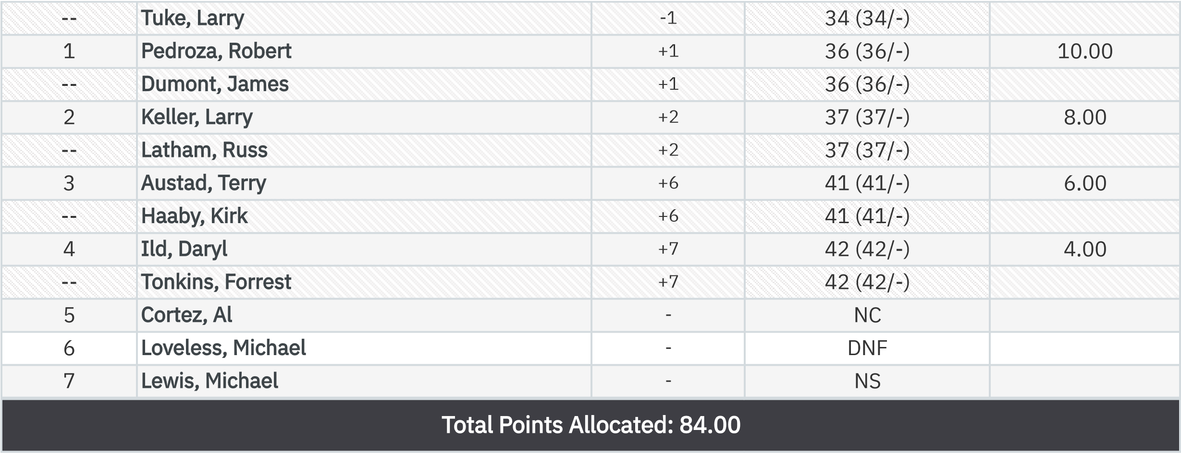

KP - Hole 4
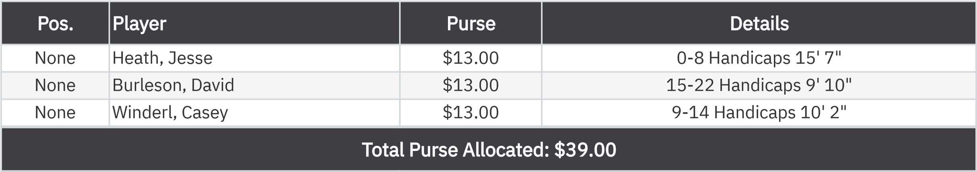

50-50 RHMC Scholarship Fund
.
er
None
Austad, Terry
$19.50
T
:

