2-Man Best Ball (01Apr2026) Leaderboard

2-Man Best Ball Front Nine (Gross)
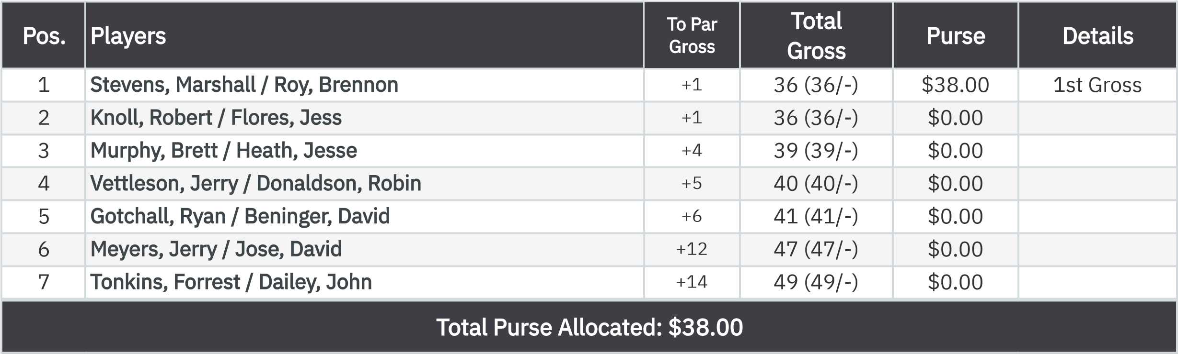
2-Man Best Ball (01Apr2026) Leaderboard

2-Man Best Ball Front Nine (Net)
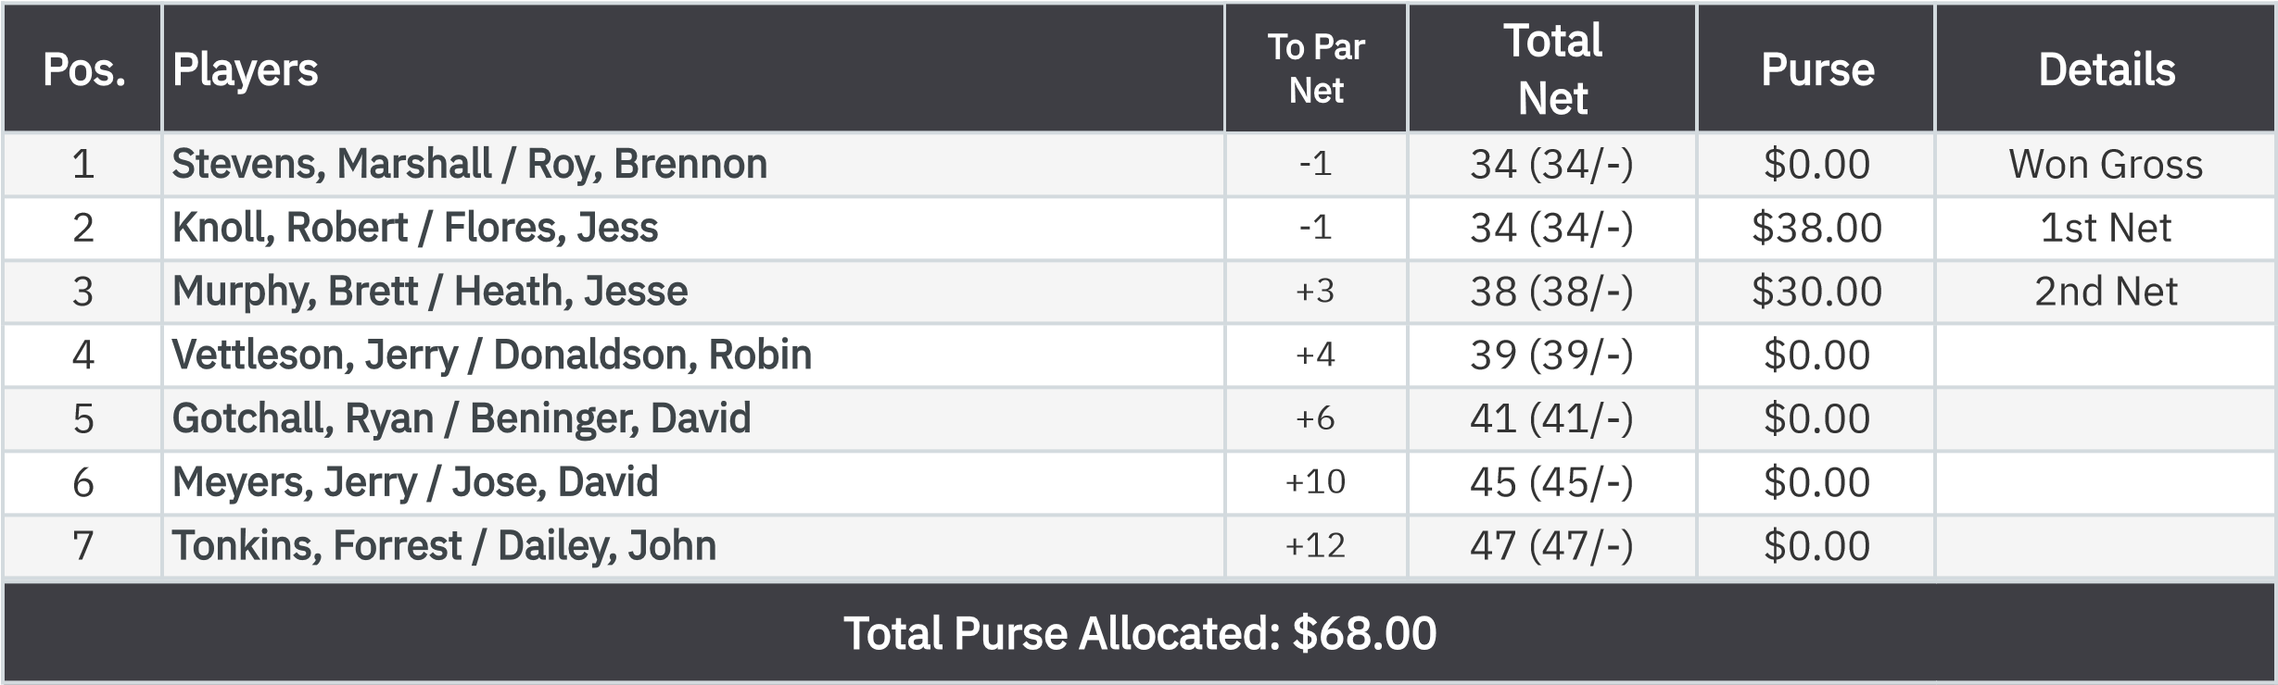
2-Man Best Ball (01Apr2026) Leaderboard

Gross VP Cup Points Front Nine (Gross Bias)
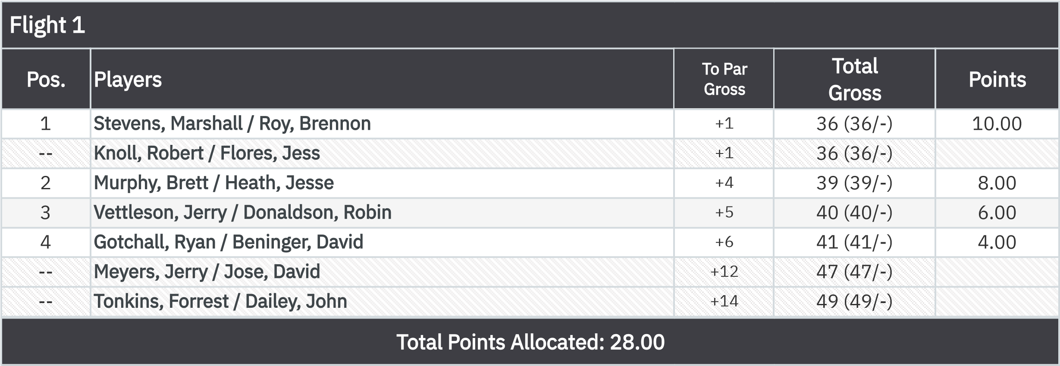
2-Man Best Ball (01Apr2026) Leaderboard

Net VP Cup Points Front Nine (Gross Bias)
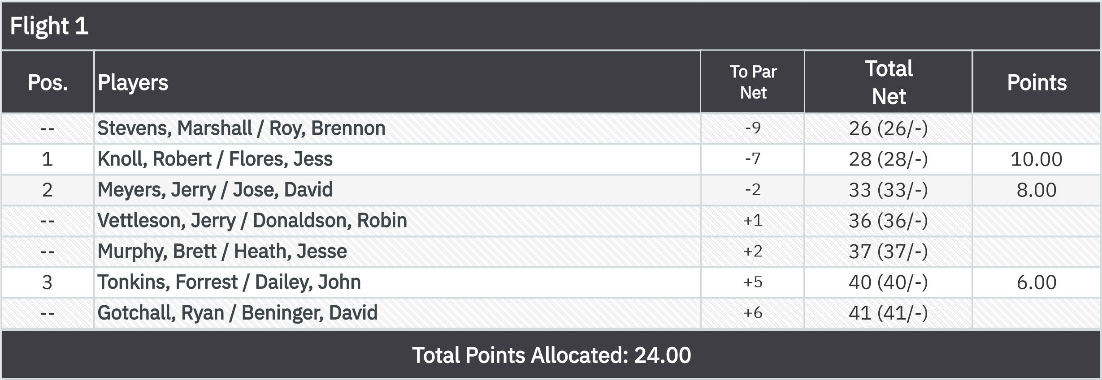
2-Man Best Ball (01Apr2026) Leaderboard

KP - Hole 4
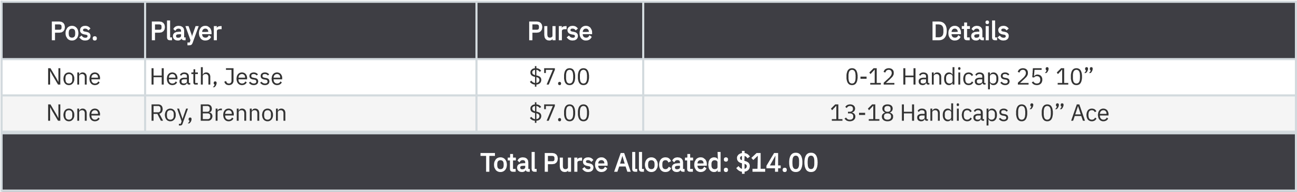
KP - Hole 9

.

None
Dailey, John
$7.00

:

.

er

To set up results for this tournament,

No results yet
50-50 RHMC Scholarship Fund

