Stroke Play Front Nine (Gross) 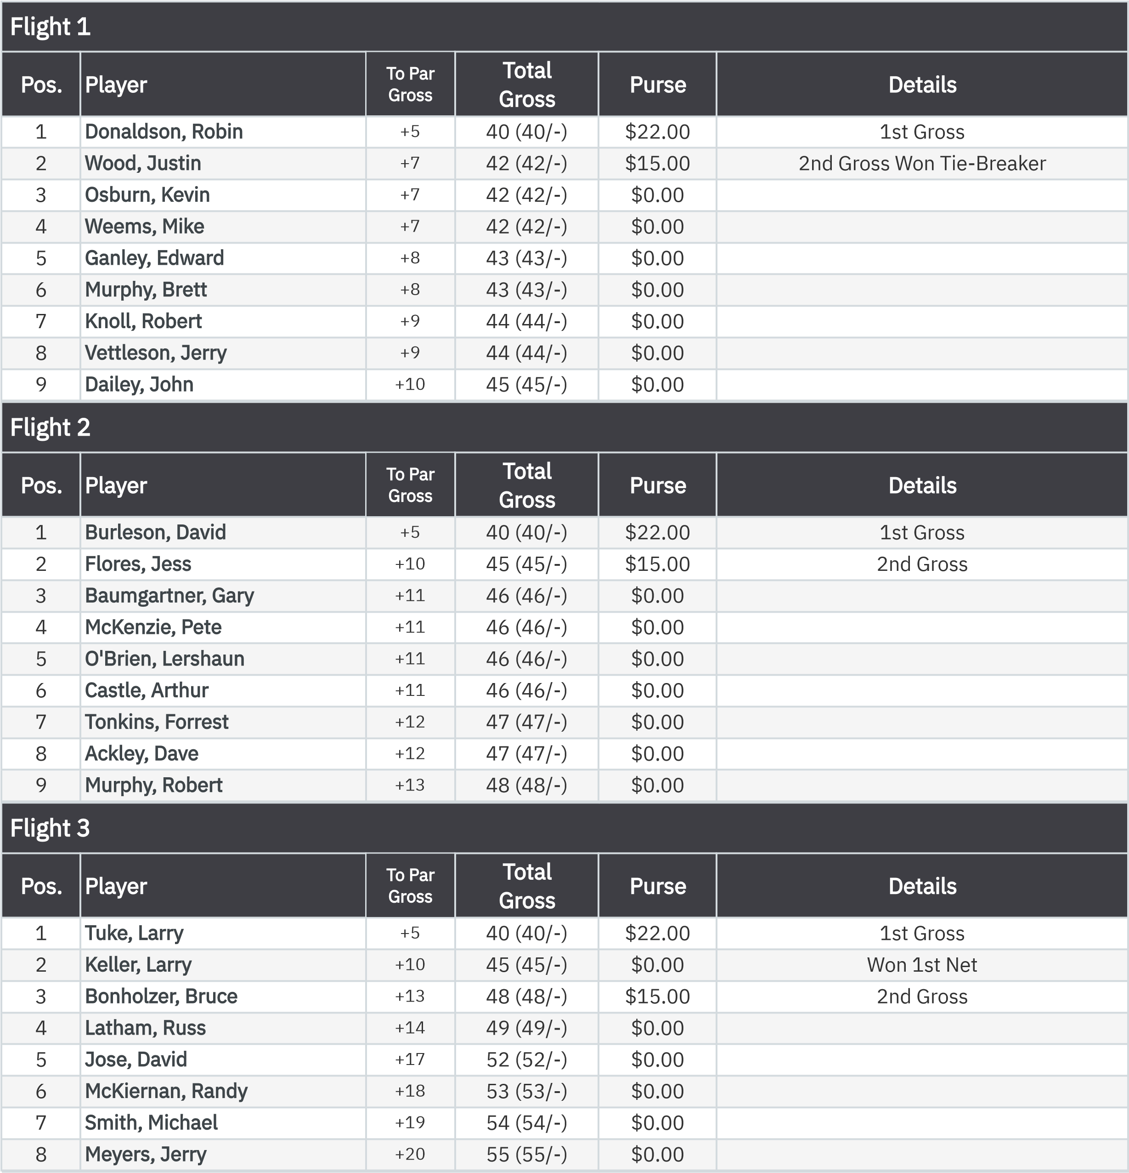

2026 Wednesday Golf Tournaments
April 15, 2026
Stroke Play (15Apr2026) Leaderboard
Total Purse Allocated
:
$111.00
Stroke Play Front Nine (Net) 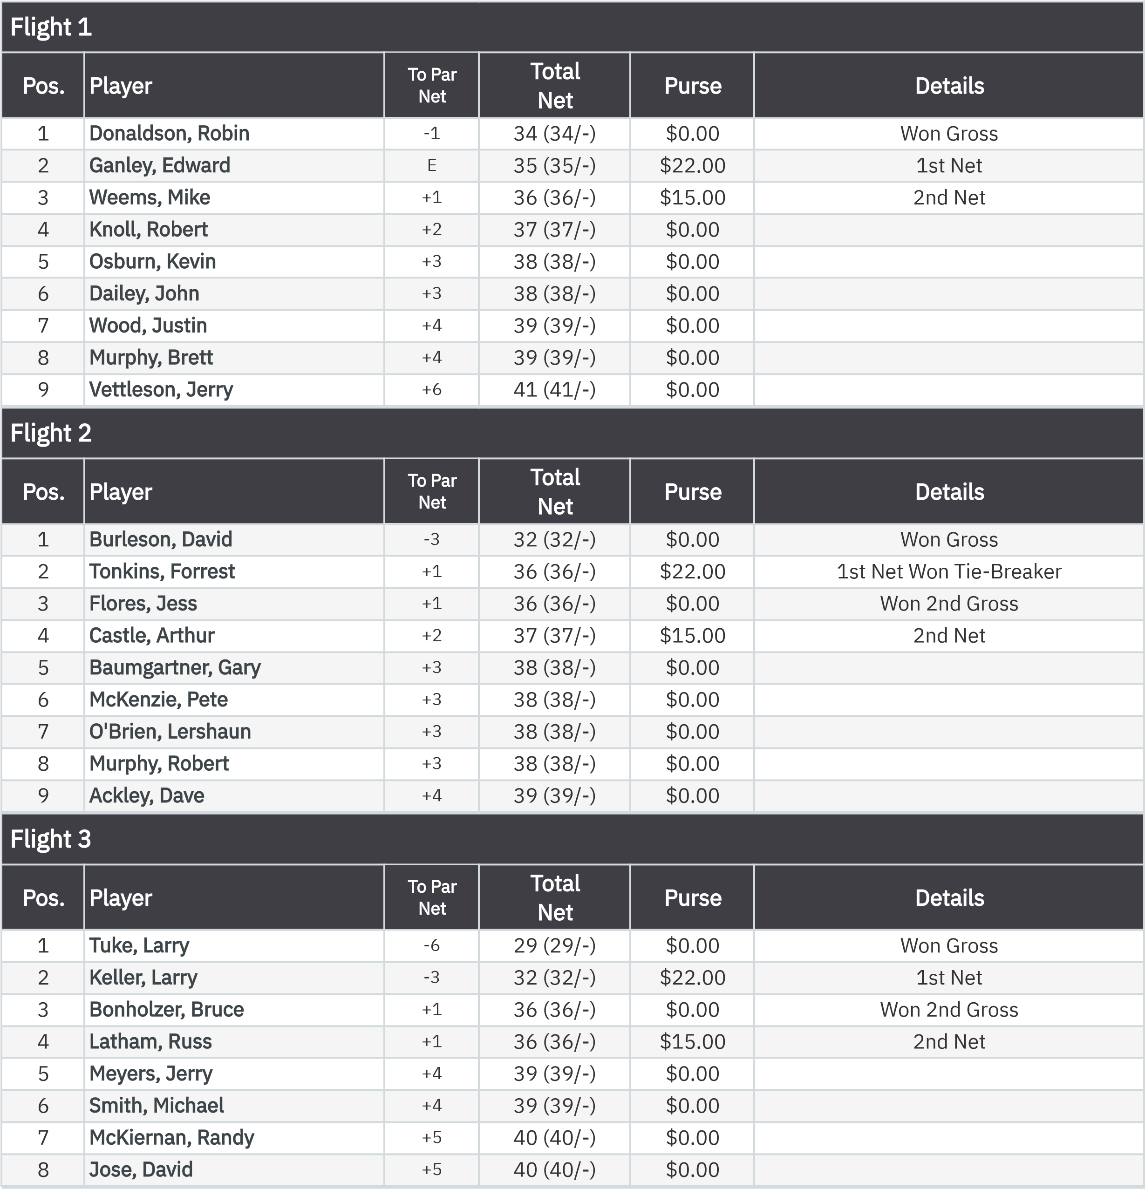

2026 Wednesday Golf Tournaments
April 15, 2026
Stroke Play (15Apr2026) Leaderboard

:
Gross VP Cup Points Front Nine (Gros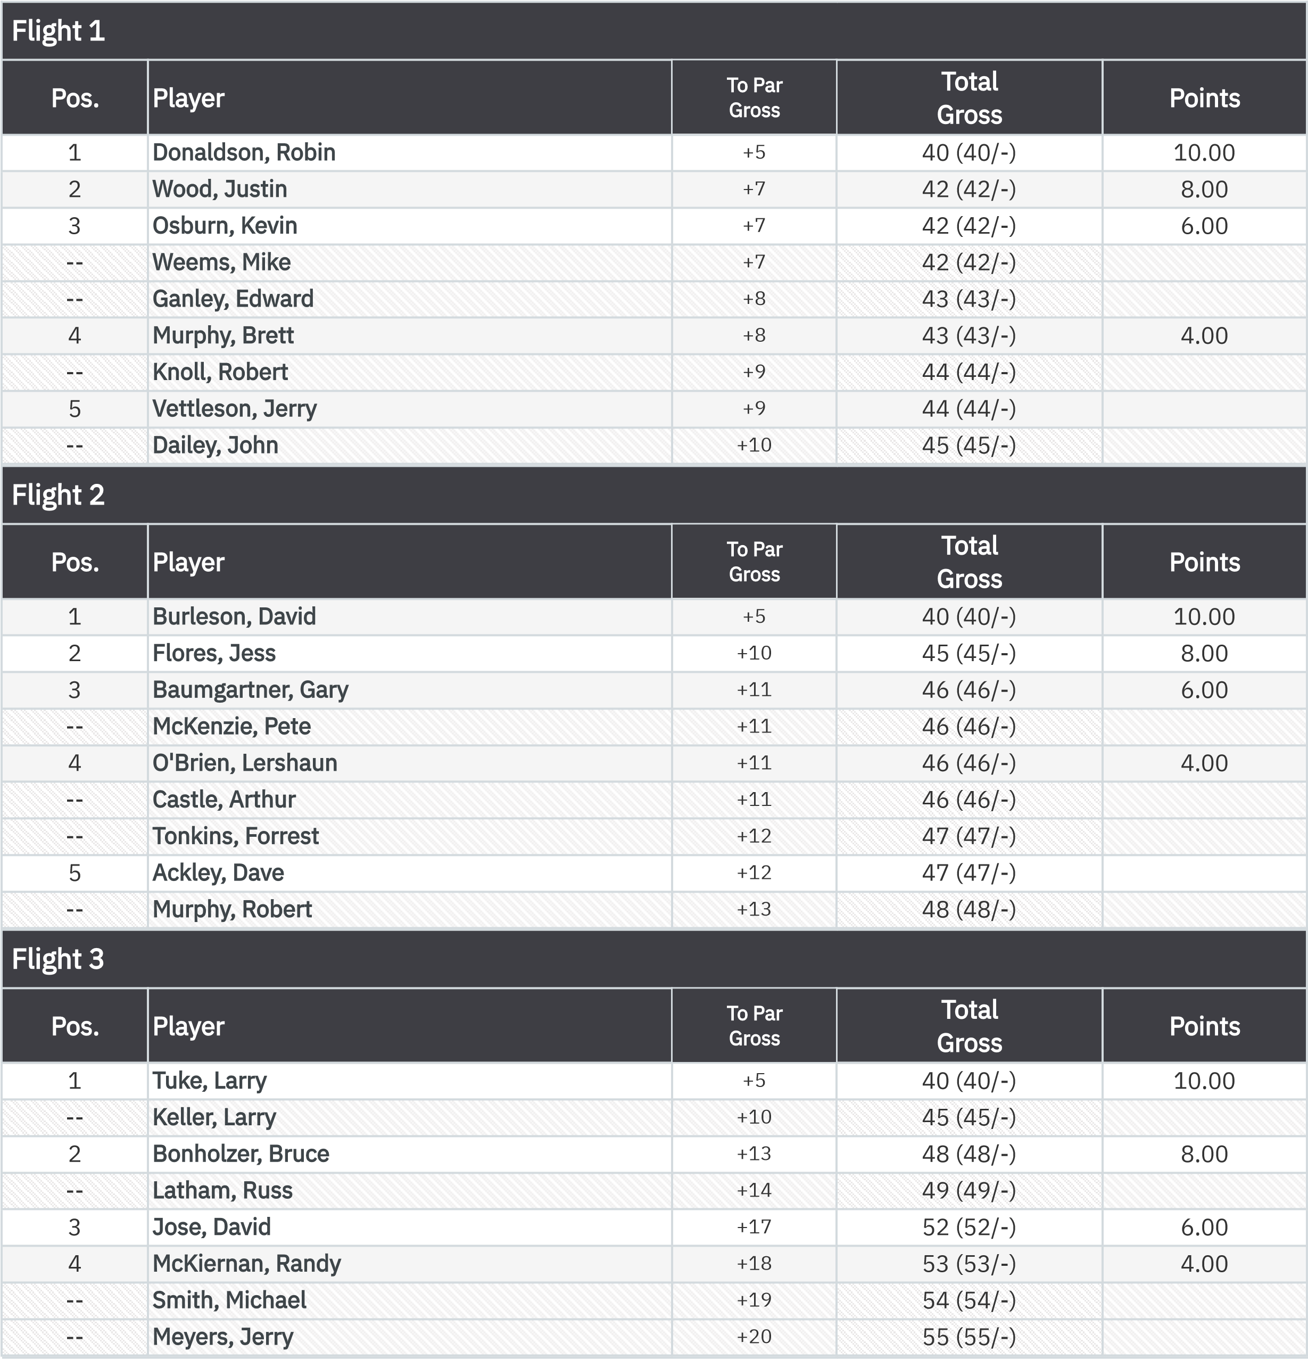s Bias)

2026 Wednesday Golf Tournaments
April 15, 2026
Stroke Play (15Apr2026) Leaderboard

:

Net VP Cup Points Front Nine (Gros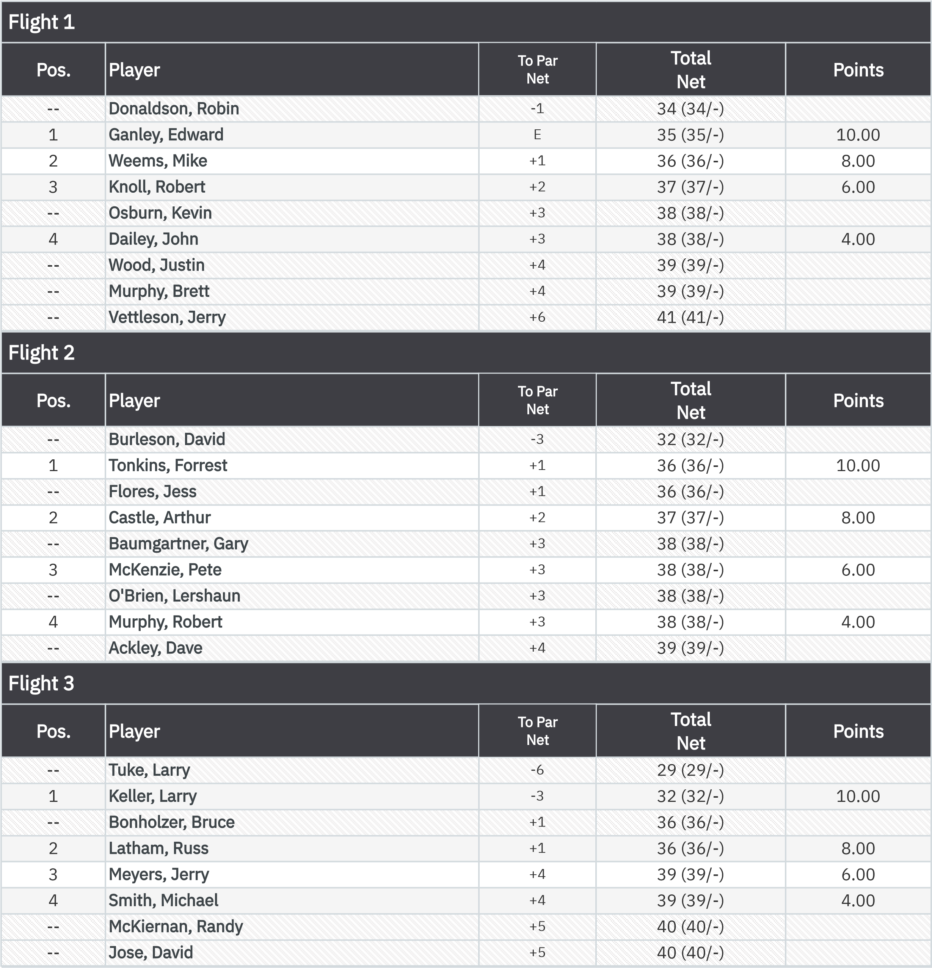s Bias)

2026 Wednesday Golf Tournaments
April 15, 2026

:

KP - Hole 9
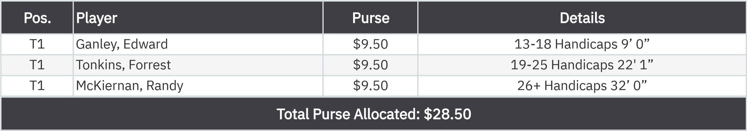
50-50 RHMC Scholarship Fund

Details
1
Ganley, Edward
$14.50

:

