2-Man Shamble Front Nine (Gross)
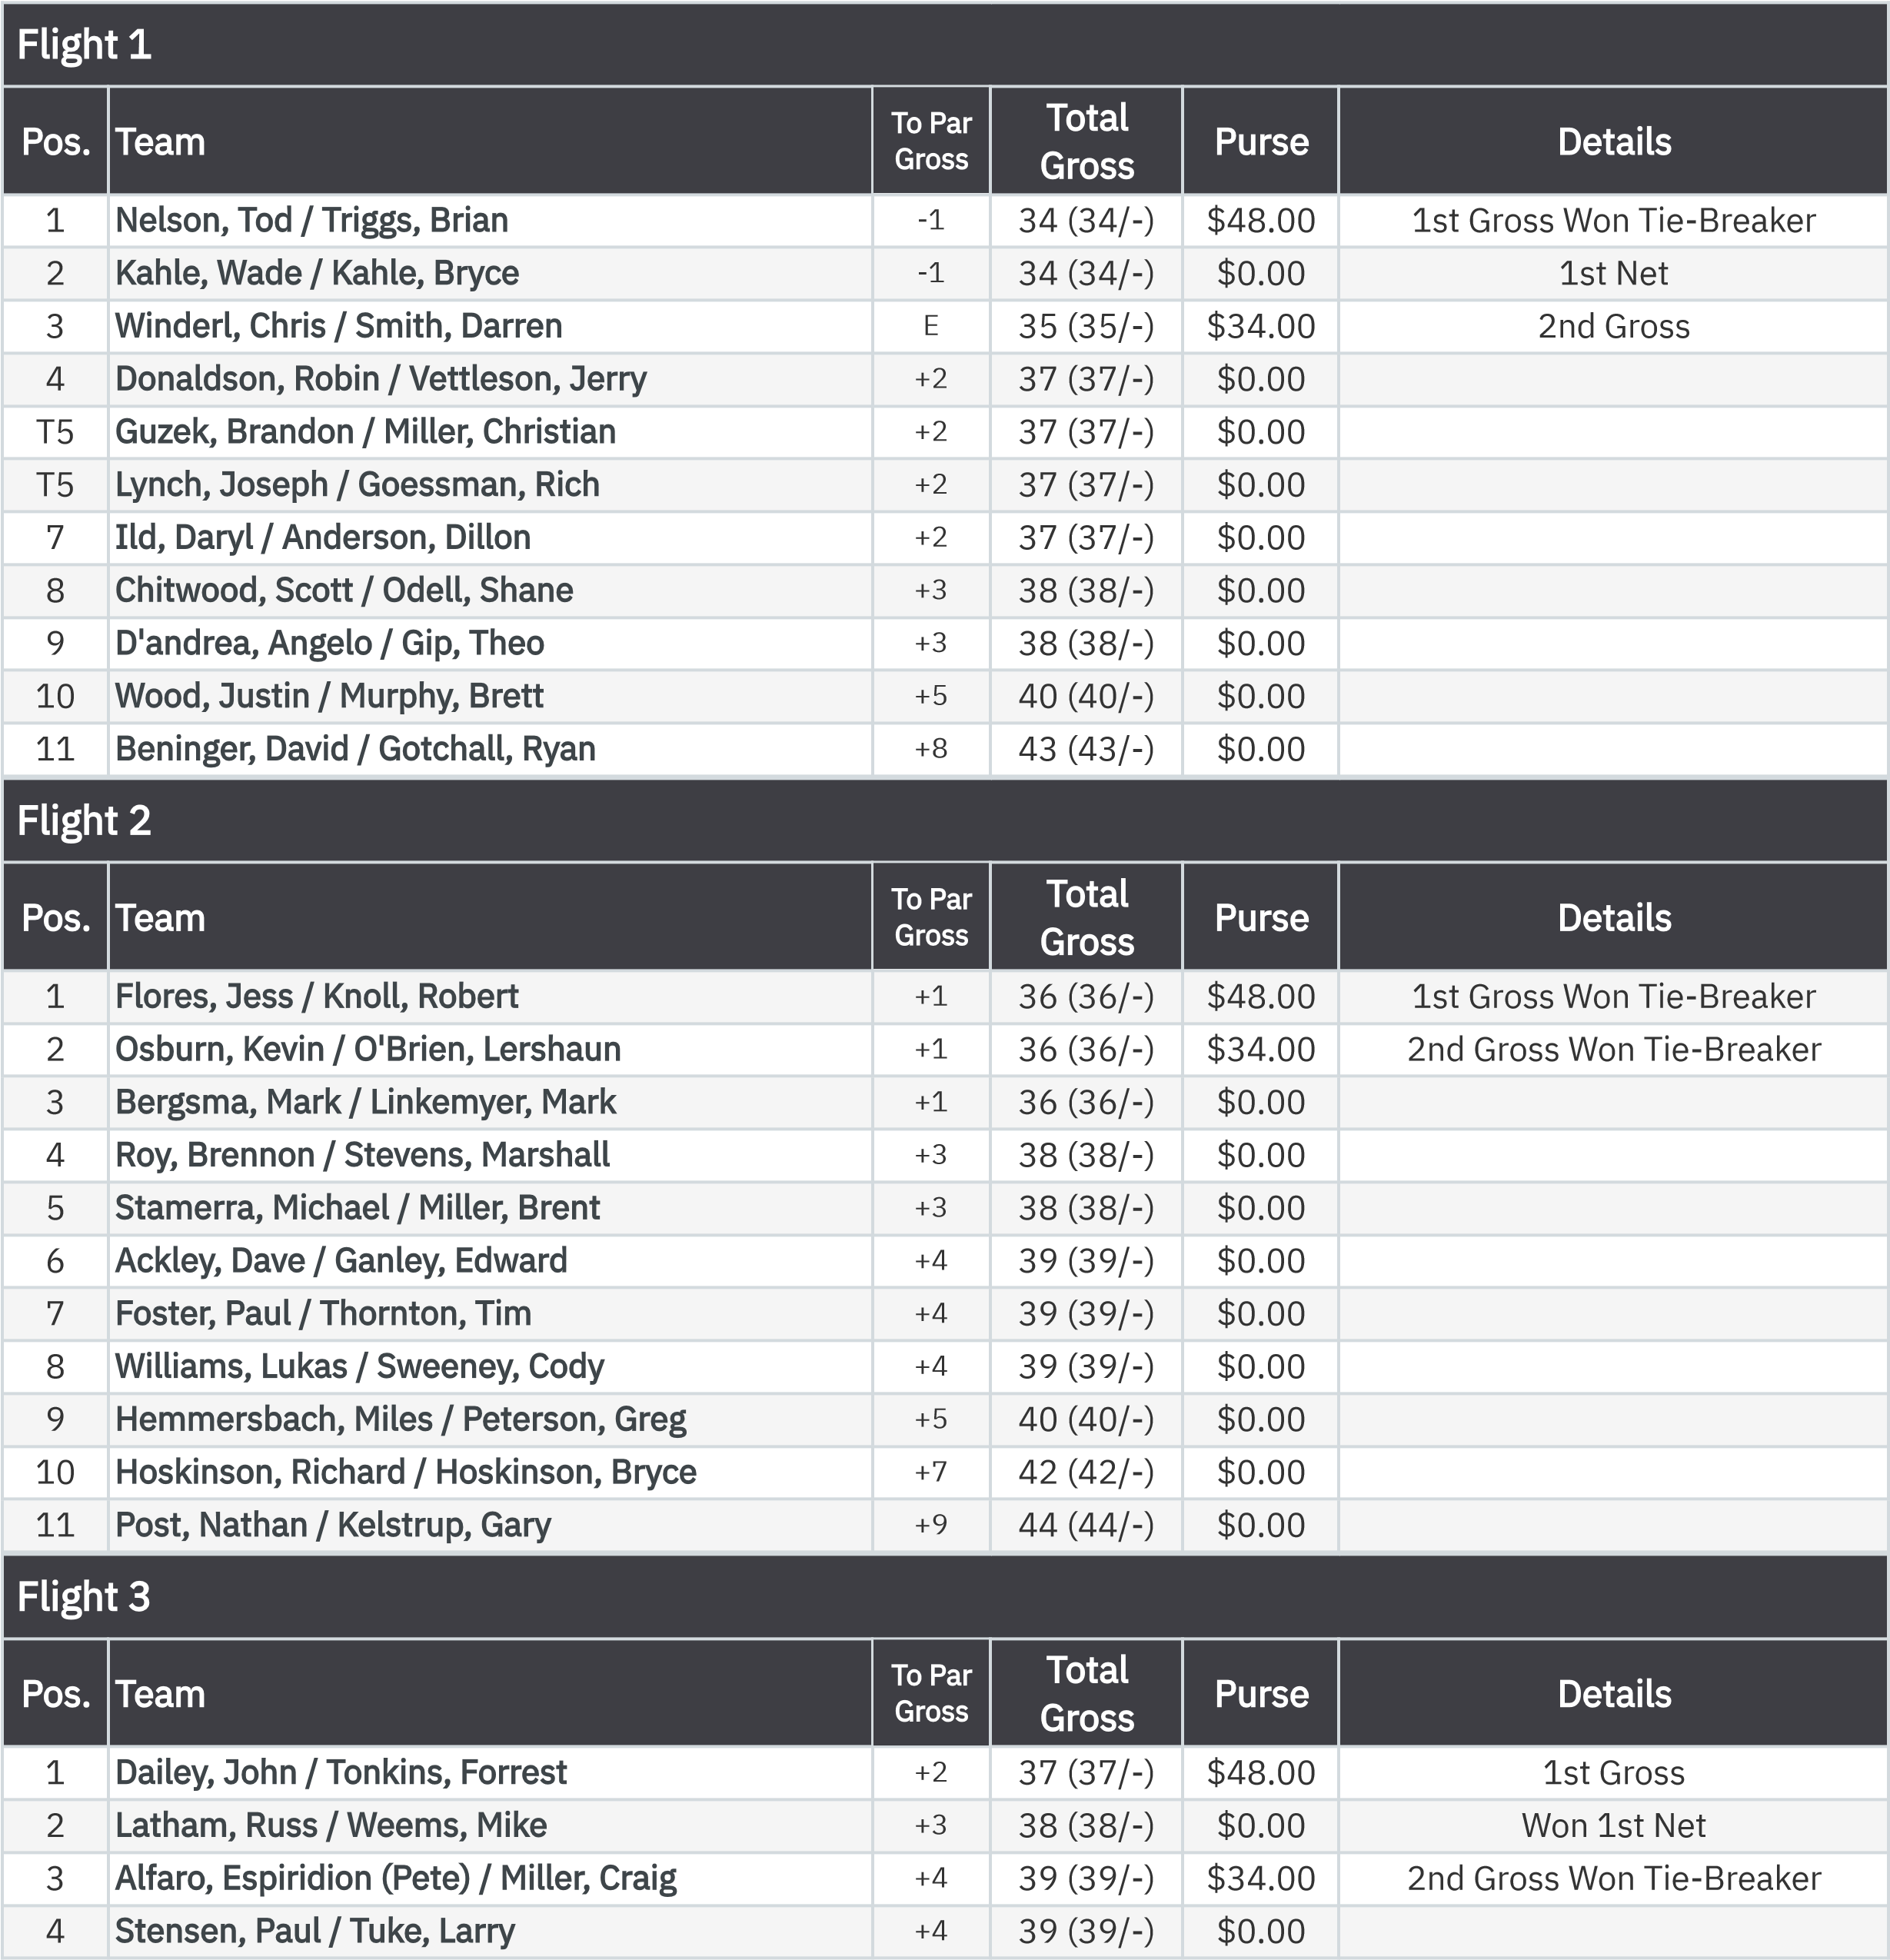
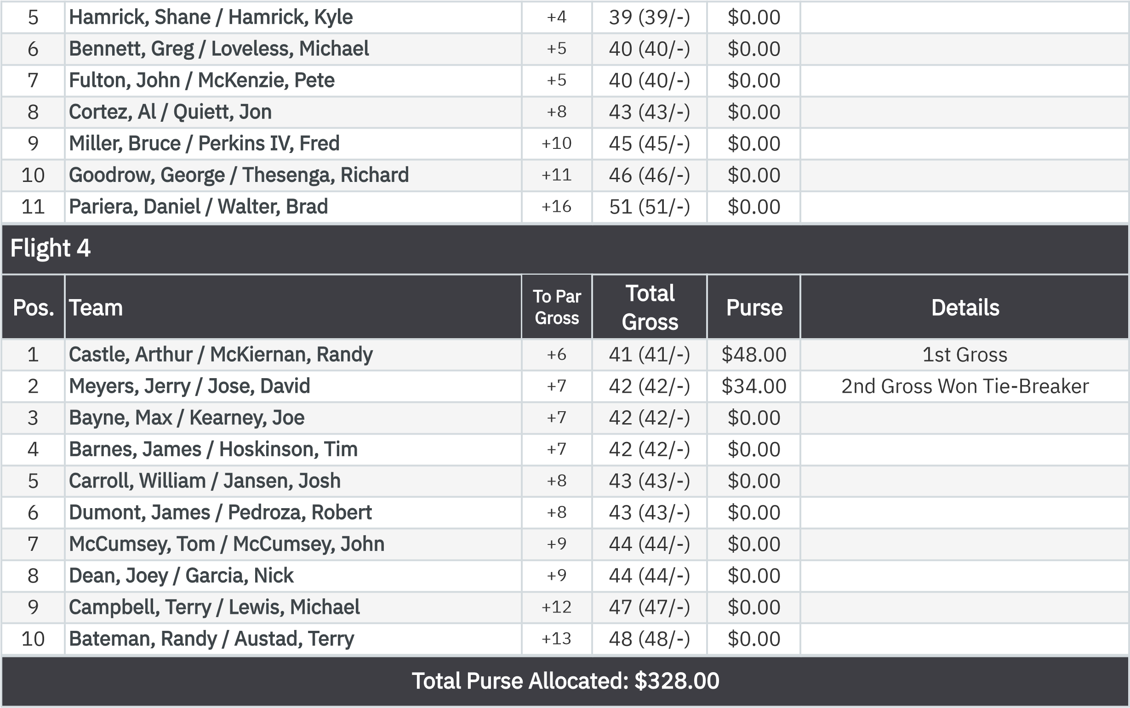
2-Man Shamble Front Nine (Net)
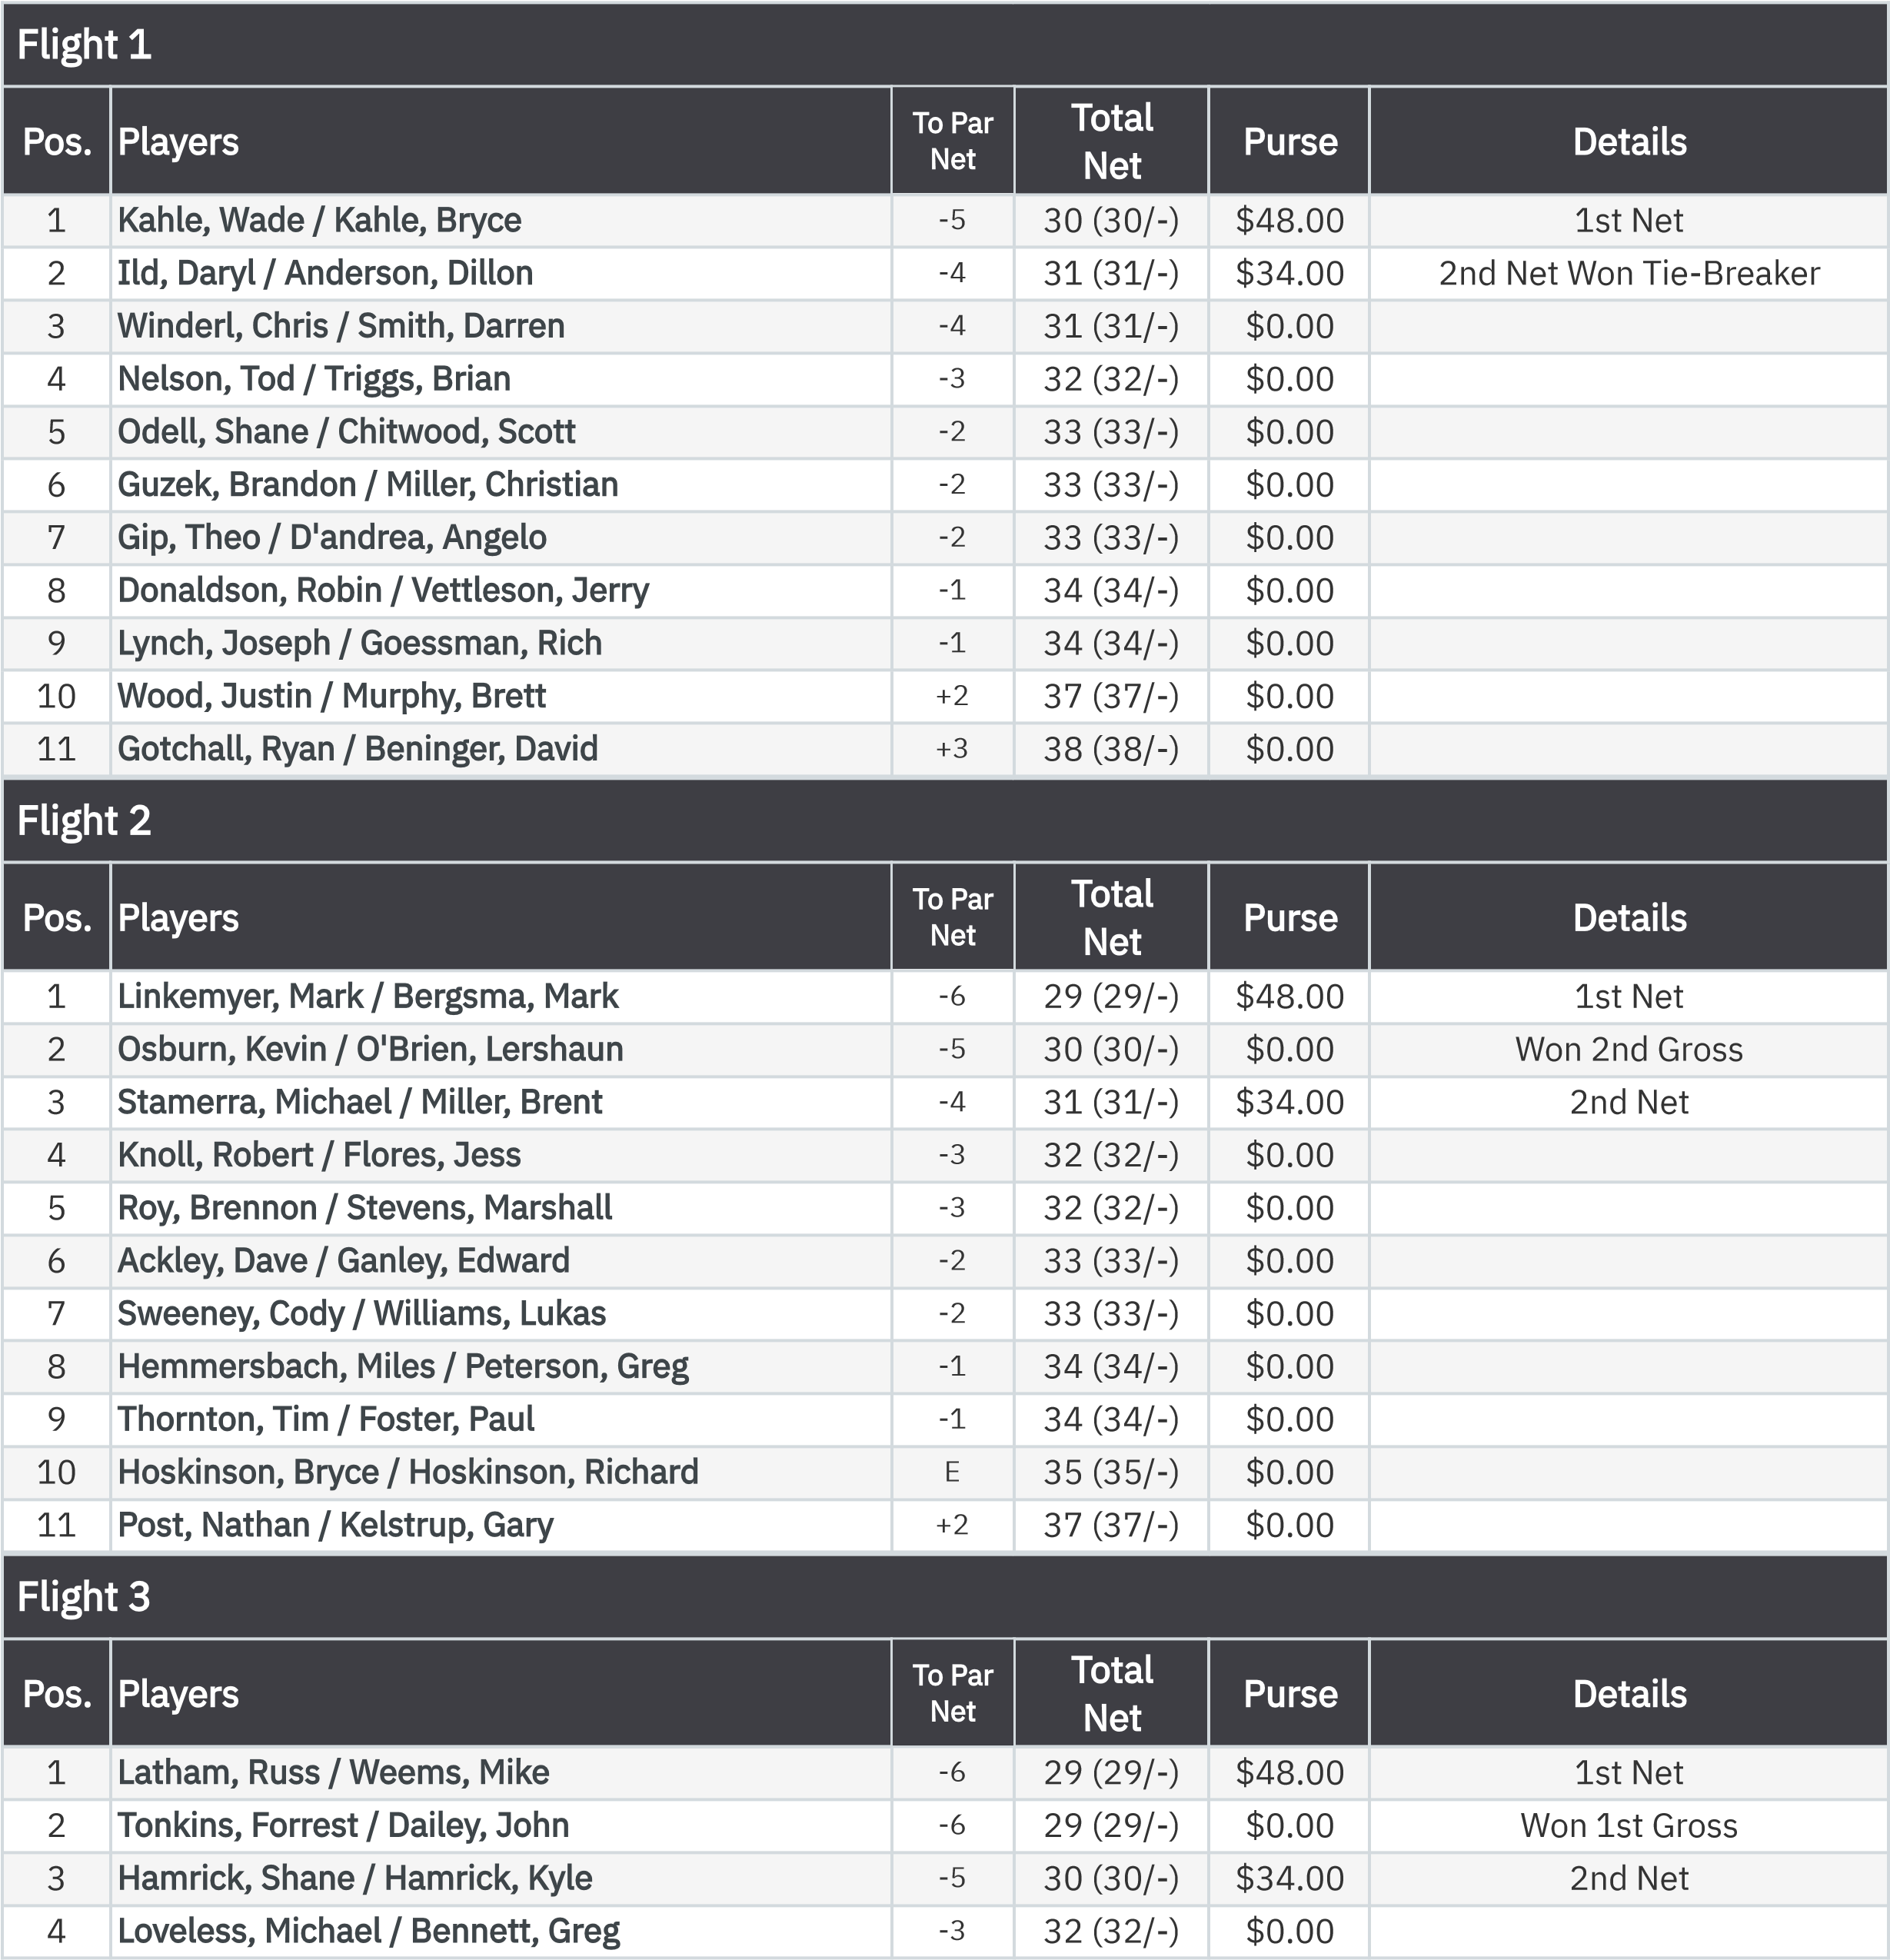
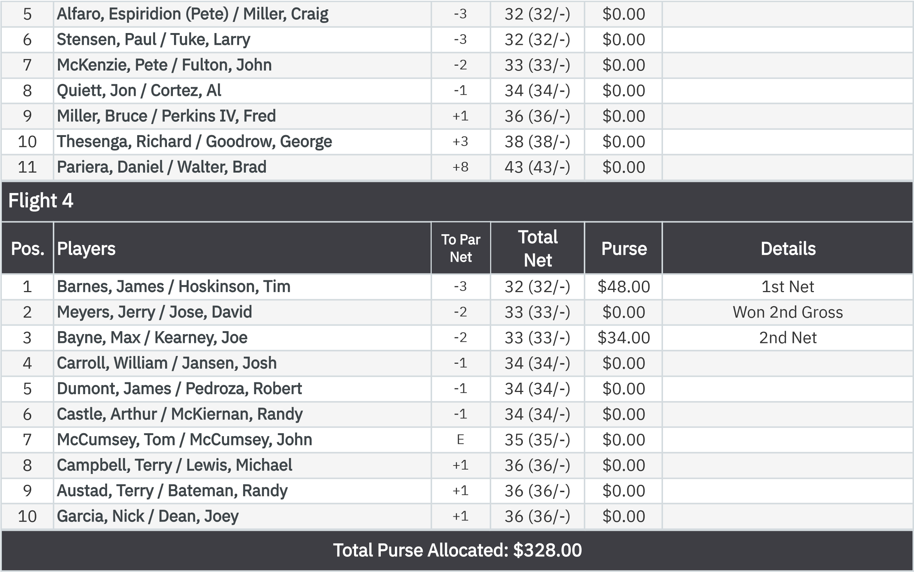
Gross VP Cup Points Front Nine (Gross Bias)
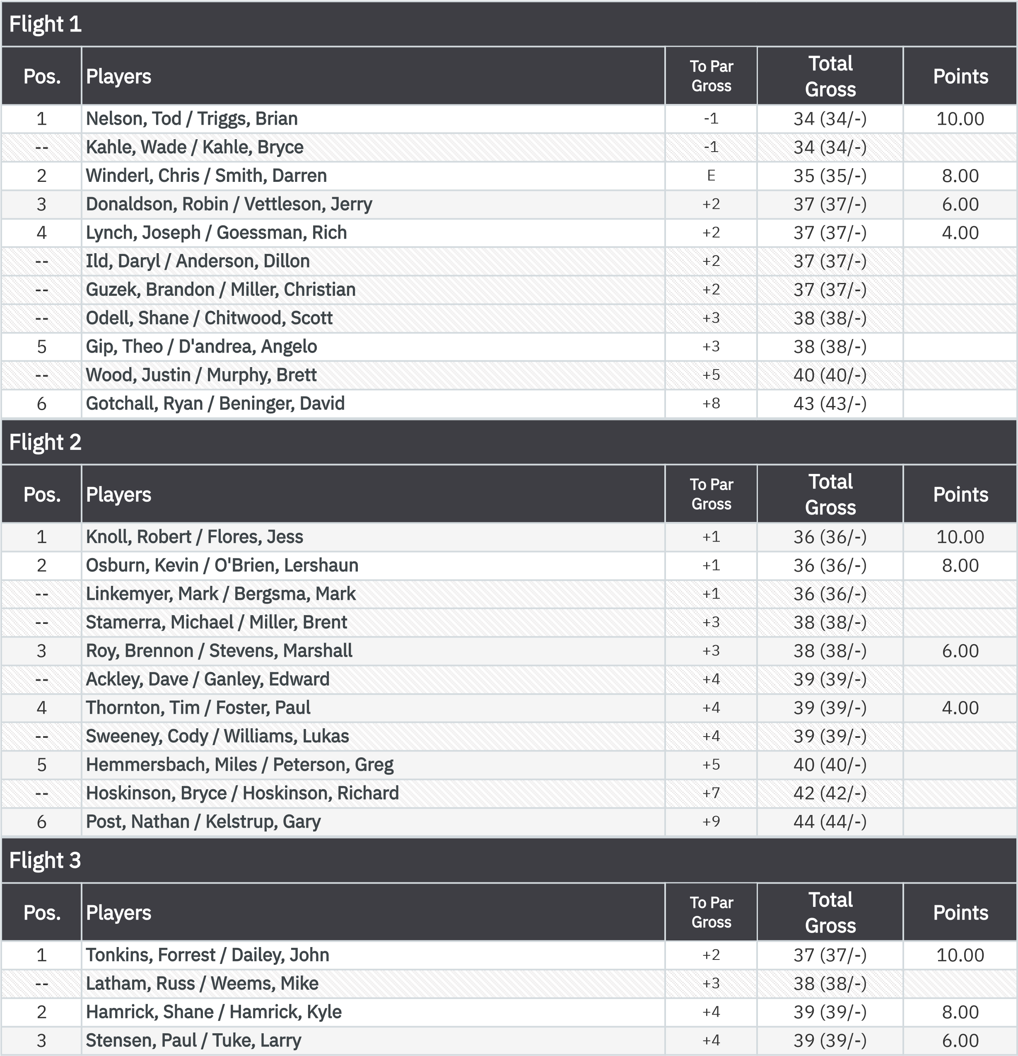
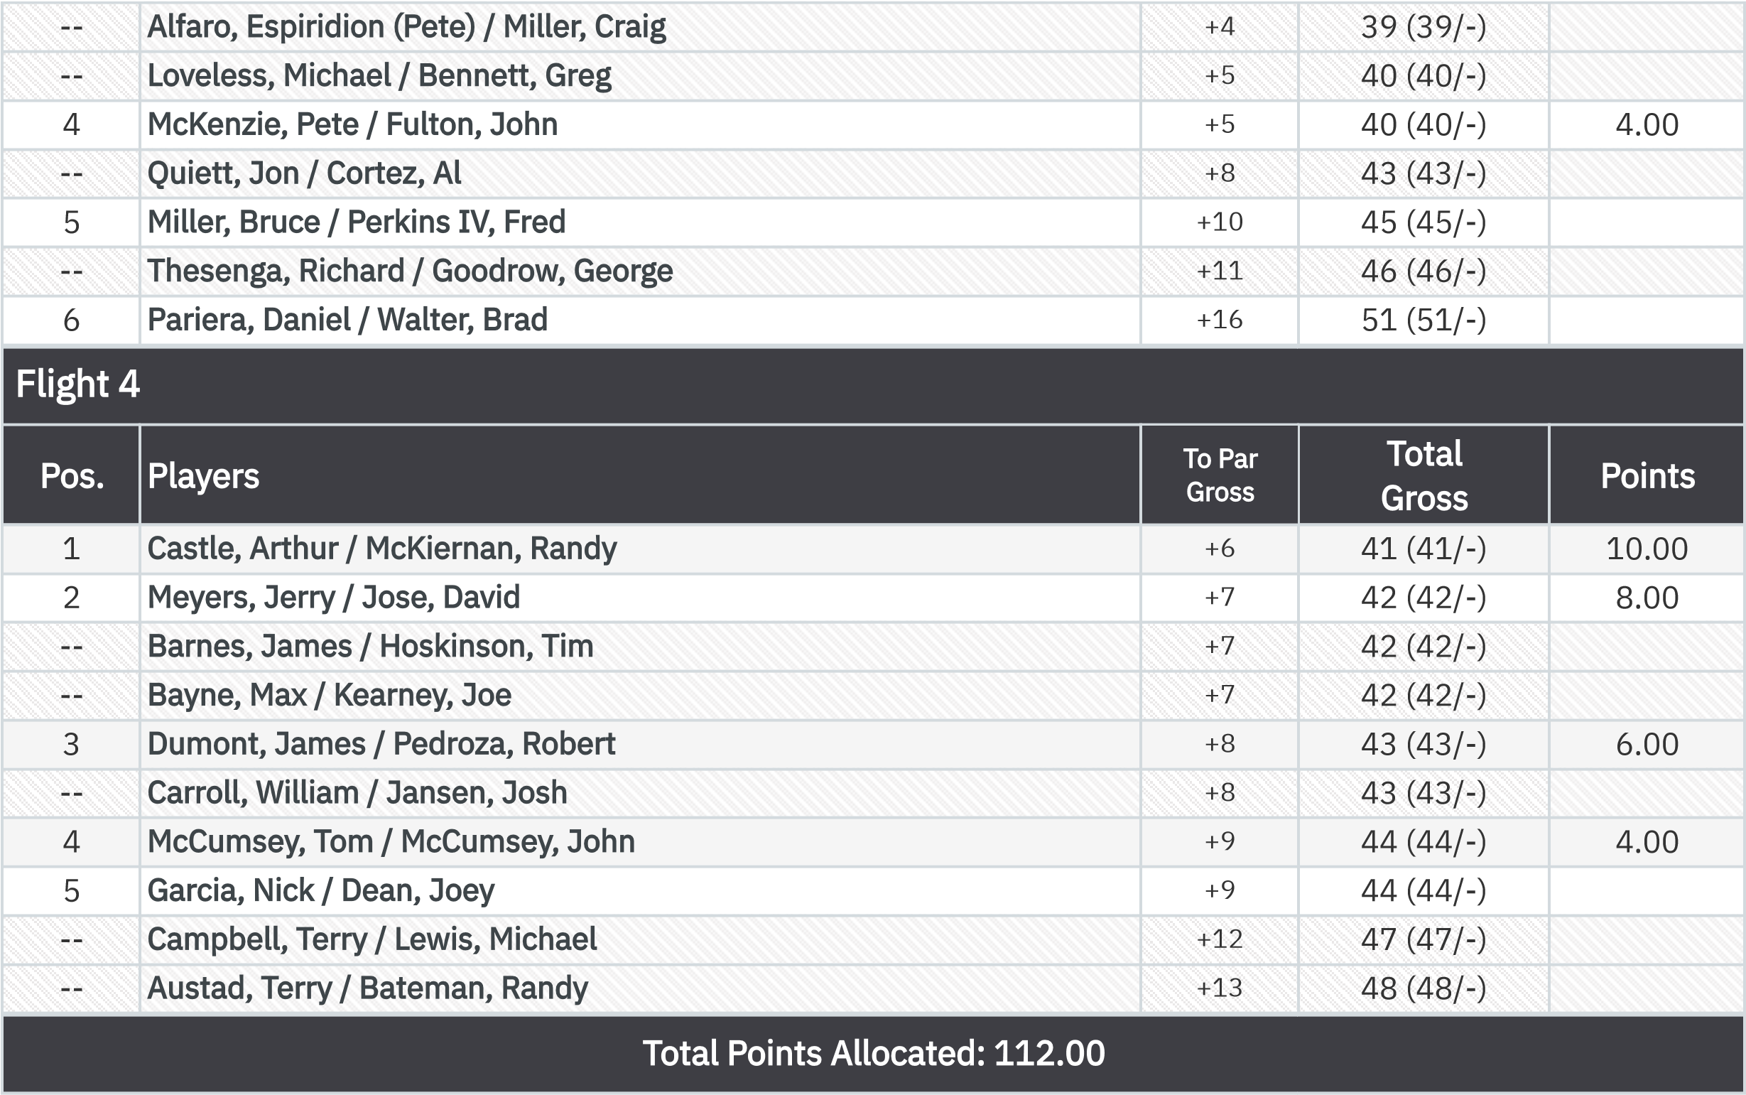
Net VP Cup Points Front Nine (Gross Bias)
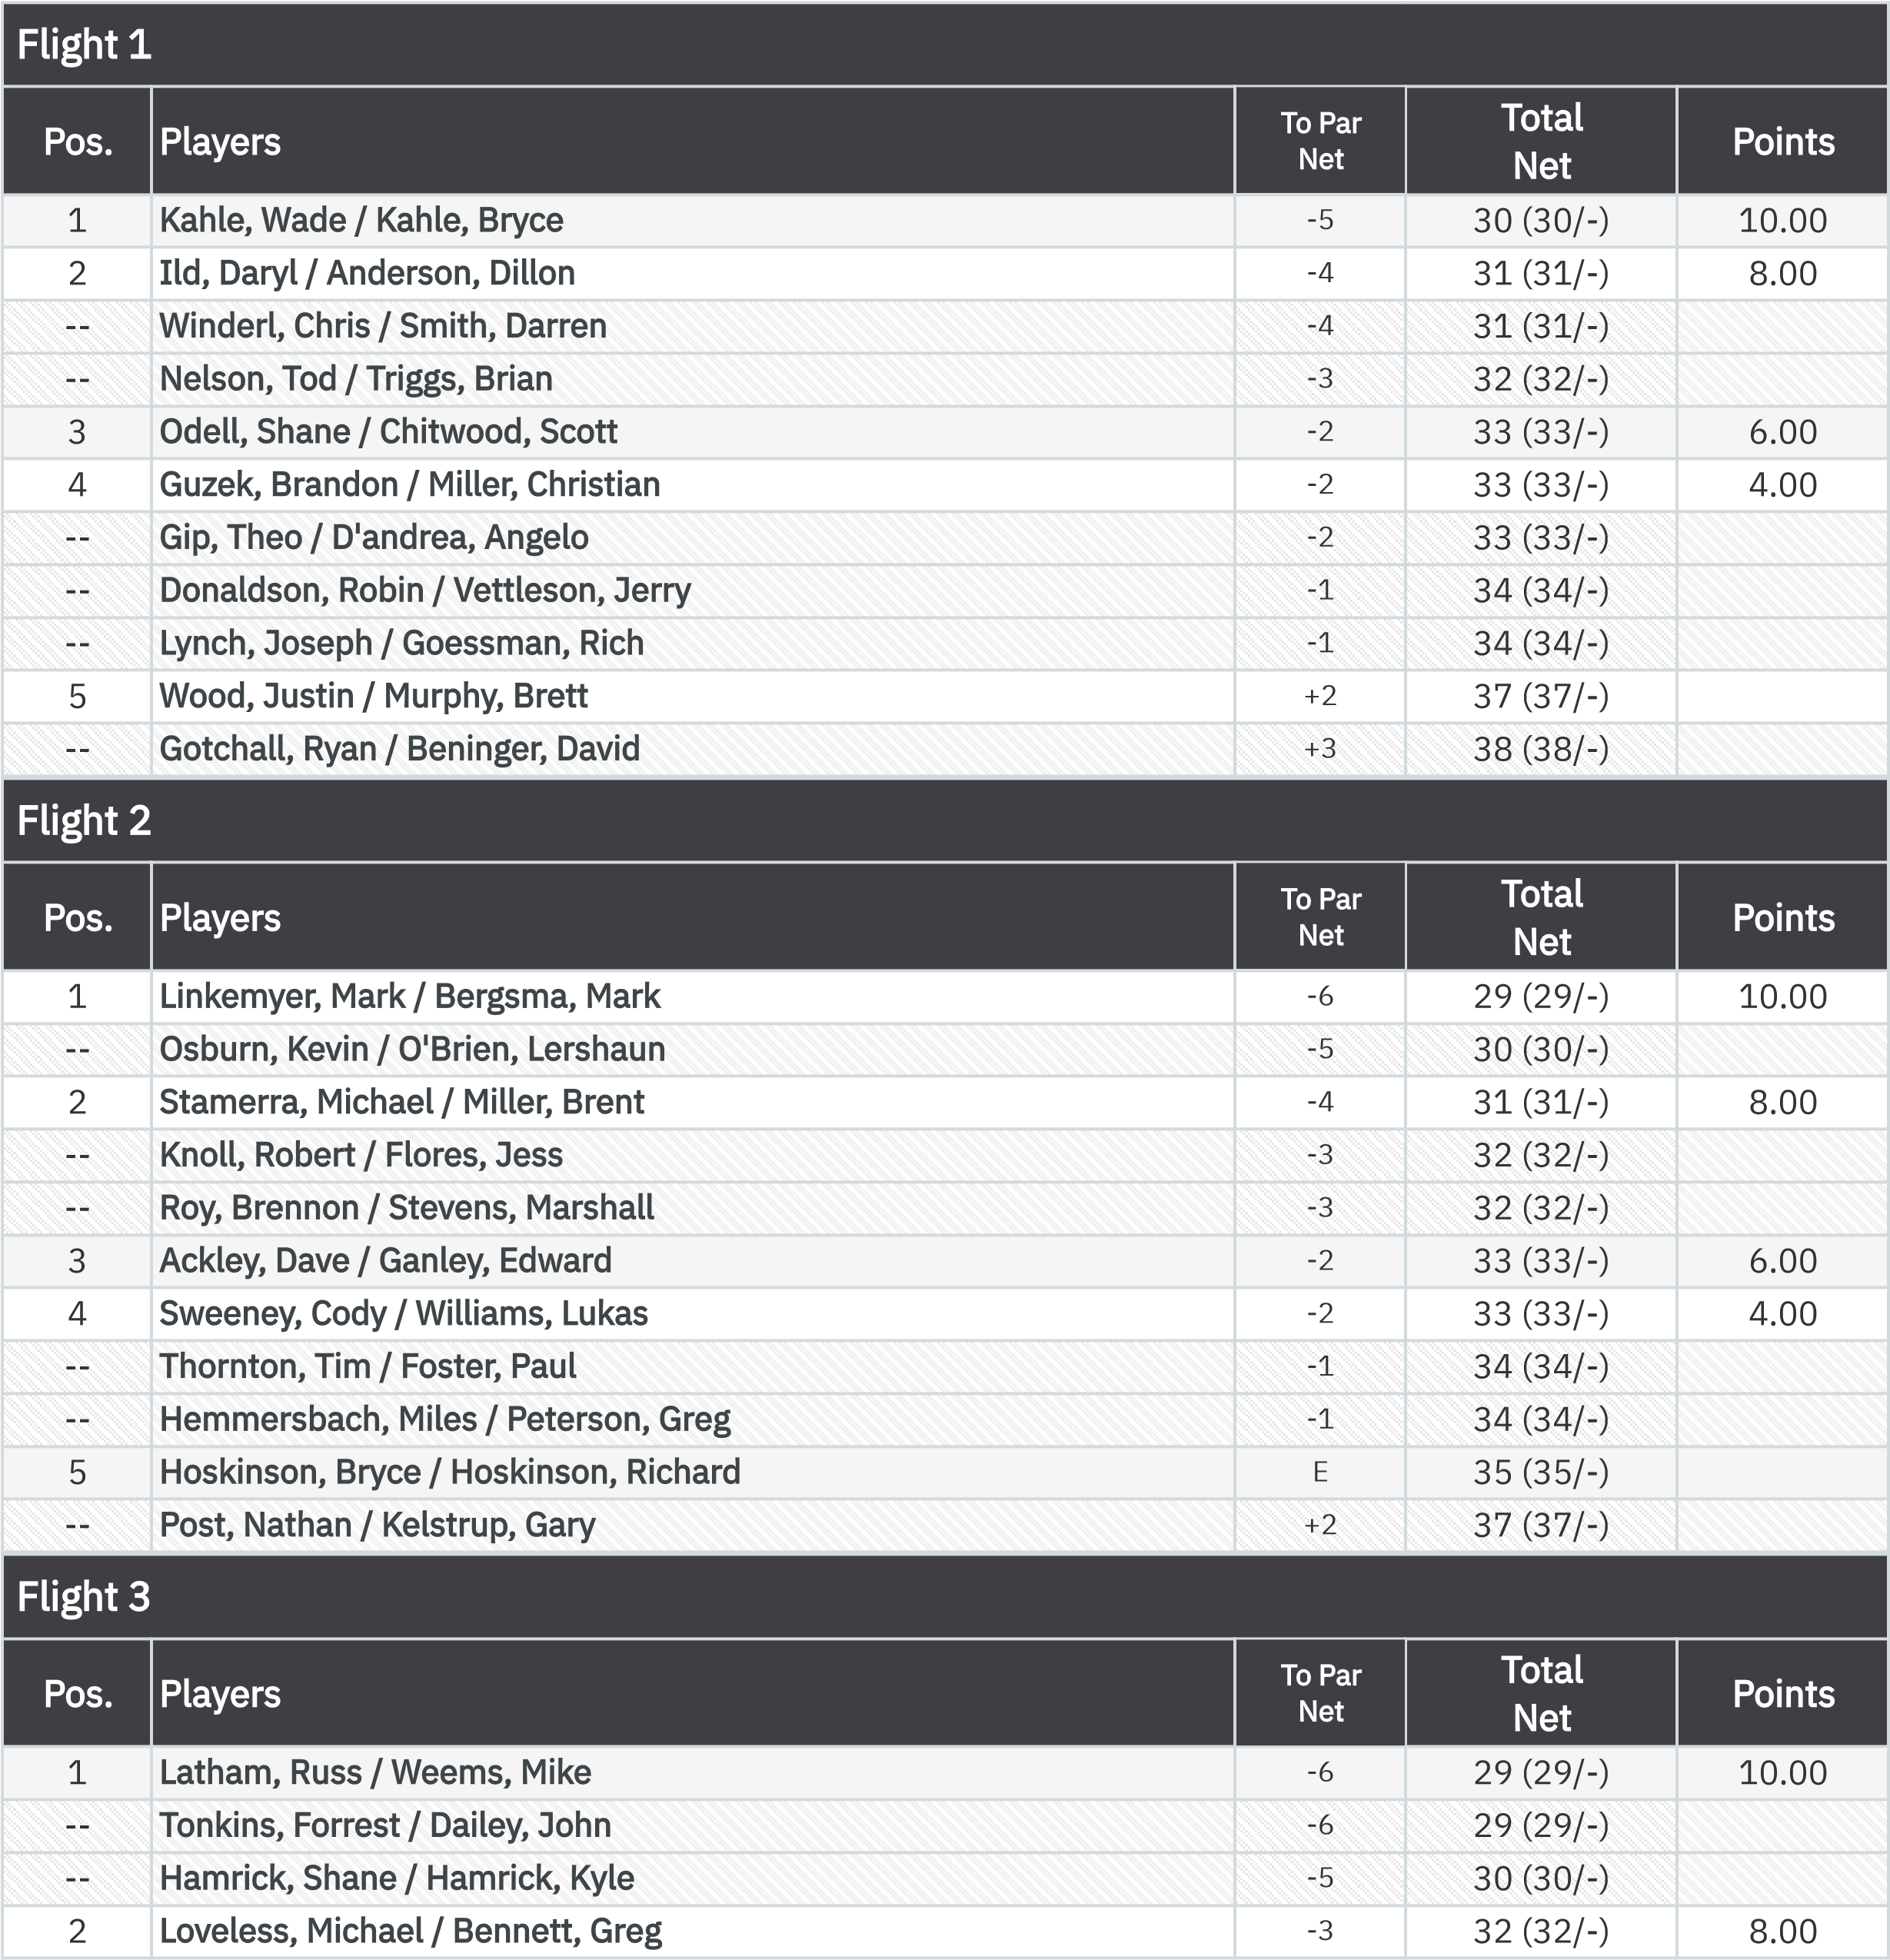
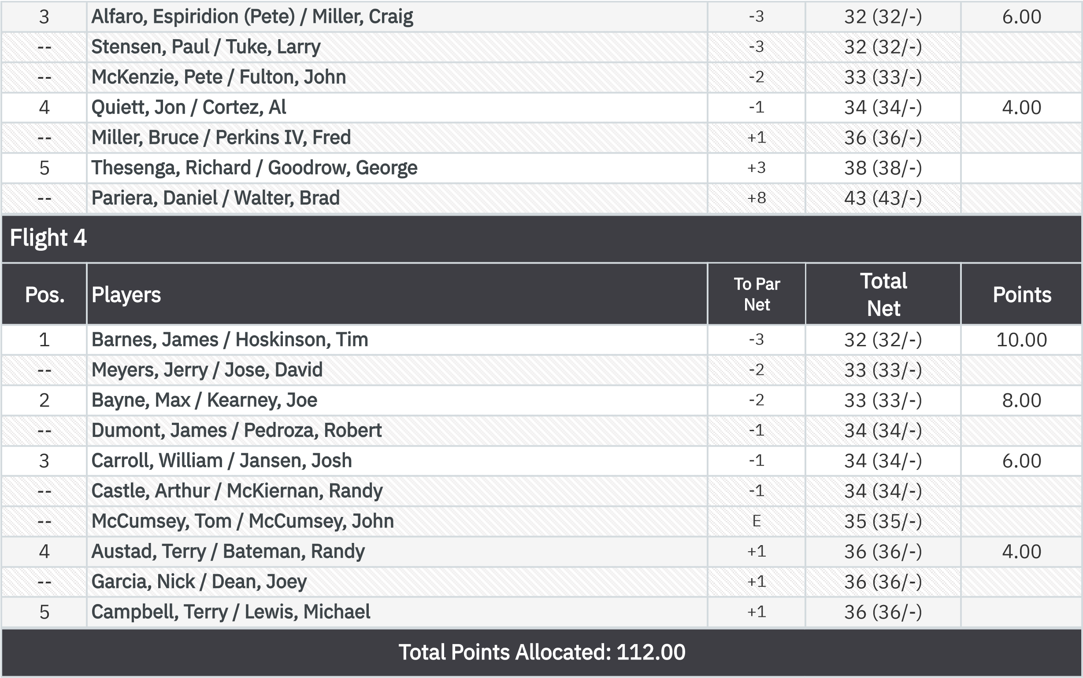
KP - Hole 4

.

1
Gotchall, Ryan
$43.00

:

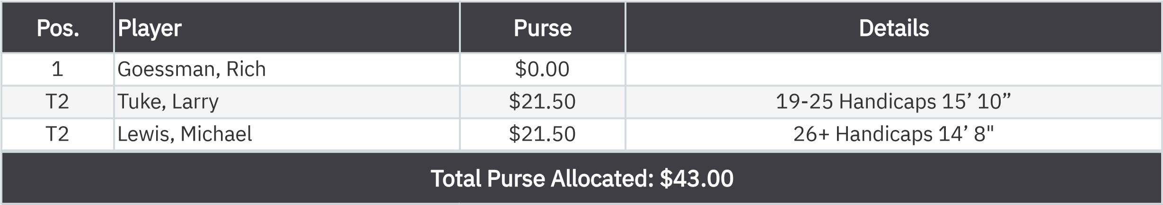
KP - Hole 9
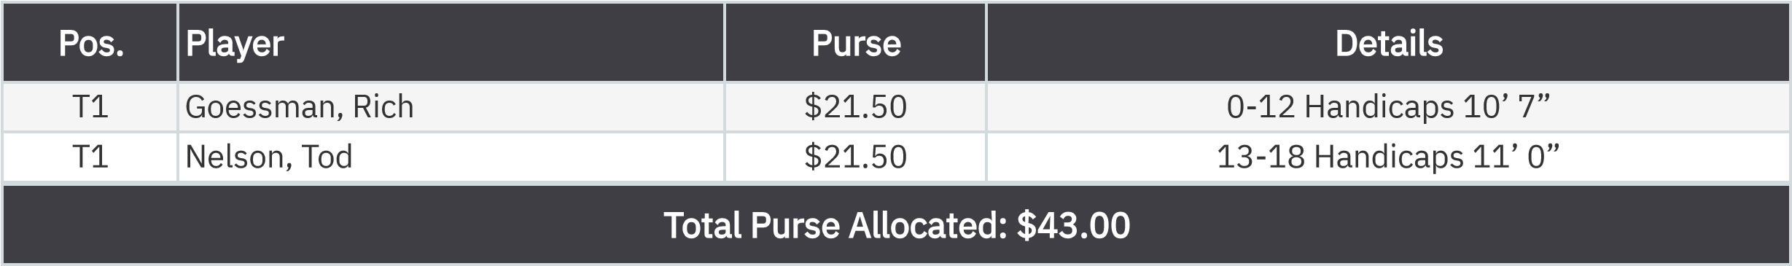
50-50 RHMC Scholarship Fund

