2-Man Scramble Front Nine (Gross)
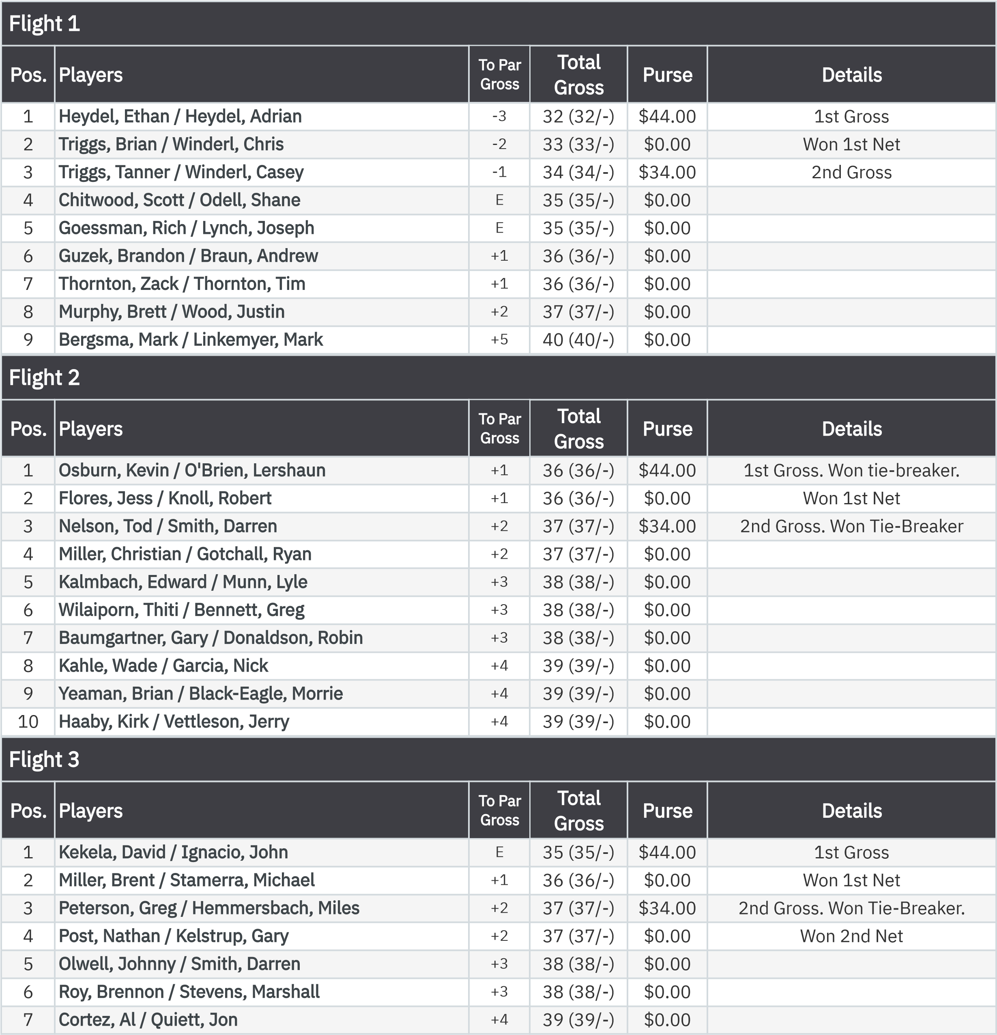
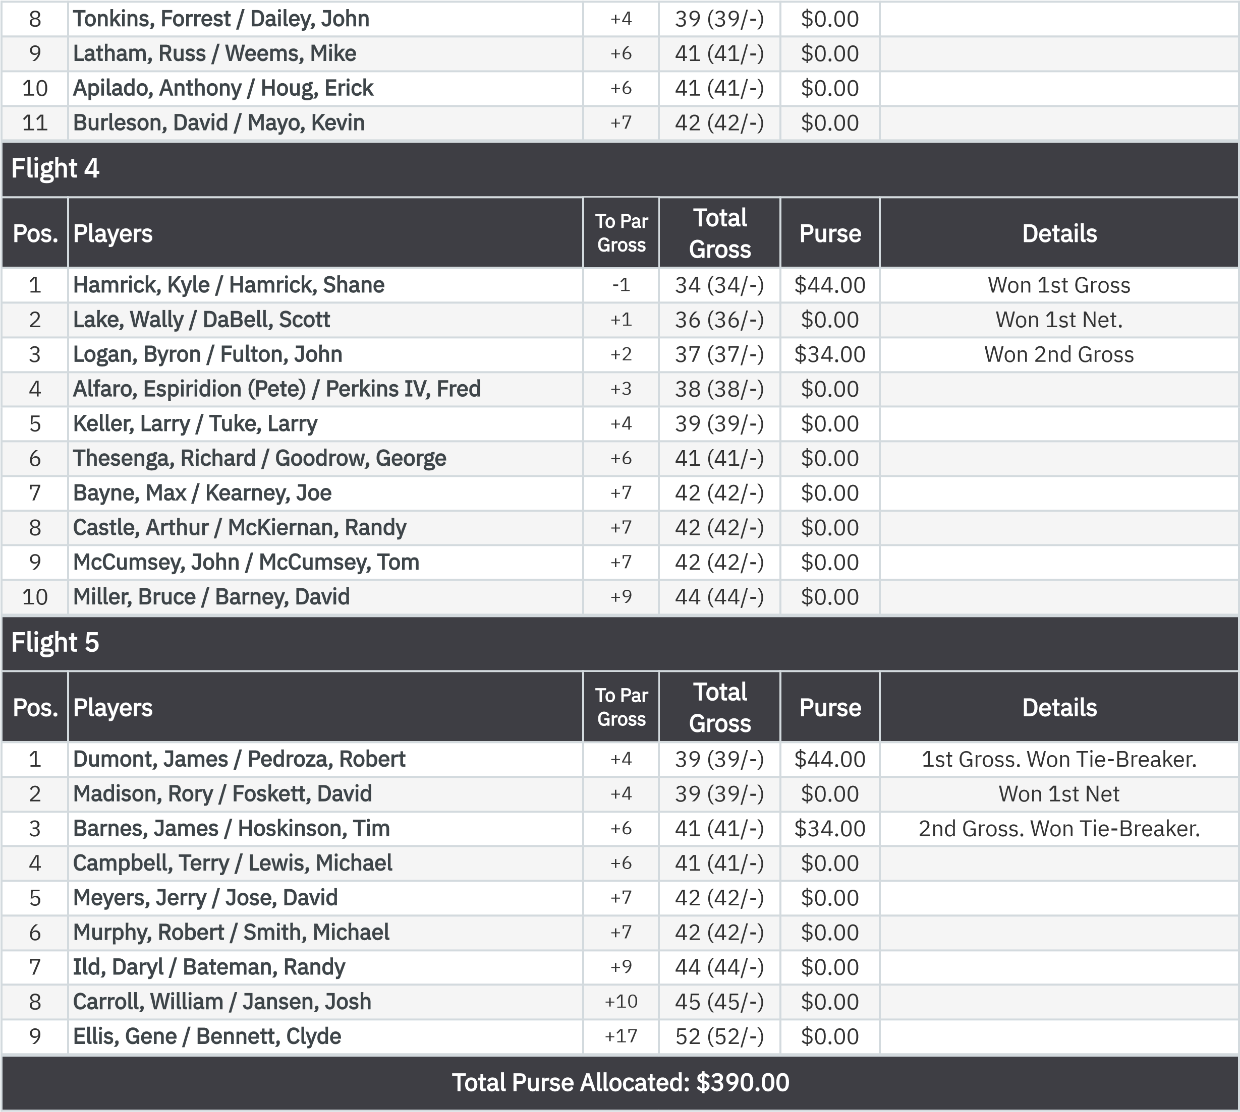
2-Man Scramble Front Nine (Net)
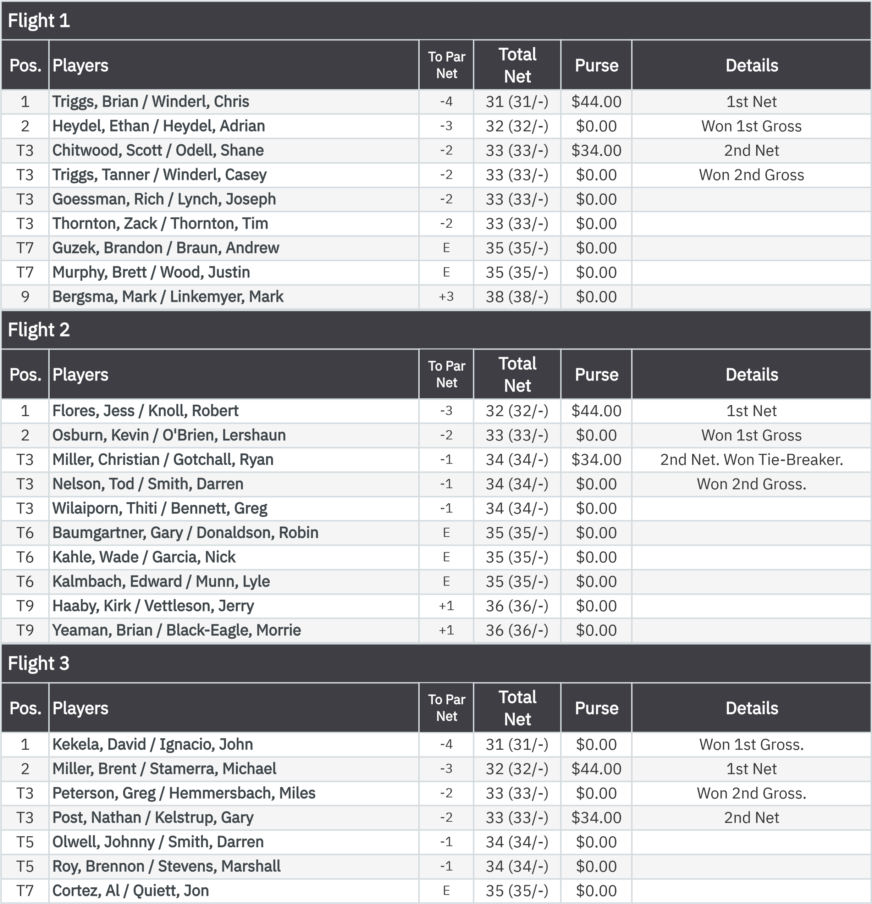
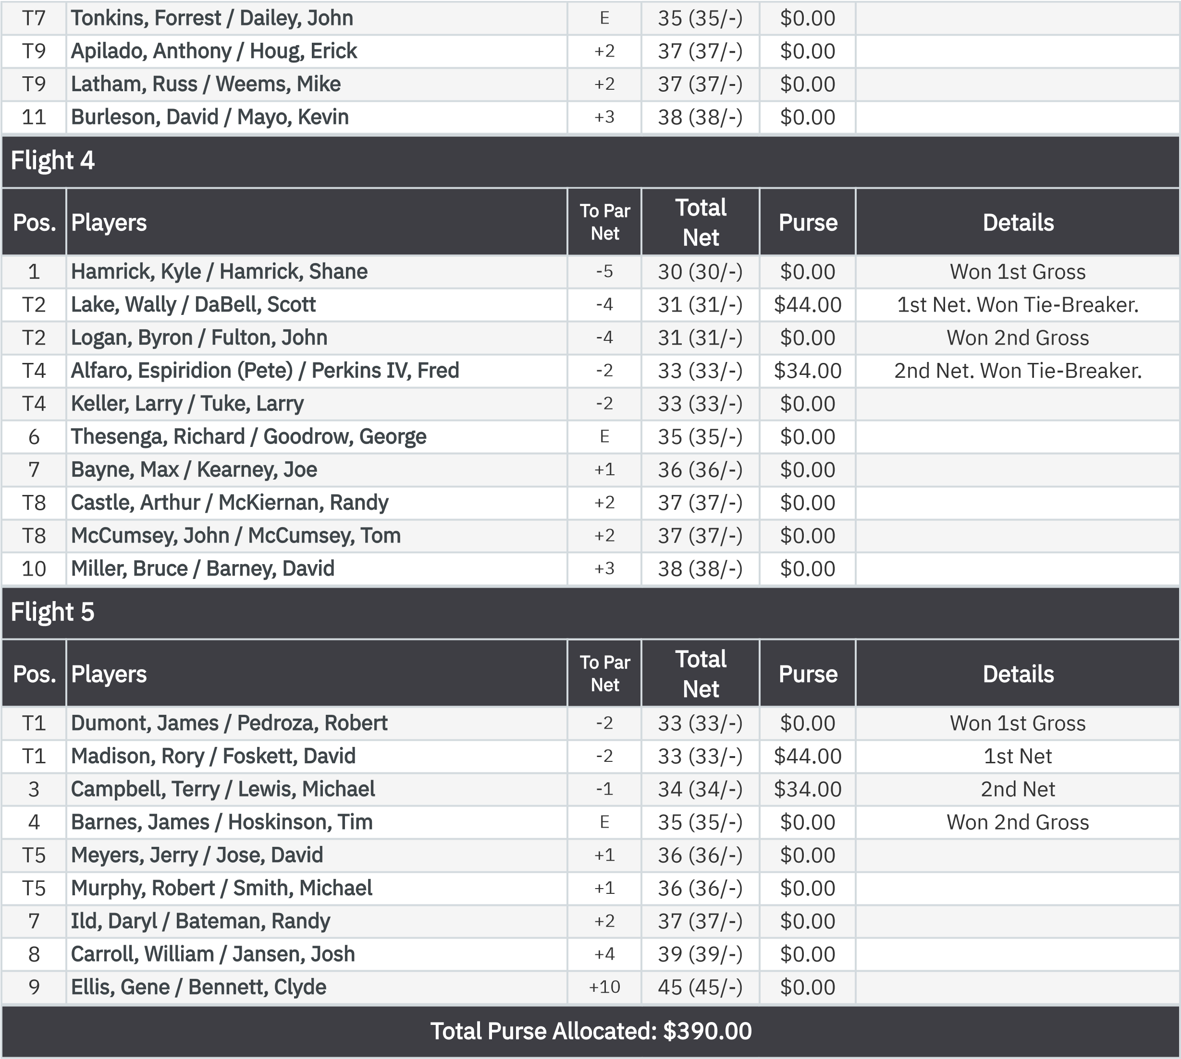
KP - Hole 4
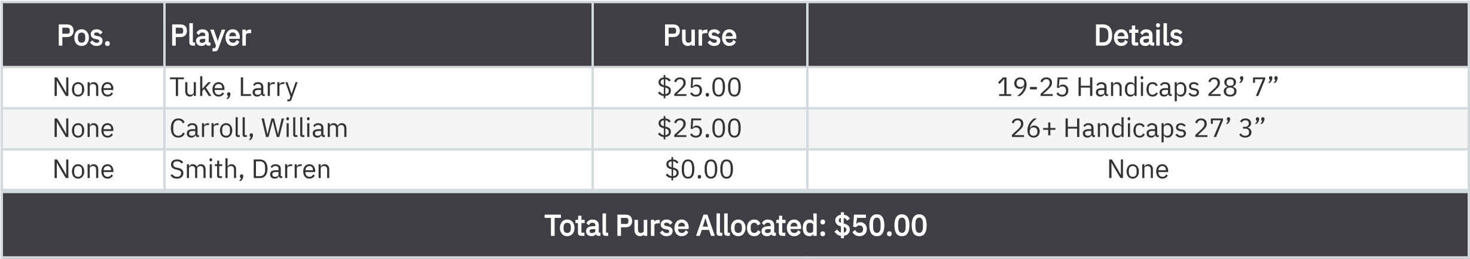
KP - Hole 9
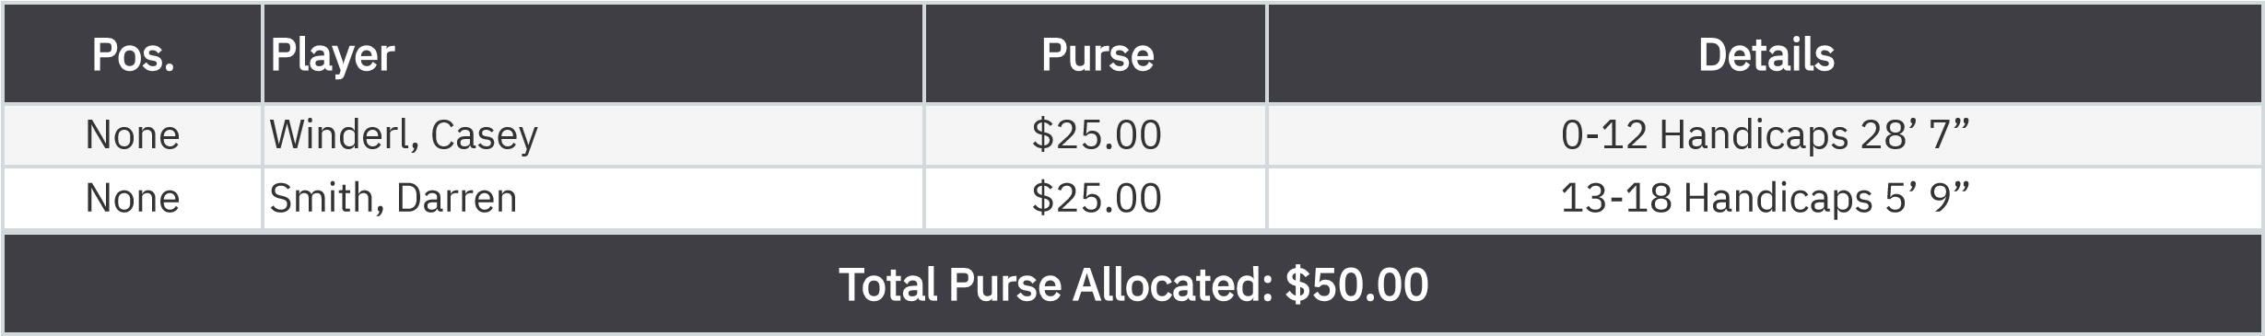
50-50 RHMC Scholarship Fund

Details
1
Odell, Shane
$50.00

:

