2-Man Combined Score Back Nine (Gross)
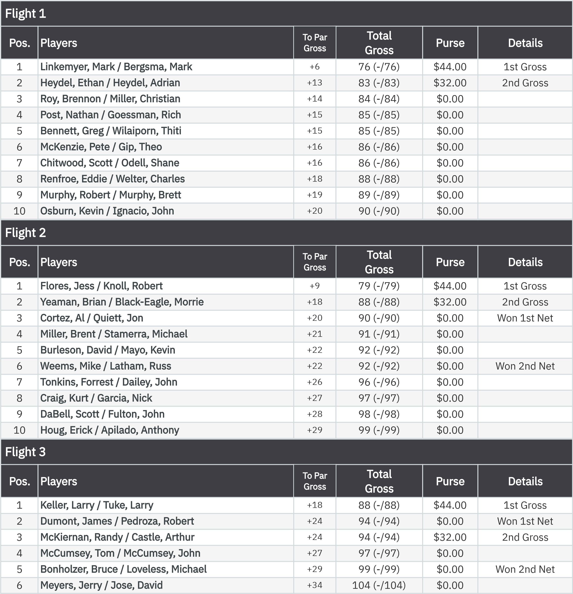
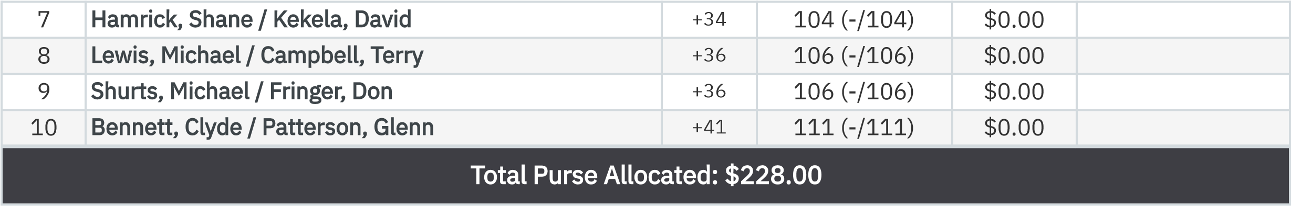

2-Man Combined Score Back Nine (Net)
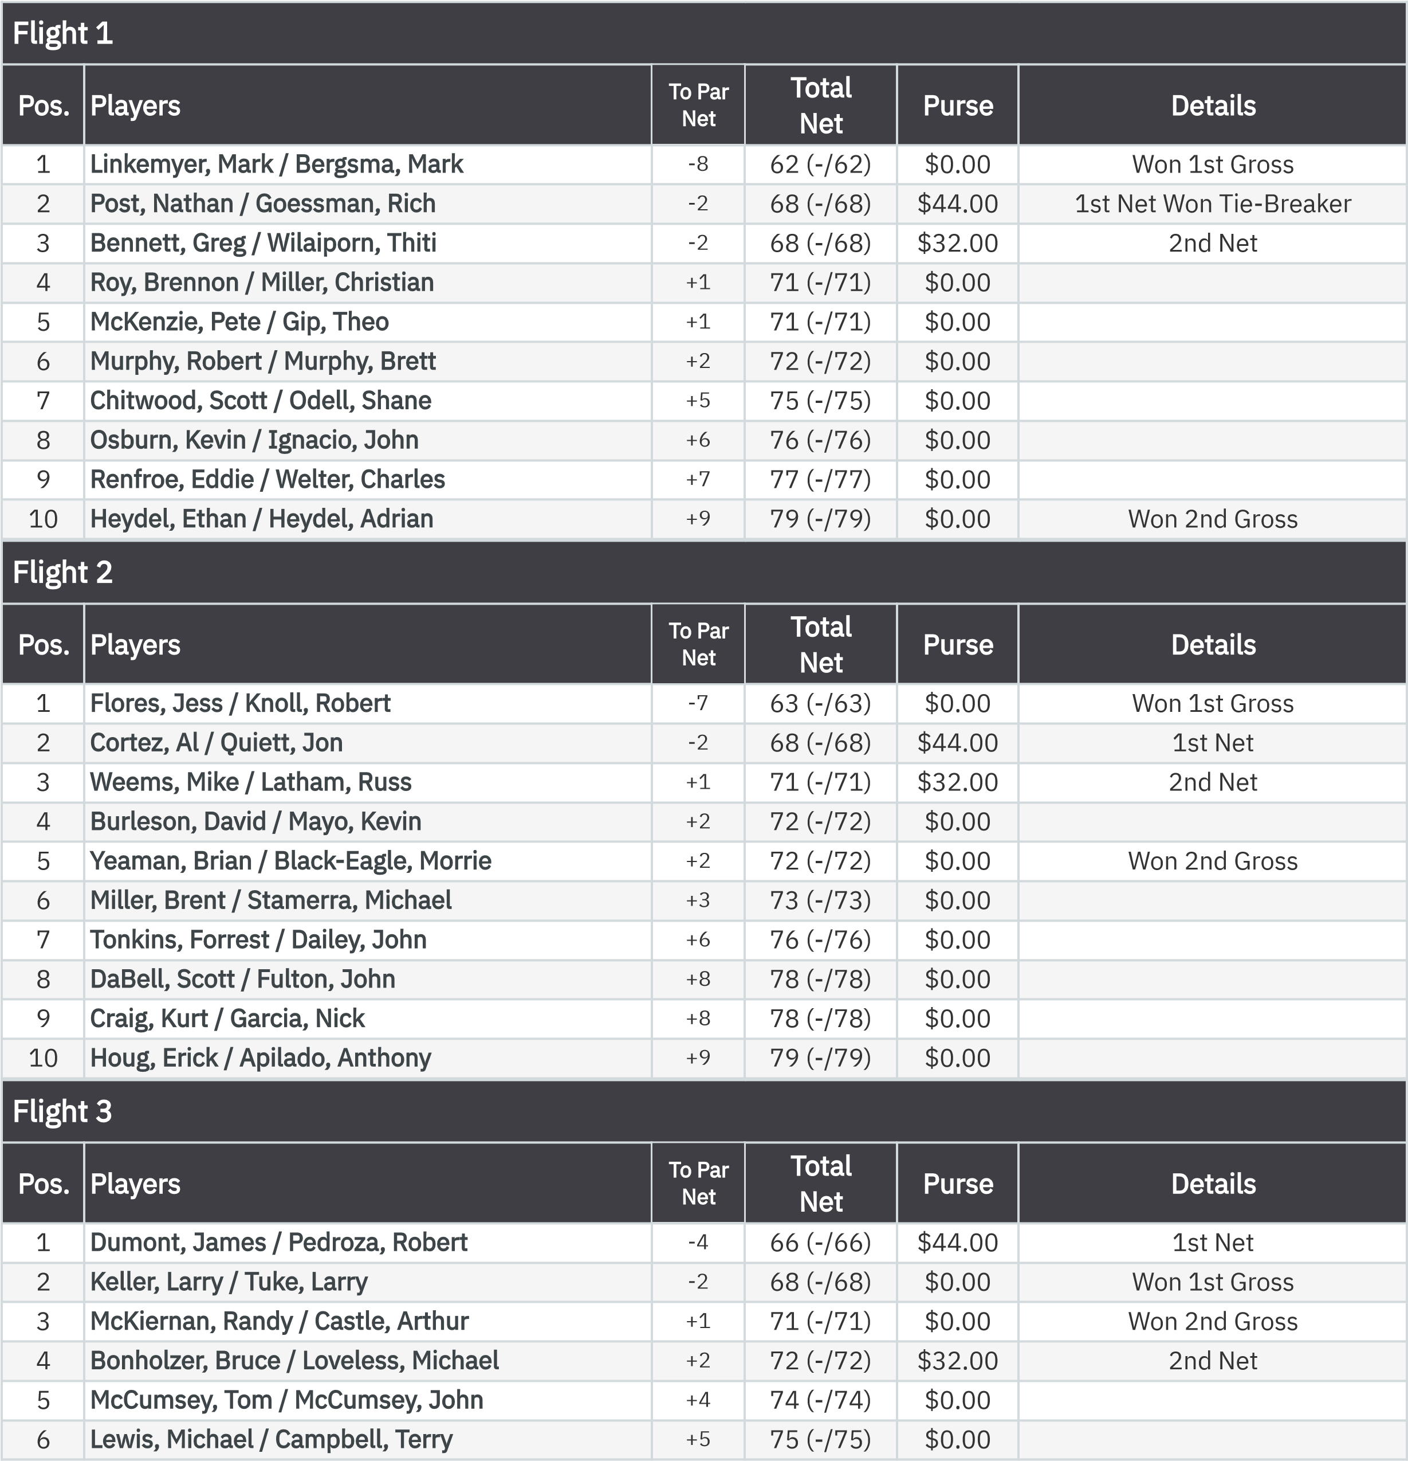
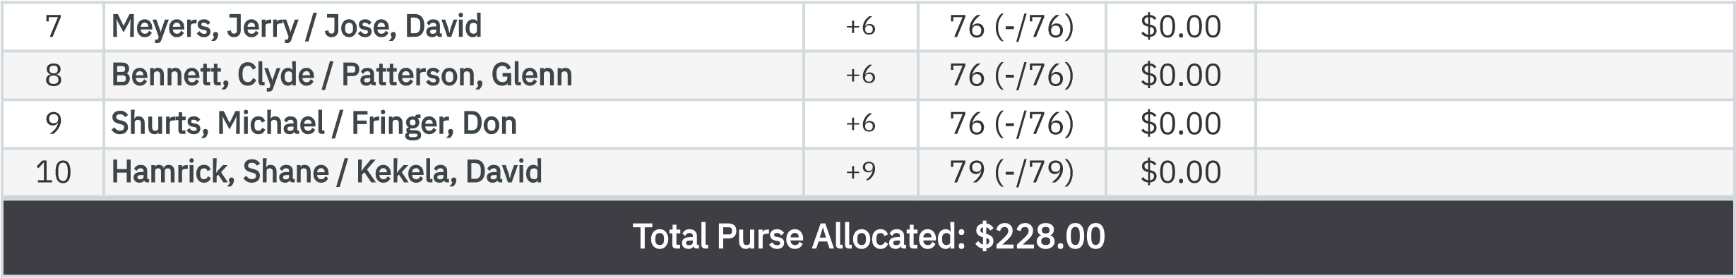

KP - Hole 16
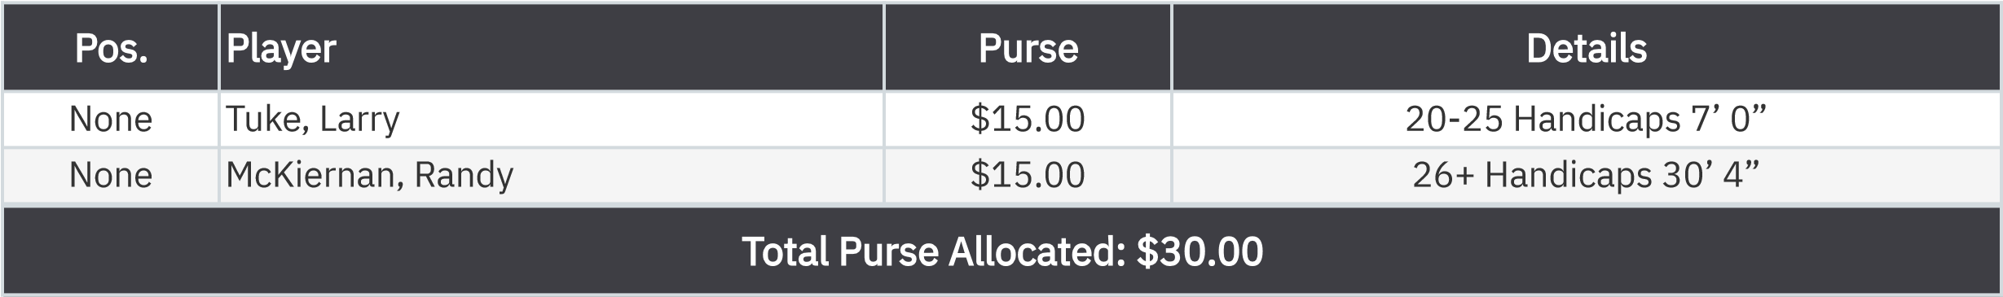

KP - Hole 13
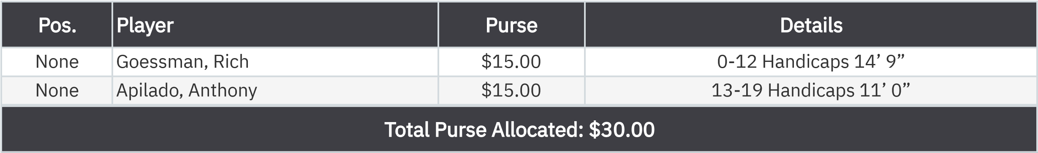

50-50 RHMC Scholarship Fund
.

None
Bergsma, Mark
$30.00

