Stroke Play Front Nine (Gross)
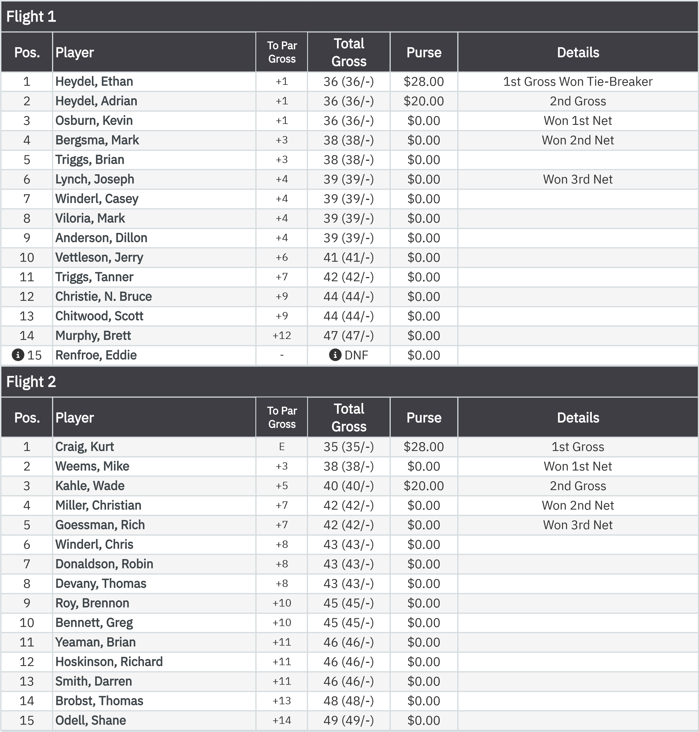

May 20, 2026
Stroke Play (20May2026) Leaderboard
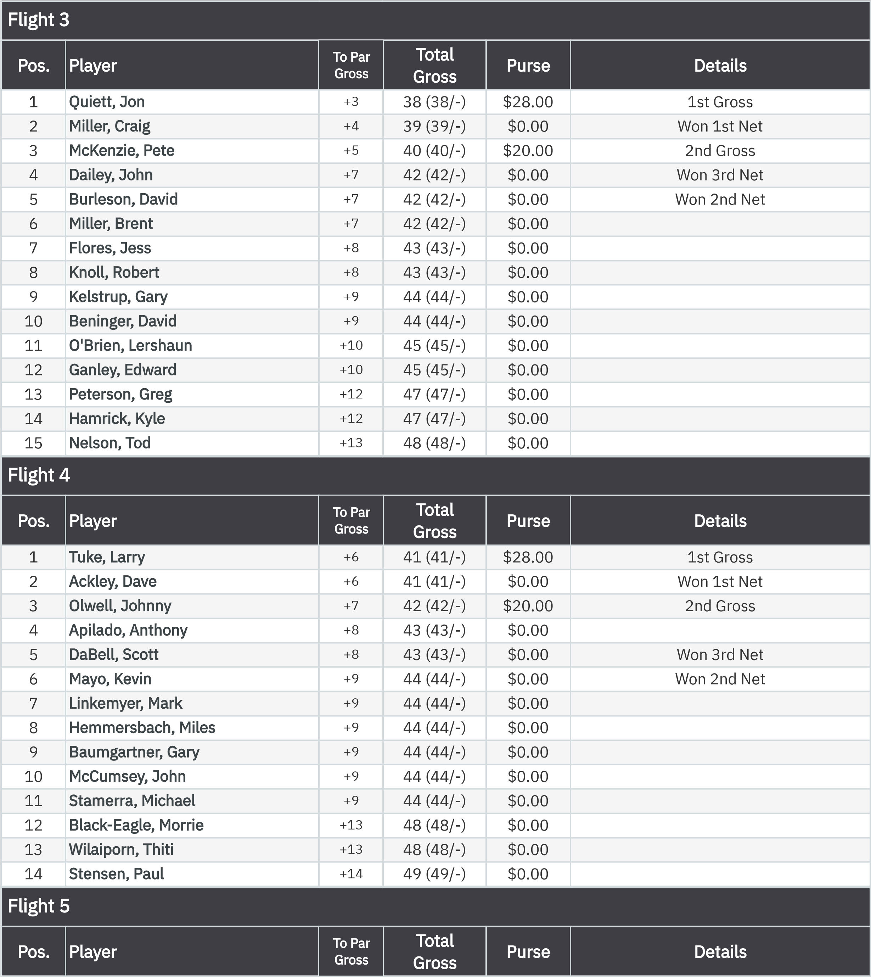
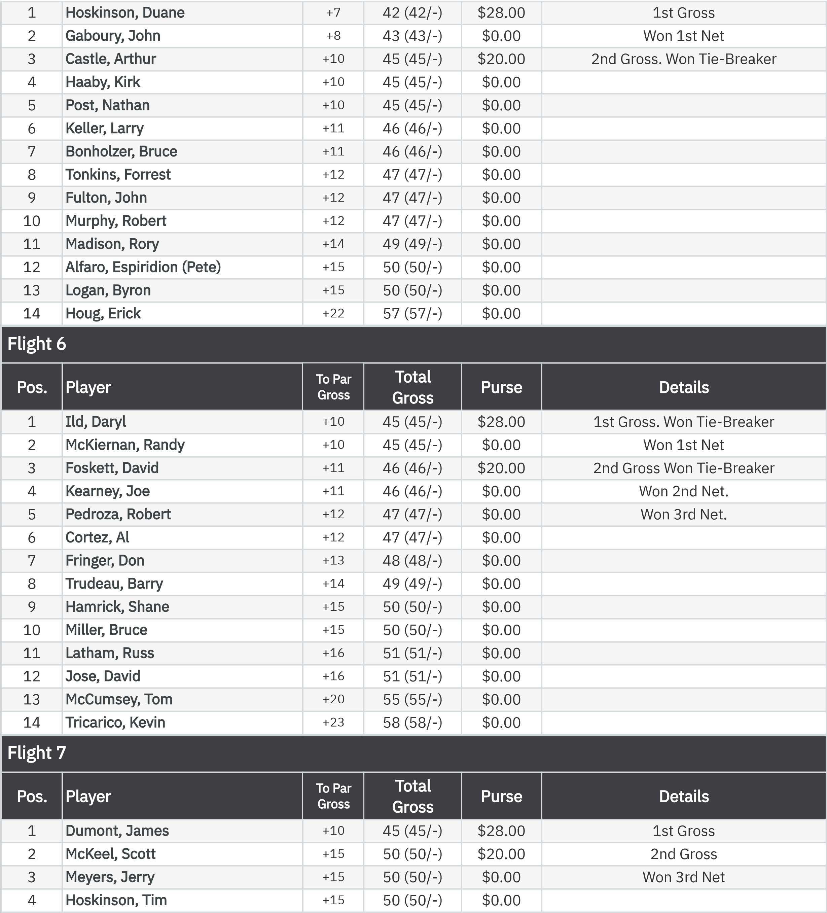

May 20, 2026
Stroke Play (20May2026) Leaderboard
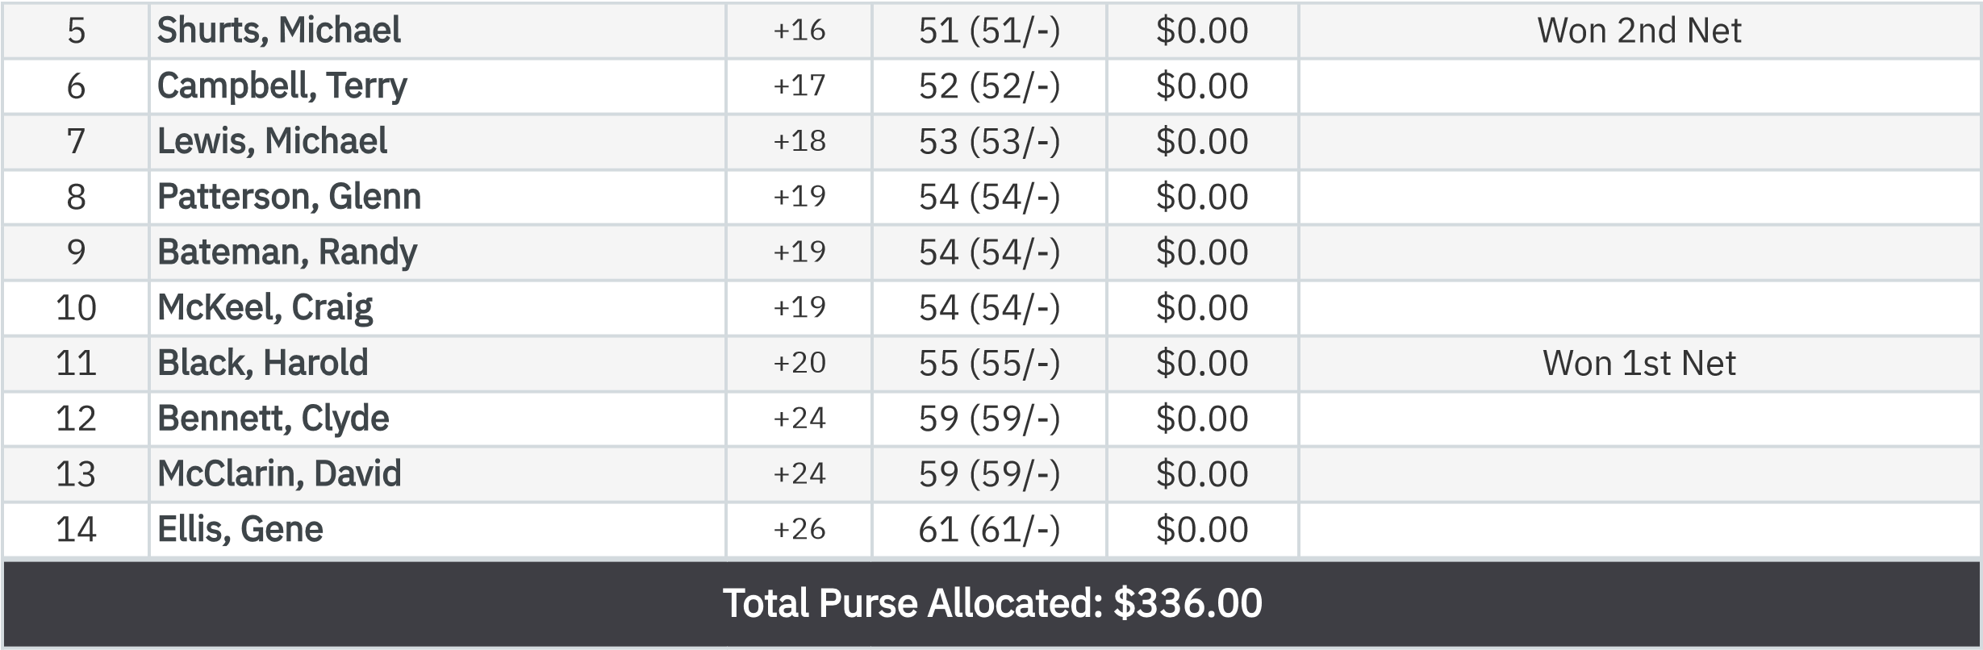

Stroke Play Front Nine (Net)
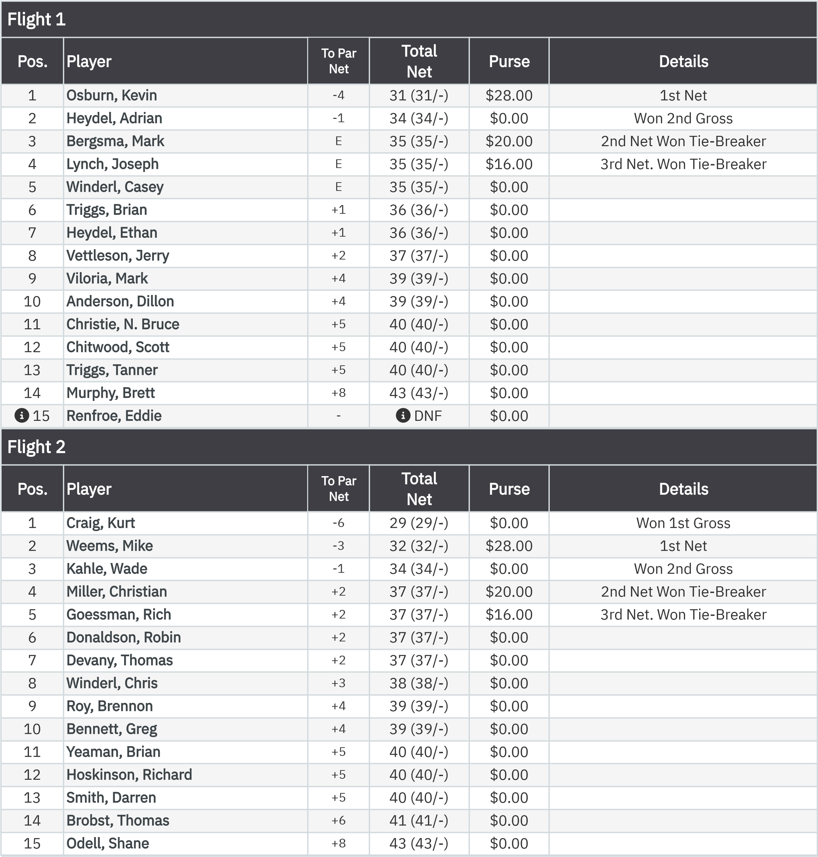

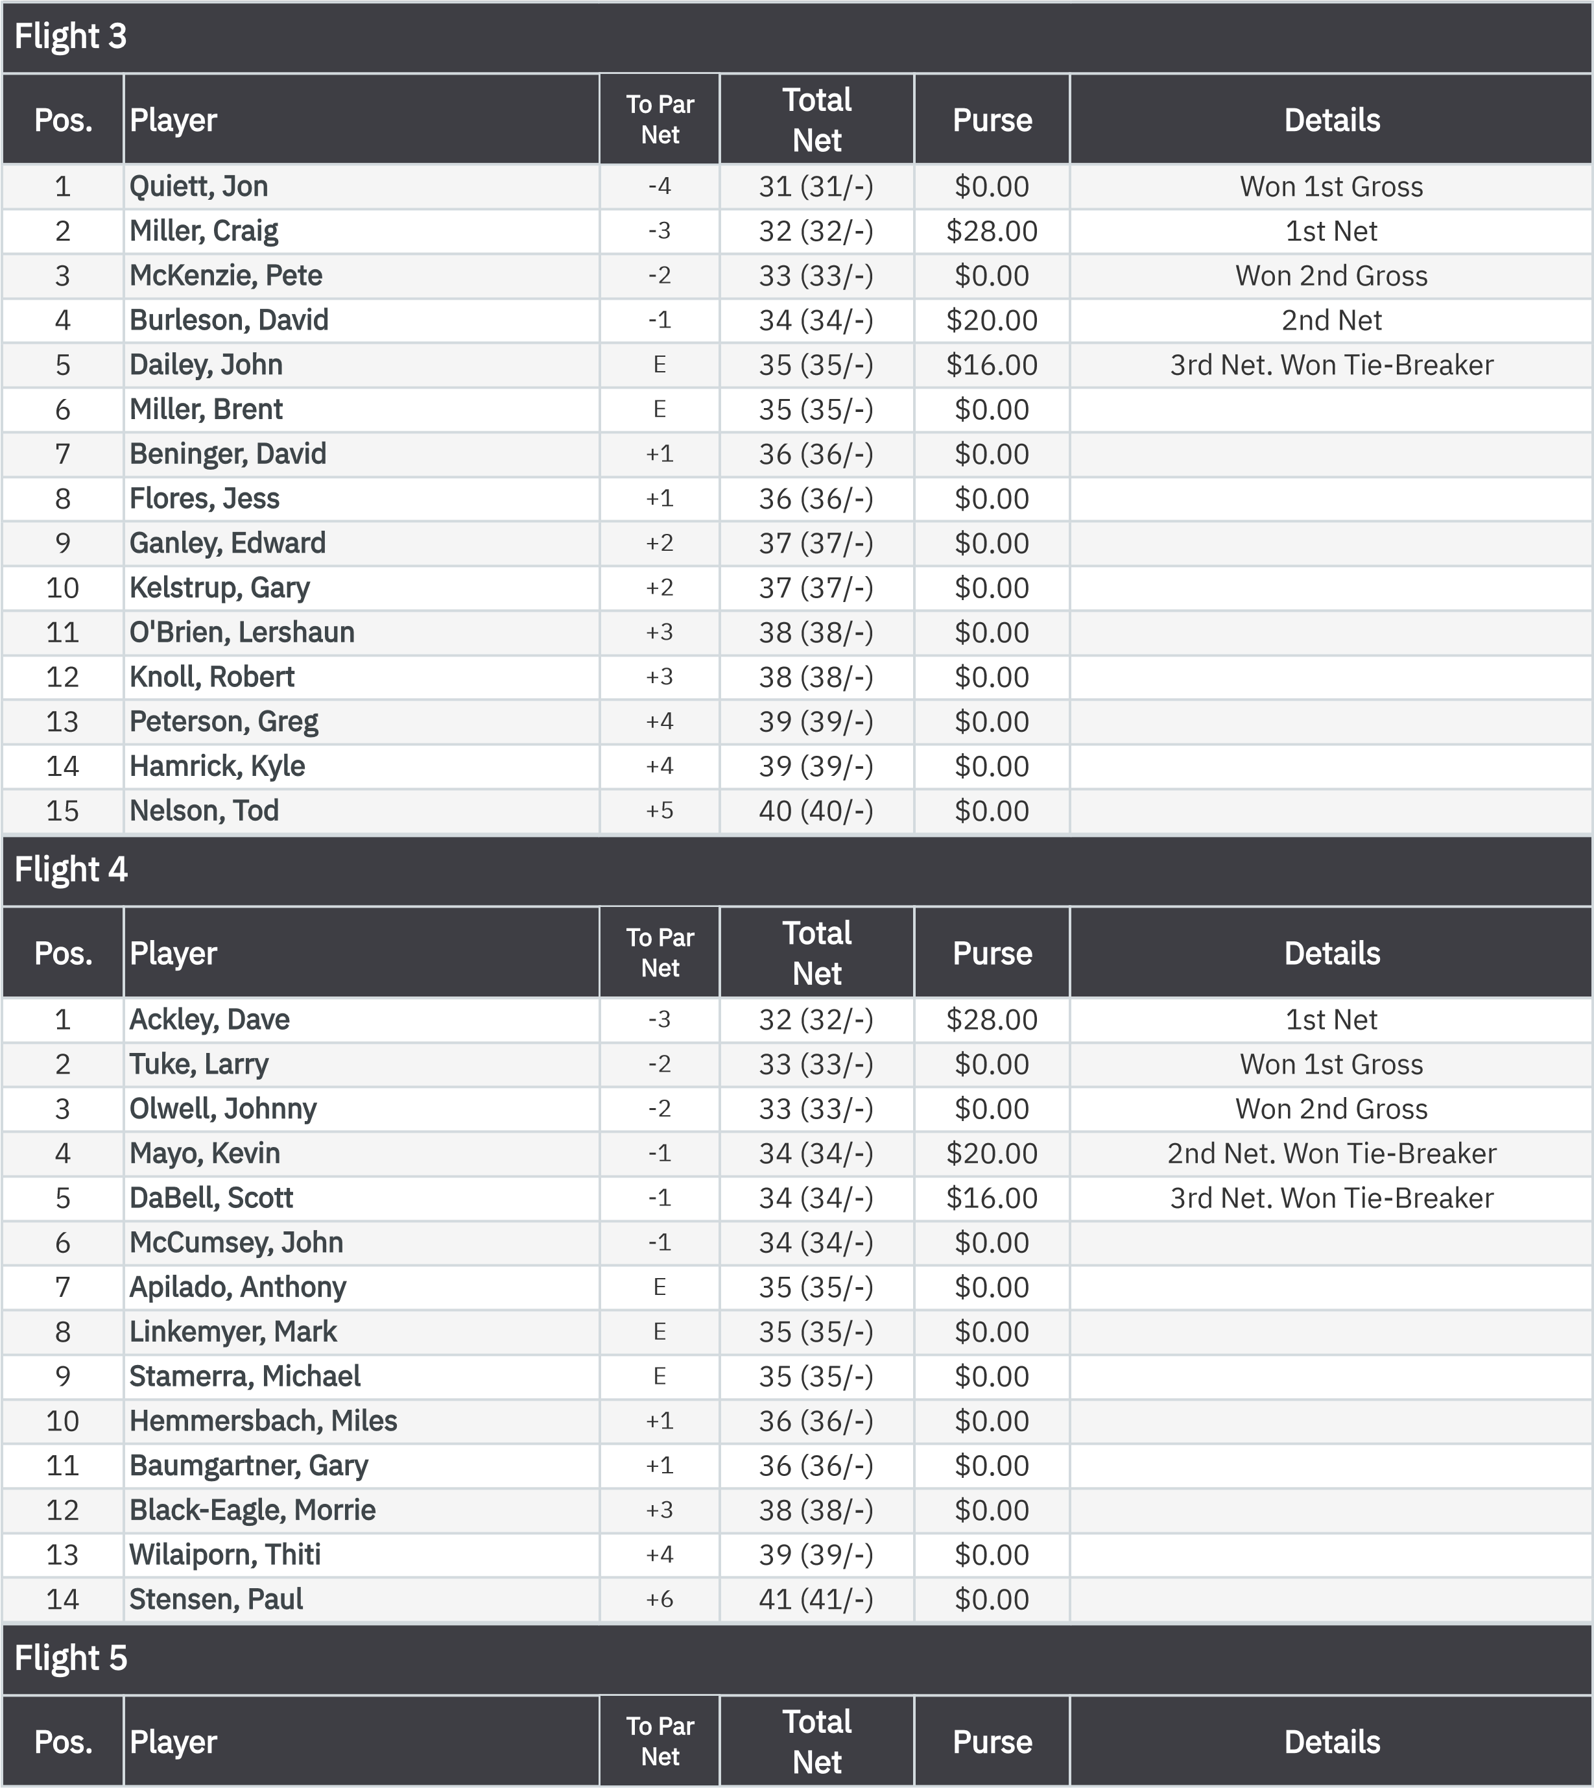
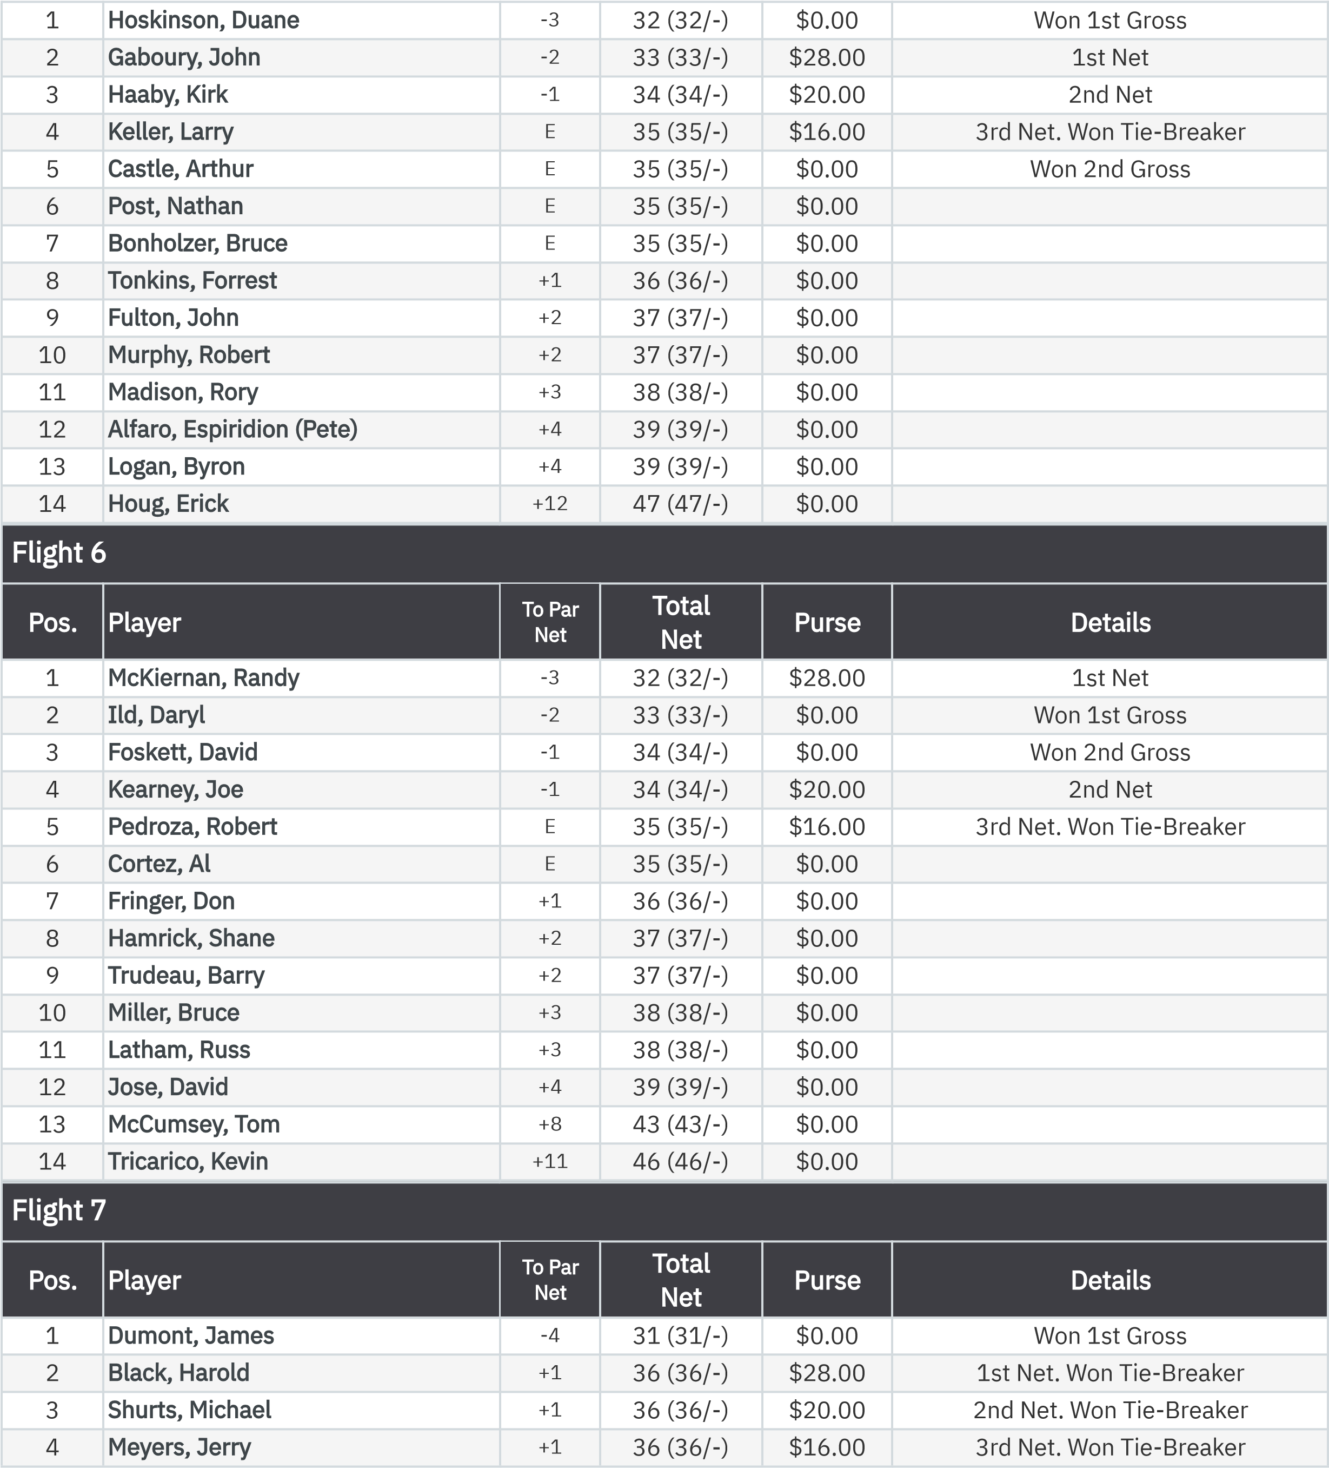

May 20, 2026
Stroke Play (20May2026) Leaderboard
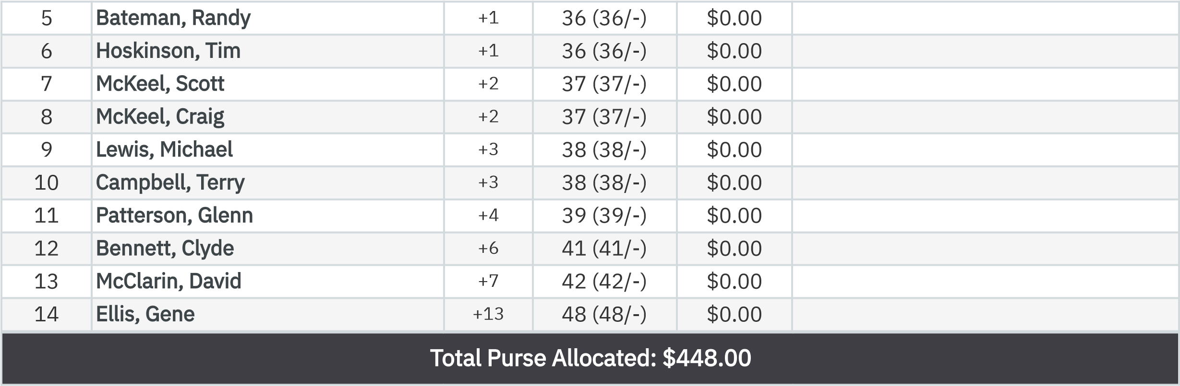

KP - Hole 4

.

1
Post, Nathan
$50.50

:
.
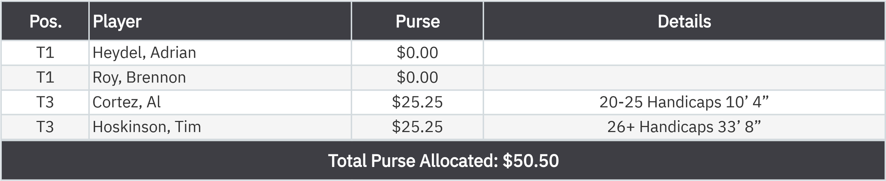

KP - Hole 9

.

er

T1
Heydel, Adrian
$25.25
Handicaps 10’ 11”
0-12
T1
Roy, Brennon
$25.25
Handicaps 6’ 4”
13-19

:

50-50 RHMC Scholarship Fund

