2-Man Scramble Back Nine (Gross)
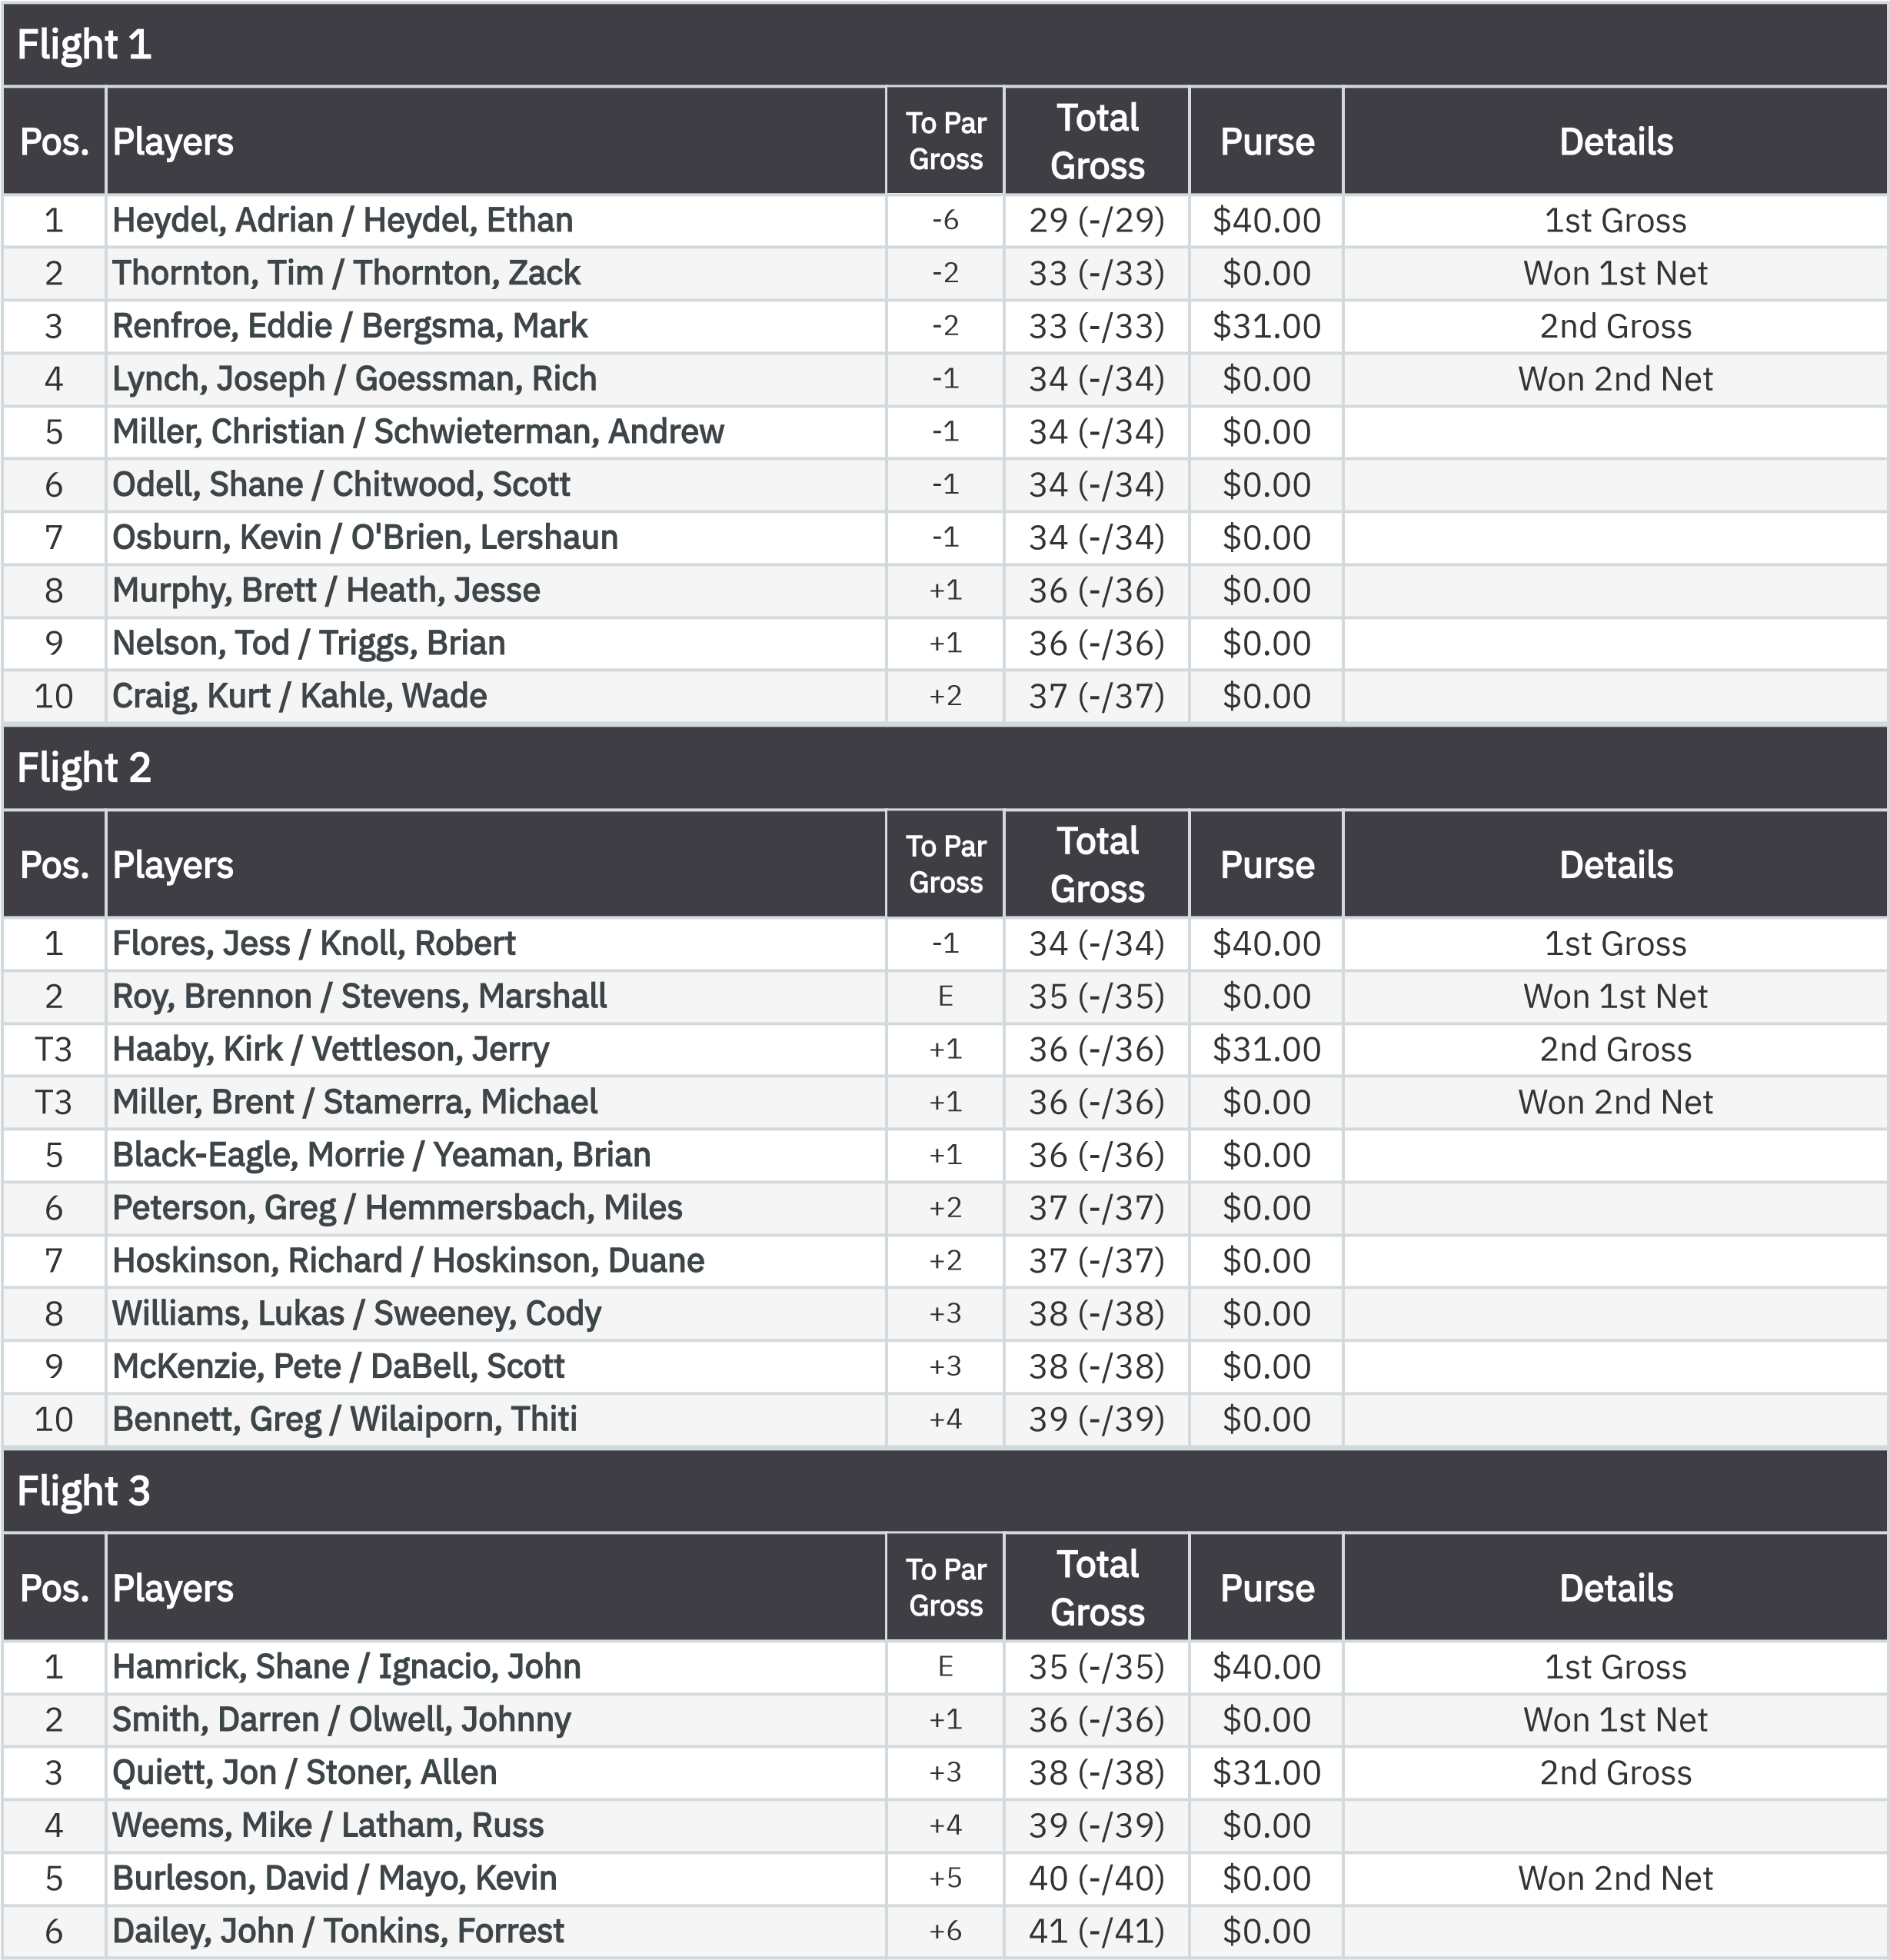
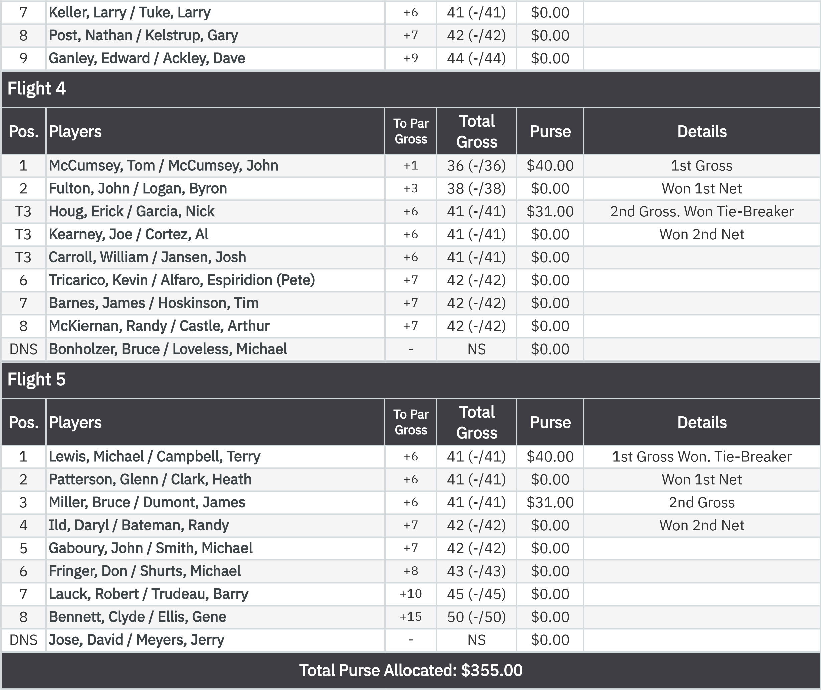
2-Man Scramble Back Nine (Net)
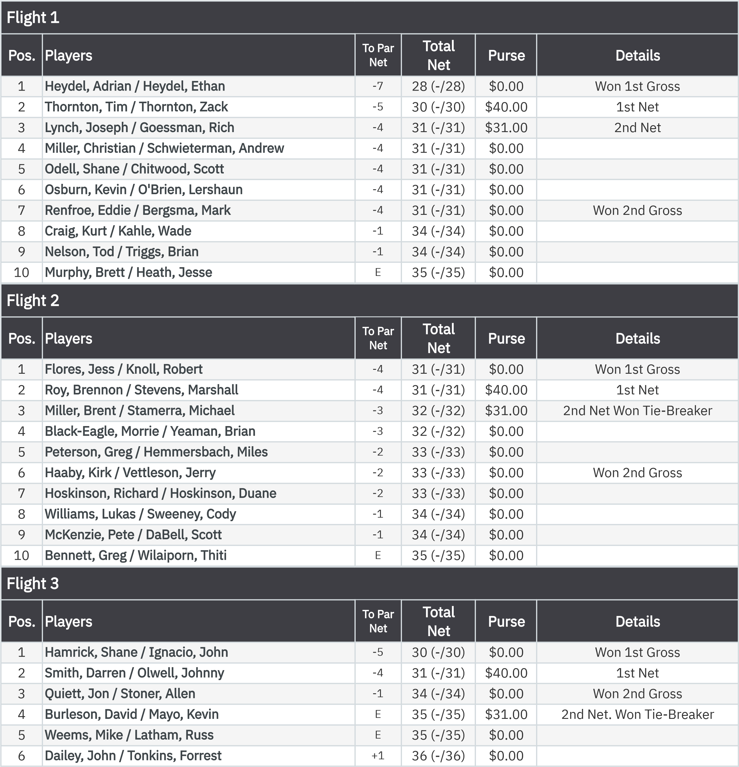
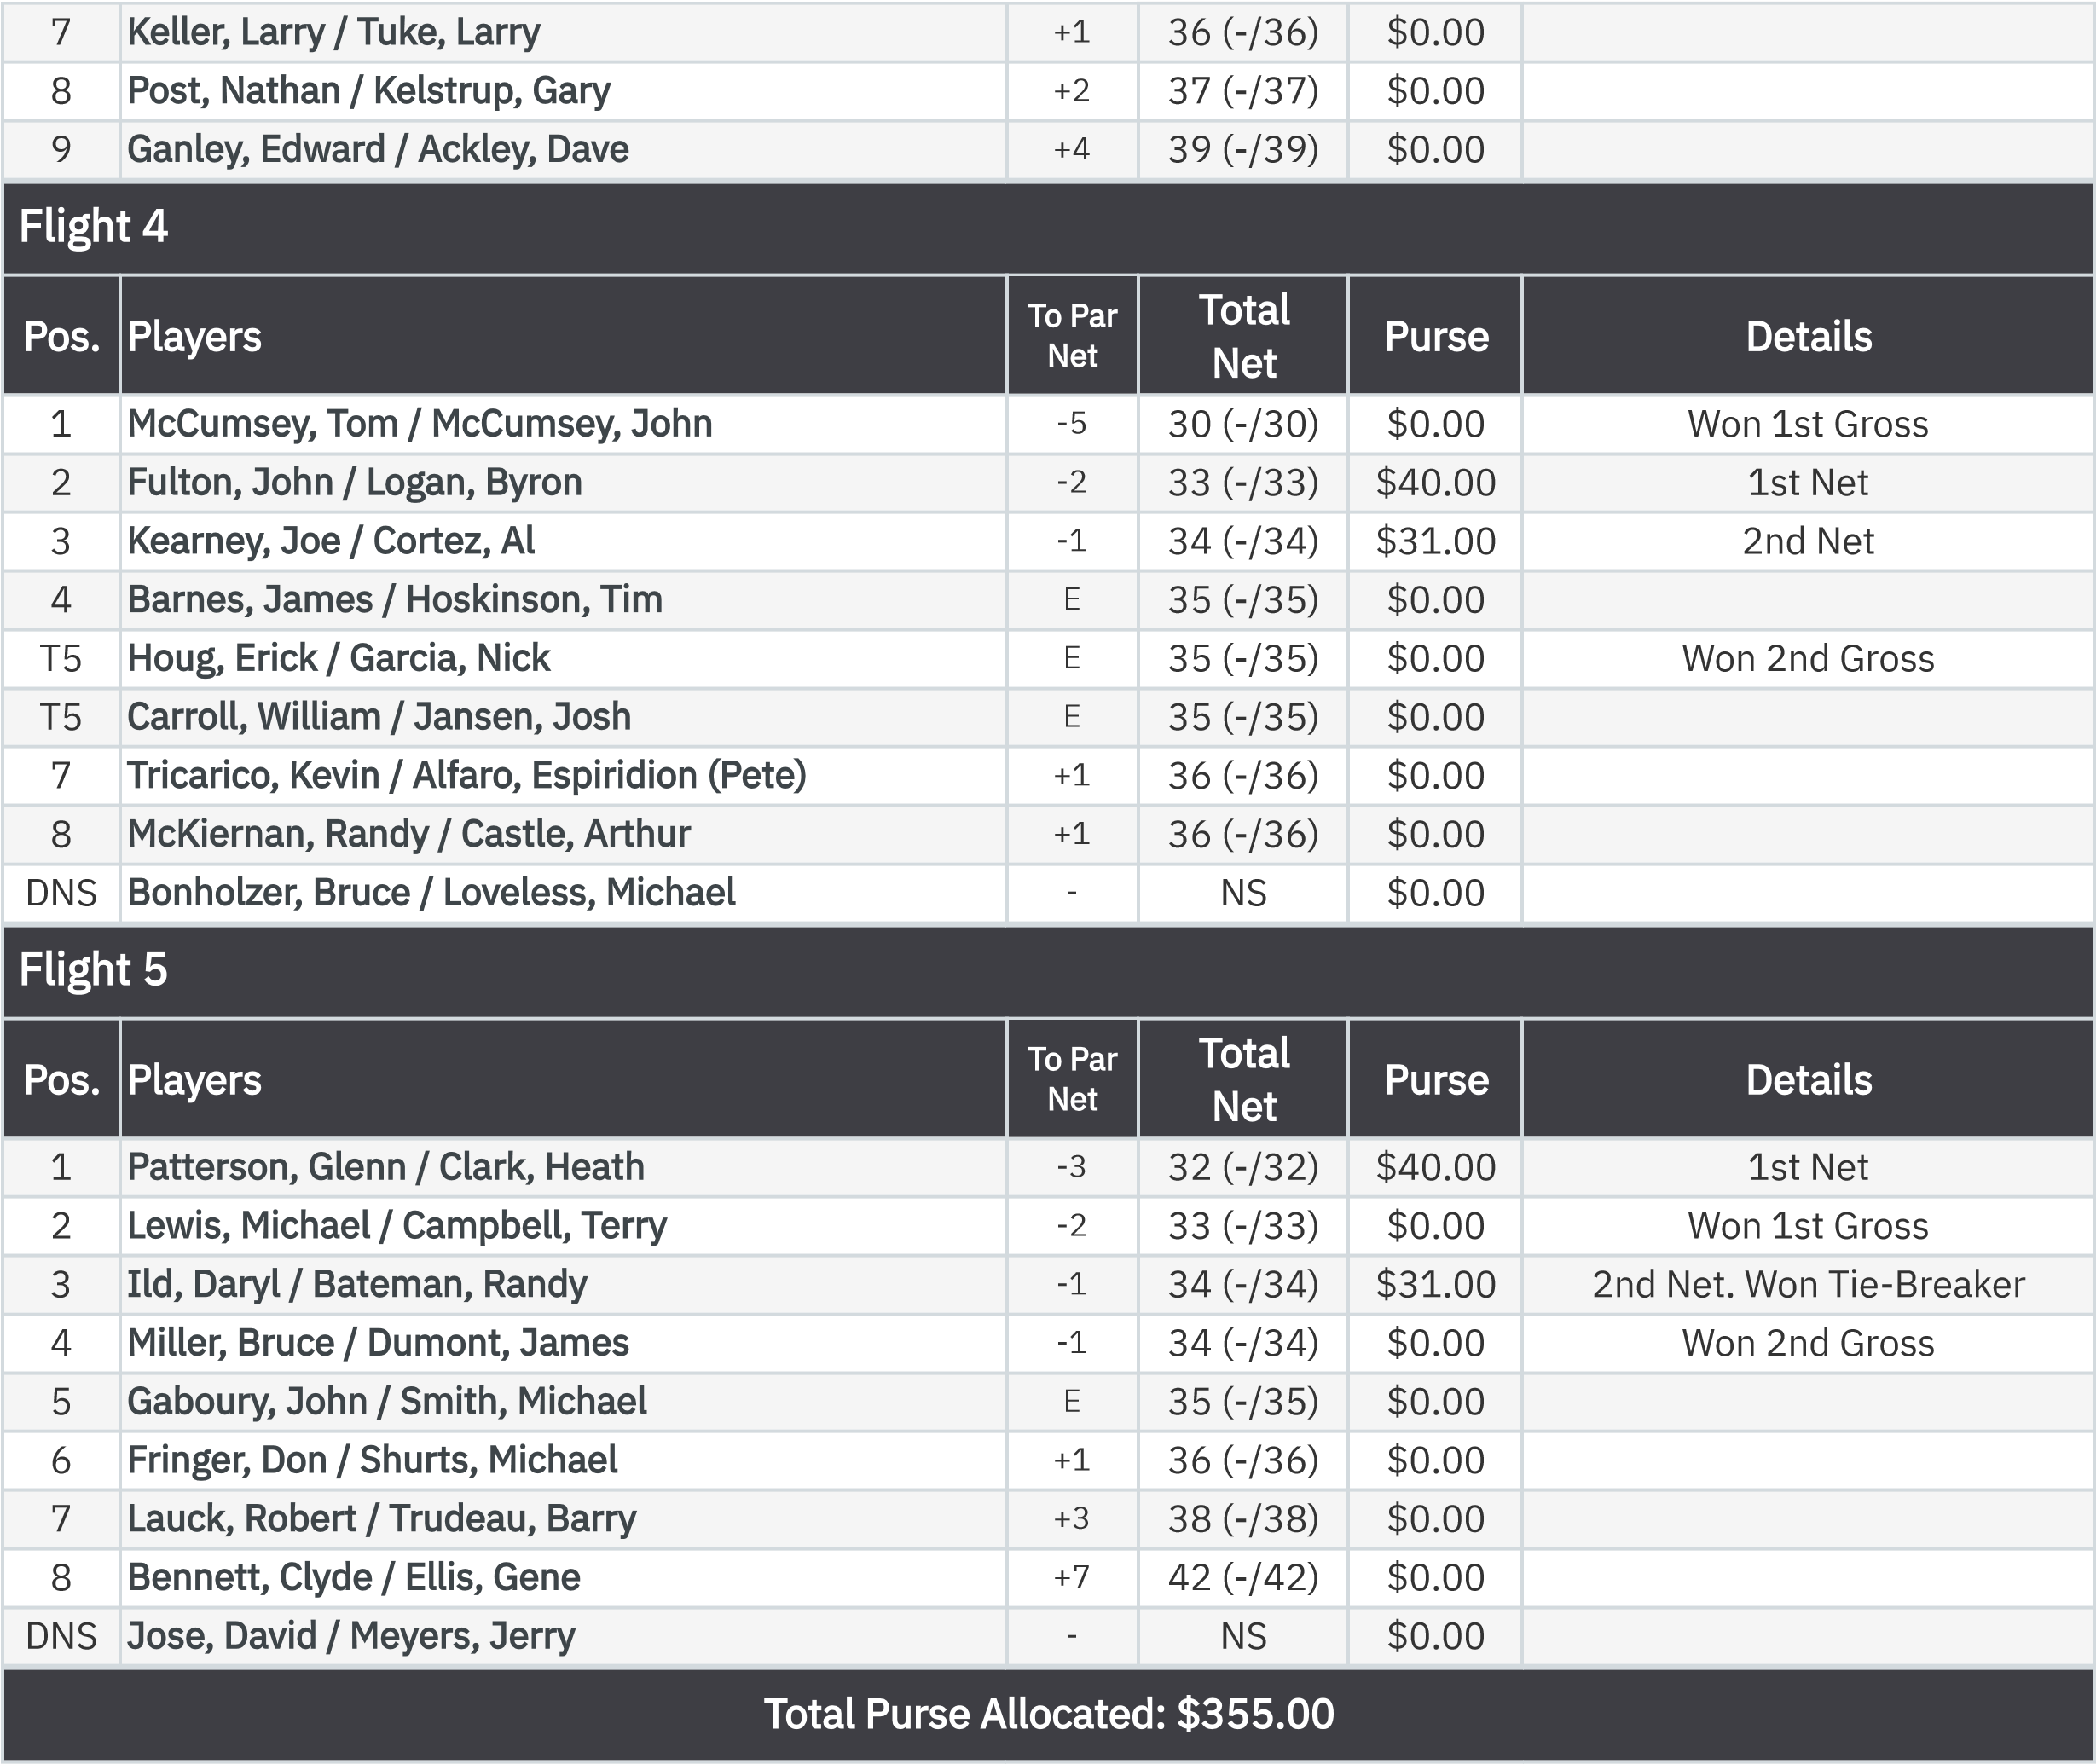
KP - Hole 13
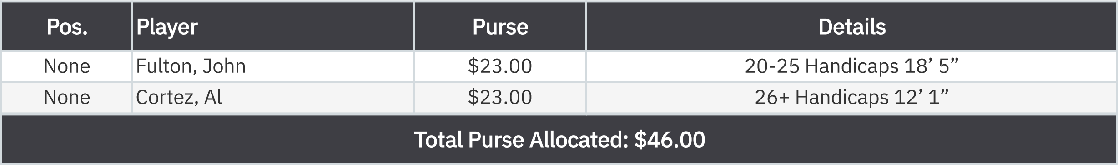
KP - Hole 16
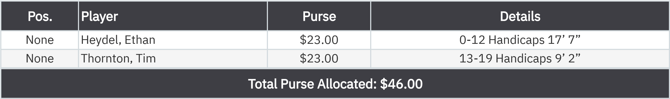
50-50 RHMC Scholarship Fund

.

None
Miller, Brent
$46.00

:

