2-Man Combined Score Front Nine (Gross)
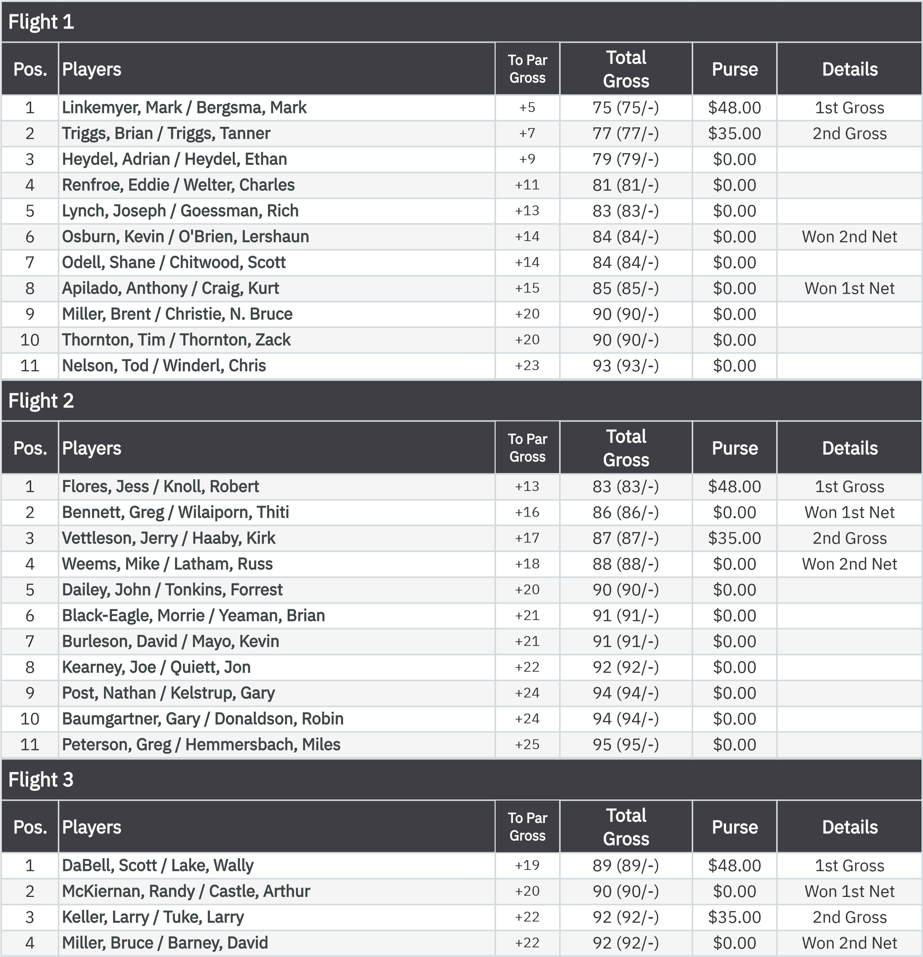
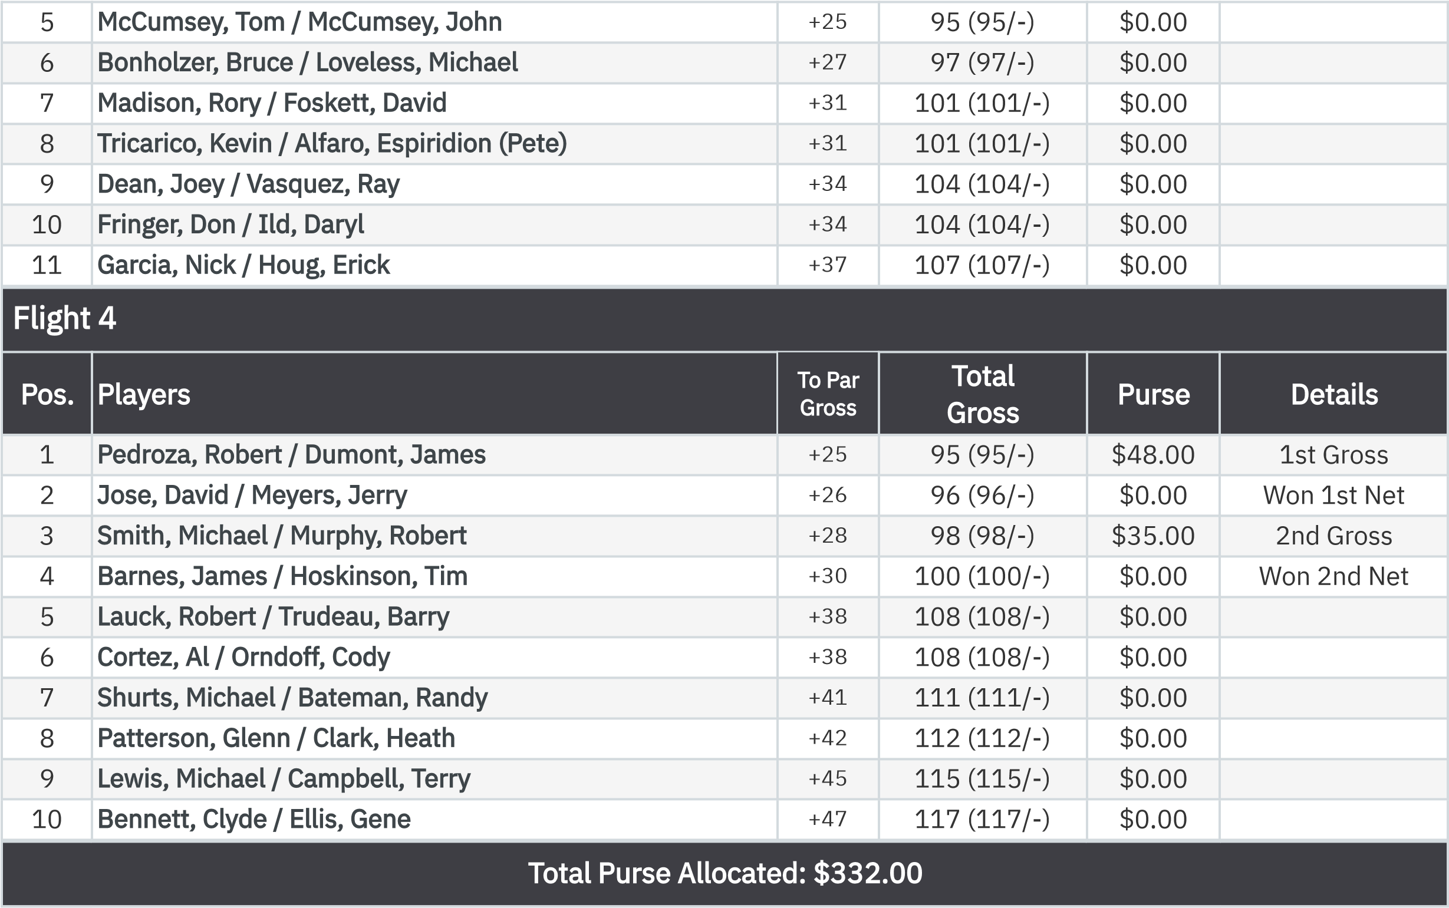
2-Man Combined Score Front Nine (Net)
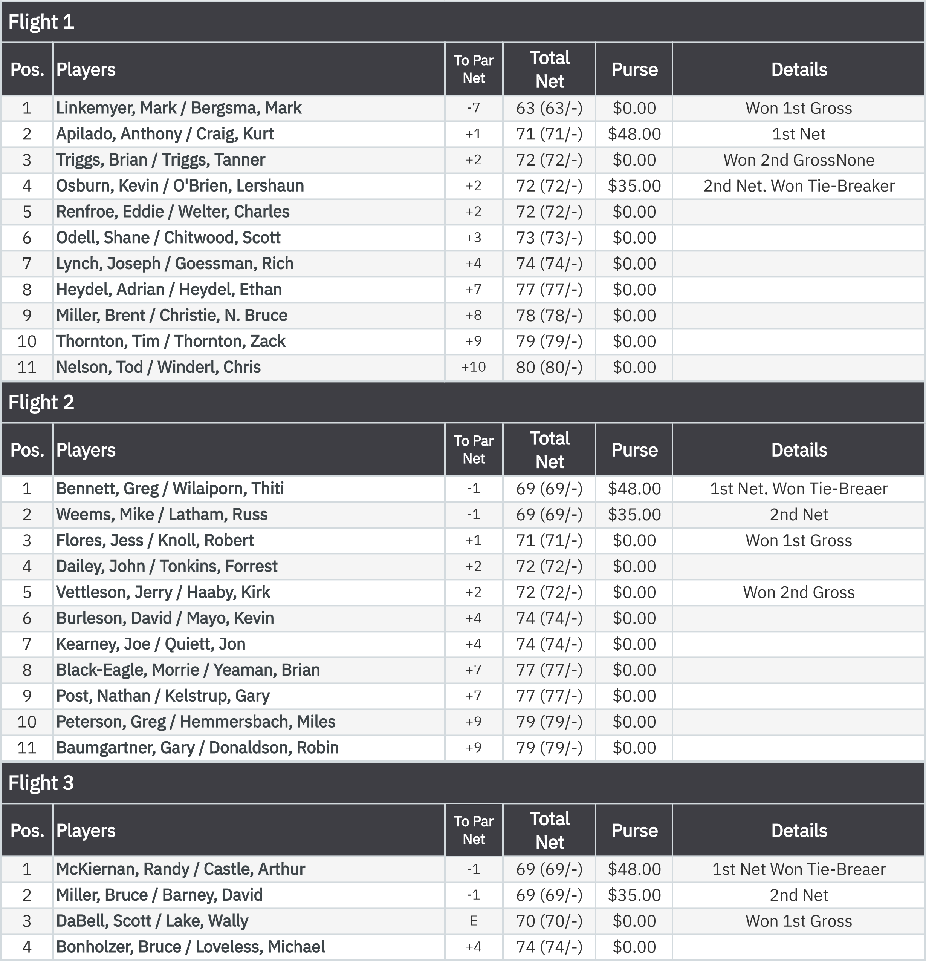
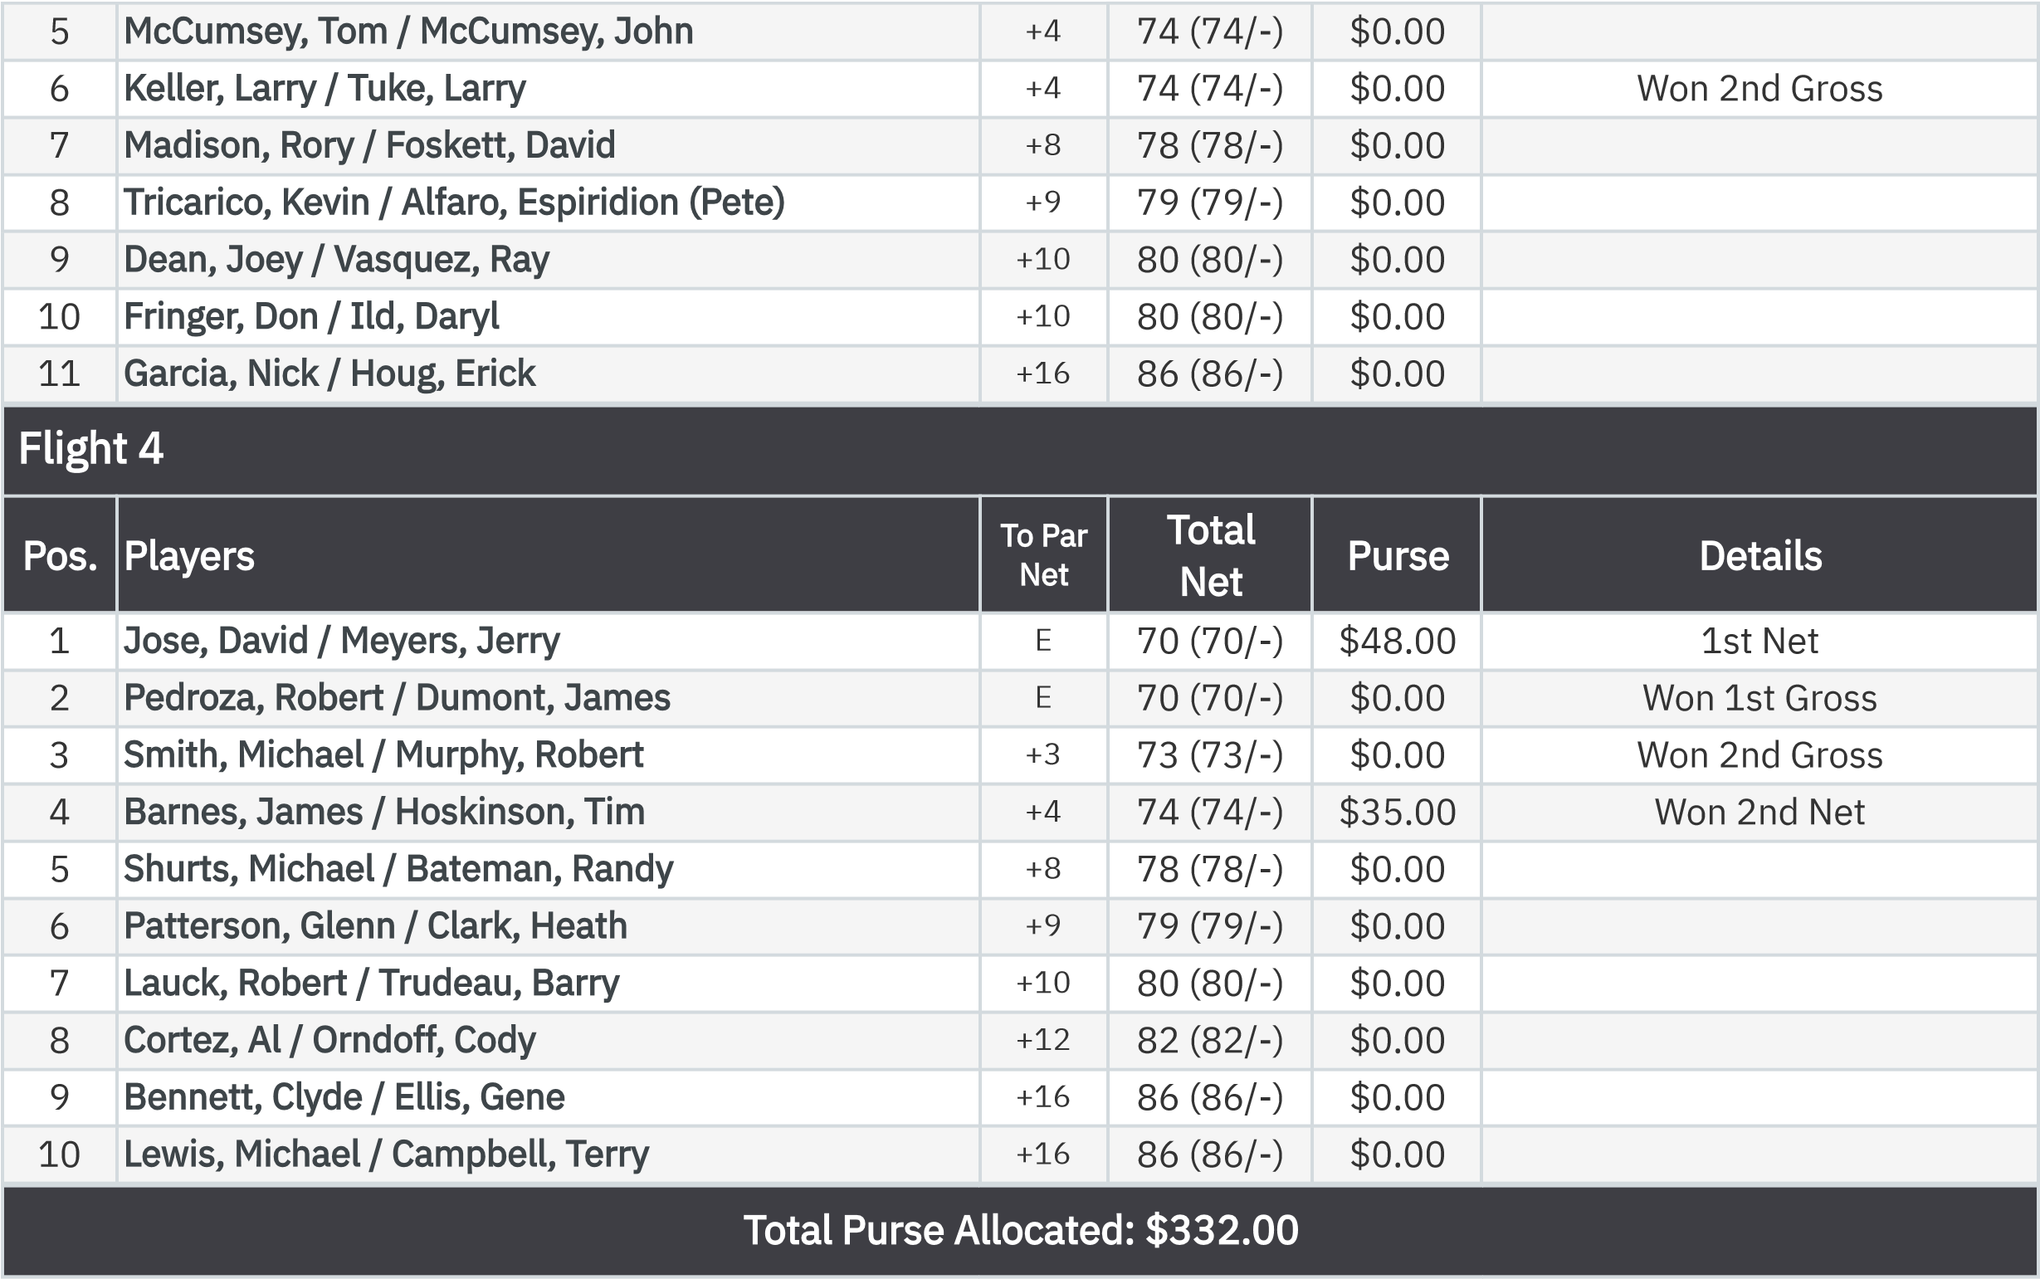
KP - Hole 4
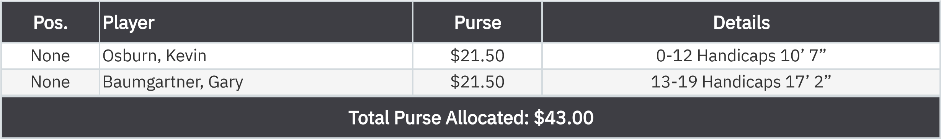
KP - Hole 9
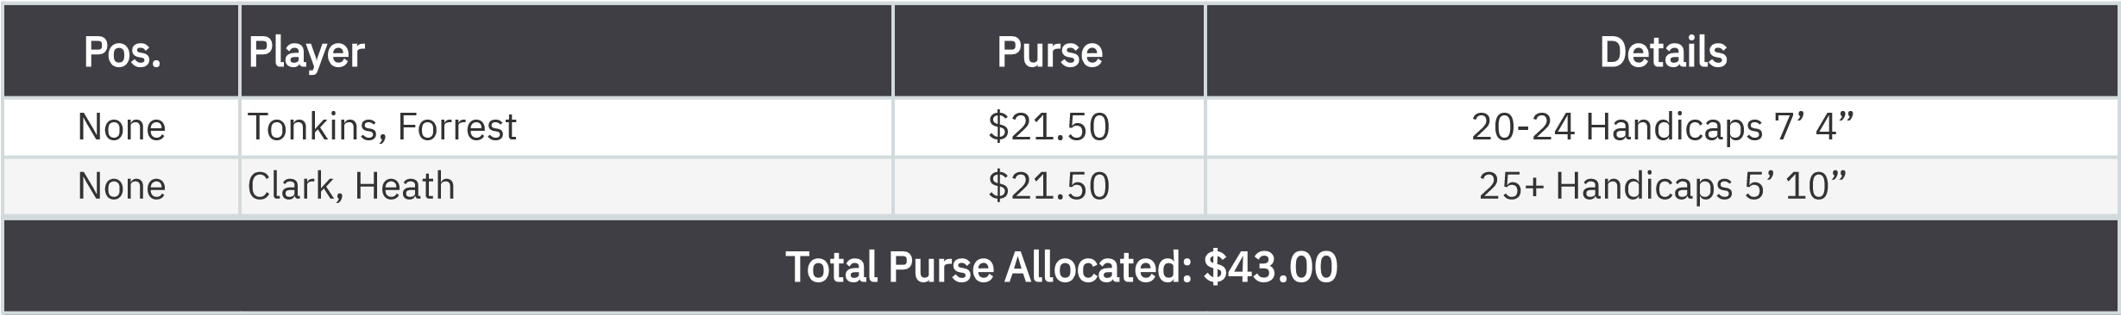
50-50 RHMC Scholarship Fund

None
Tricarico, Kevin
$43.00

:

