2-Man Scramble Back Nine (Gross)
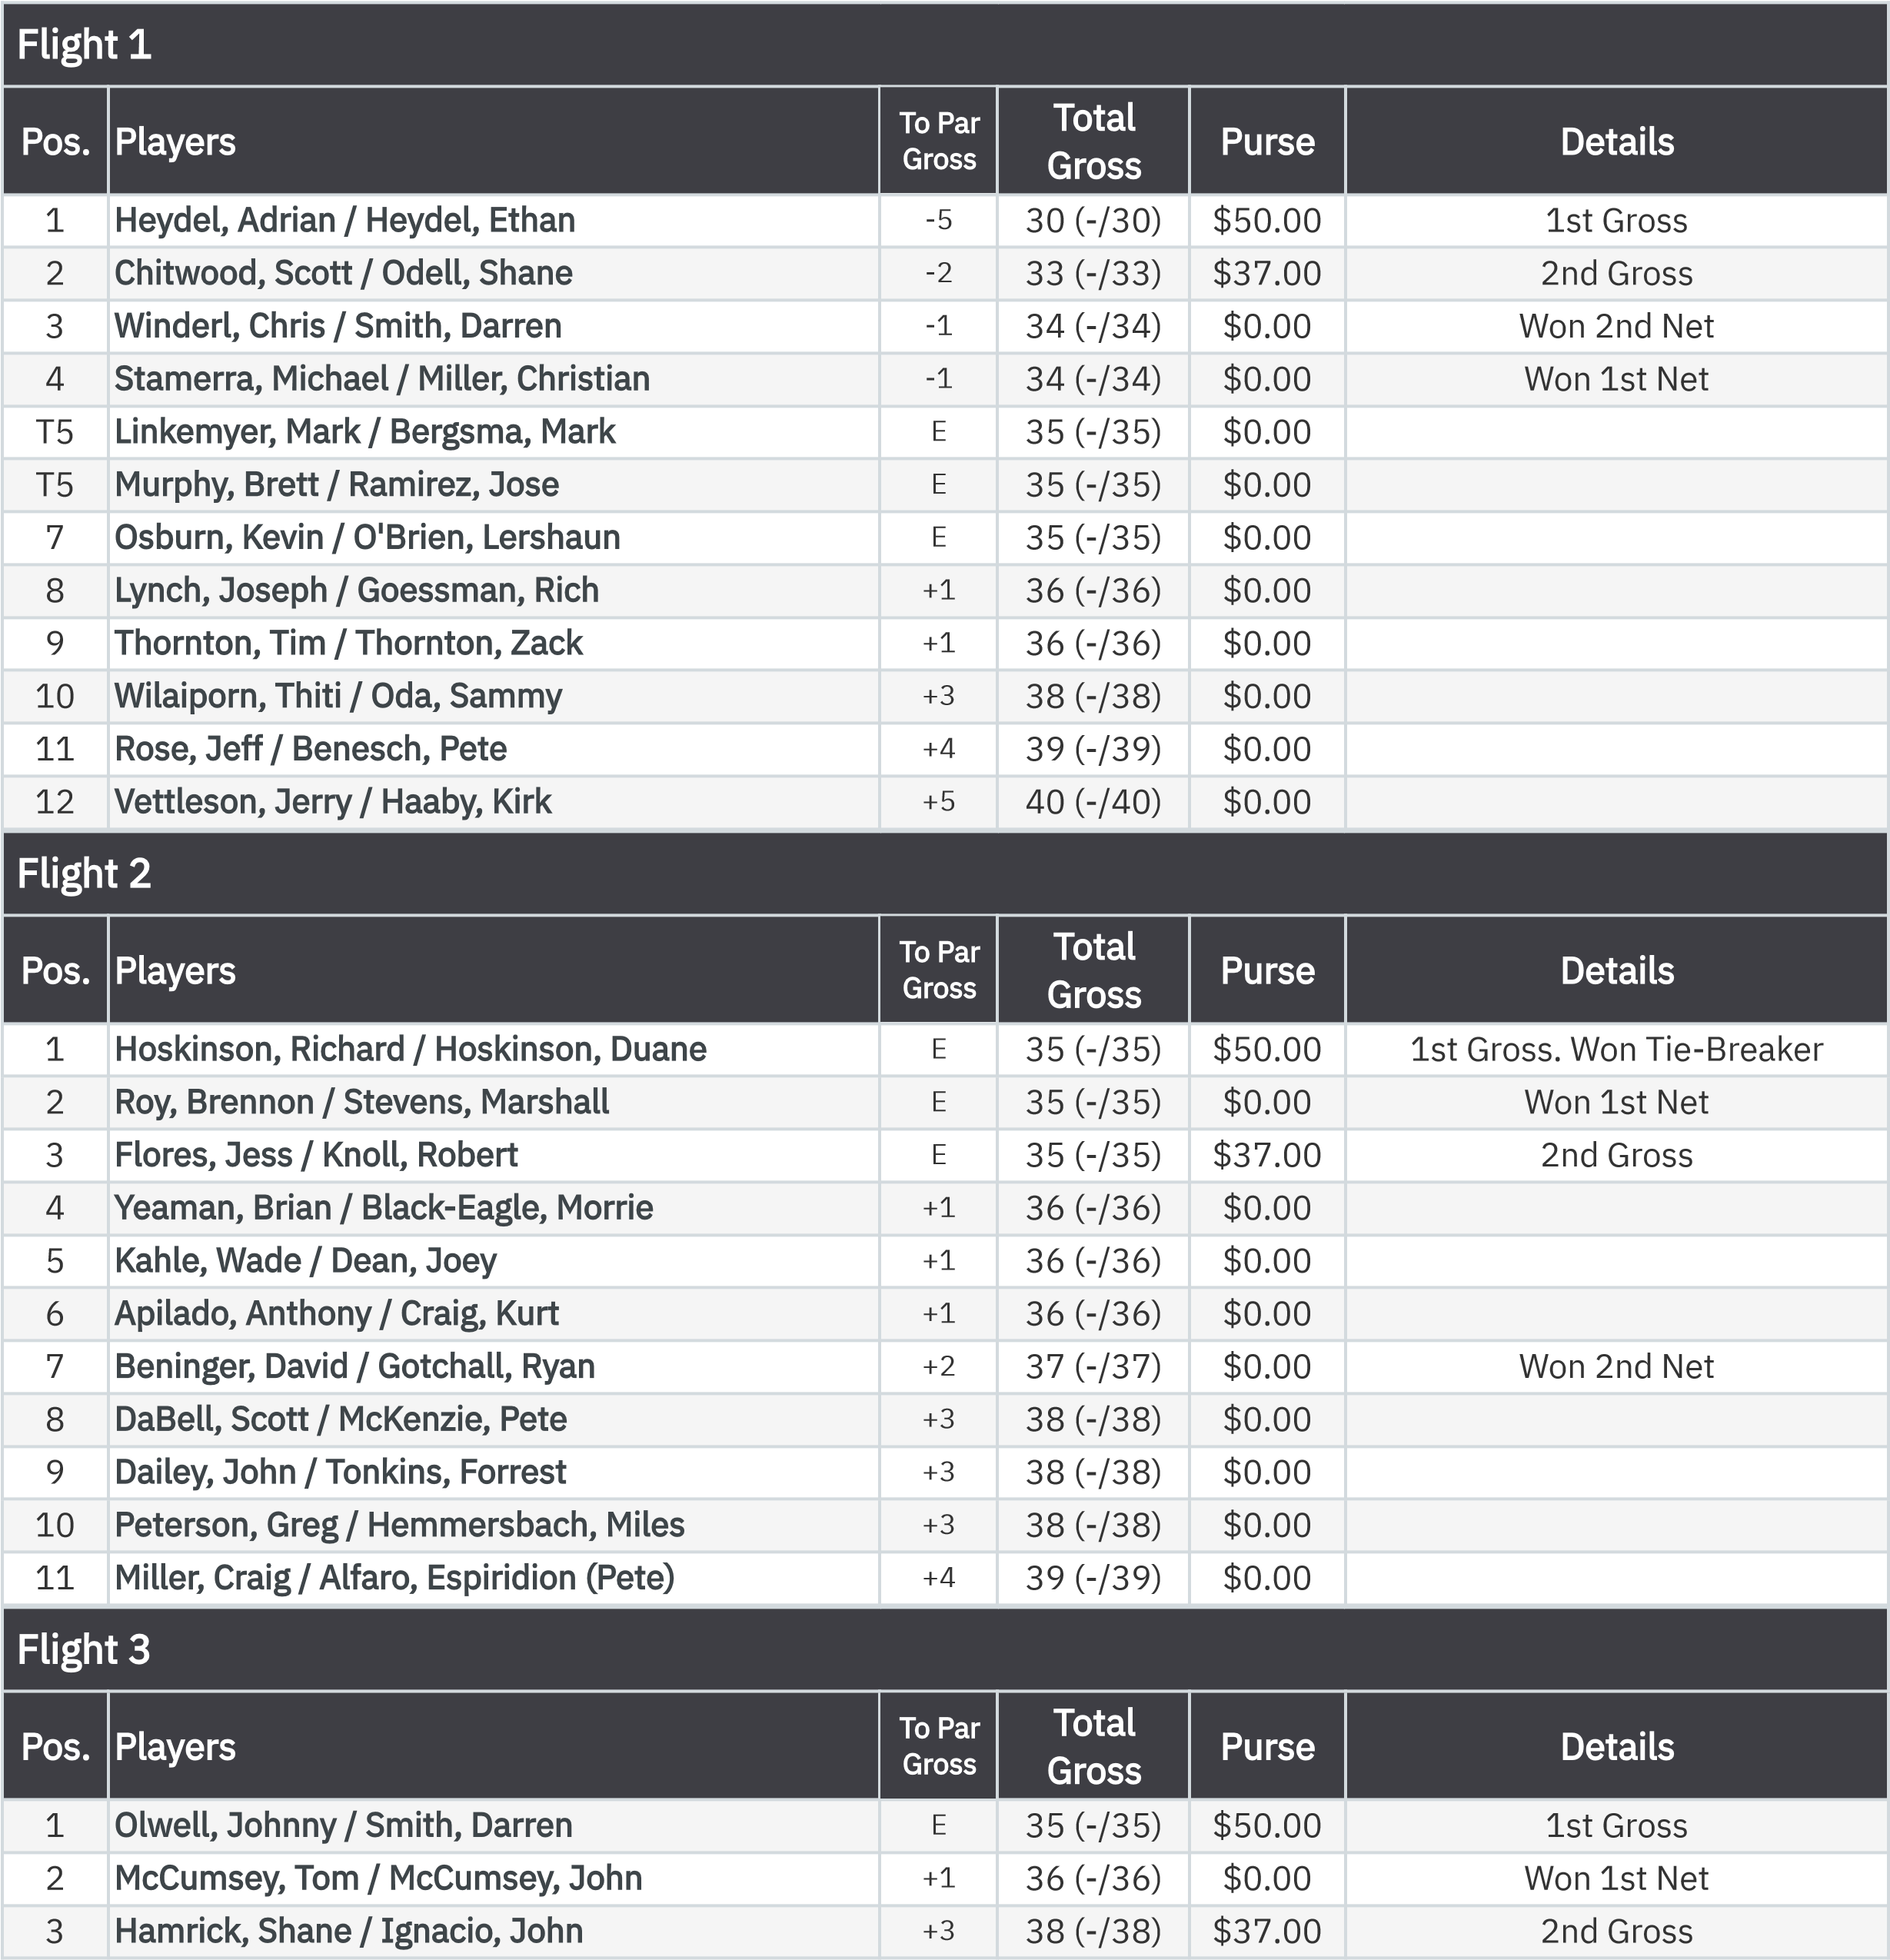
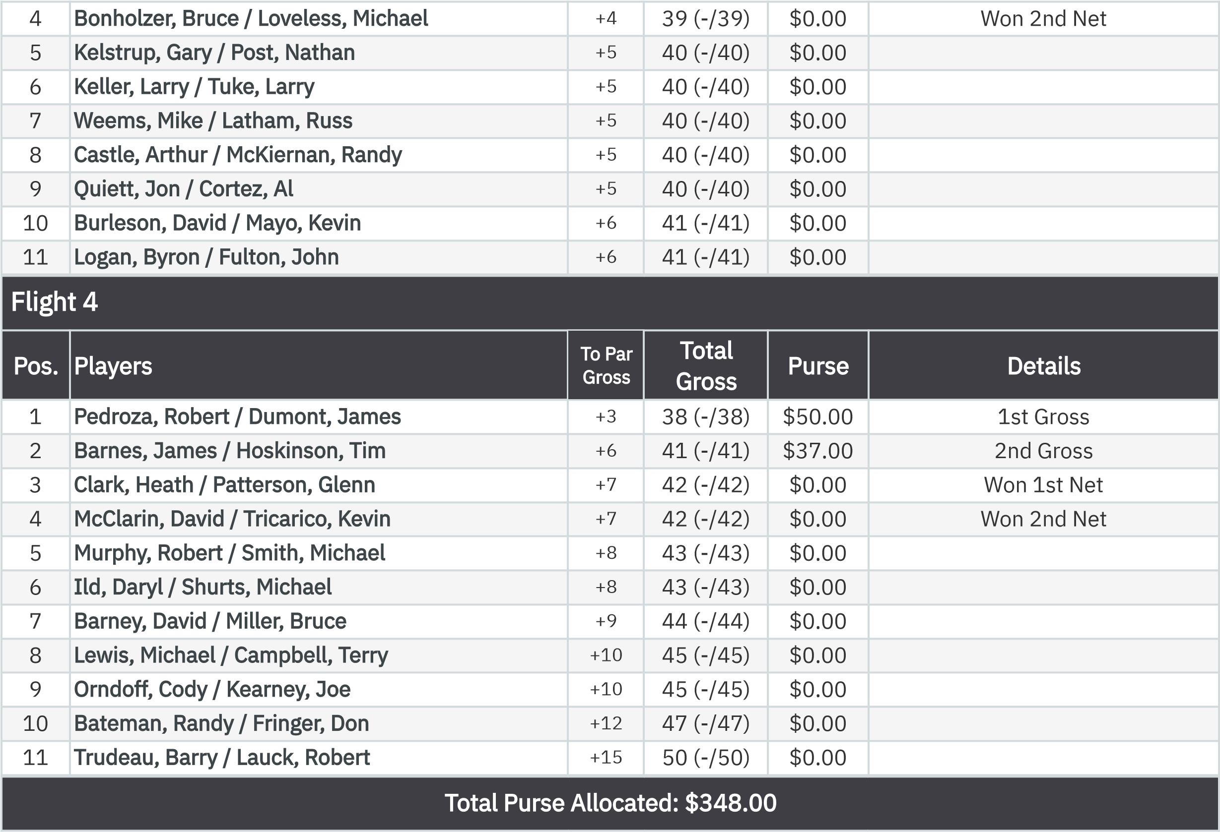
2-Man Scramble Back Nine (Net)
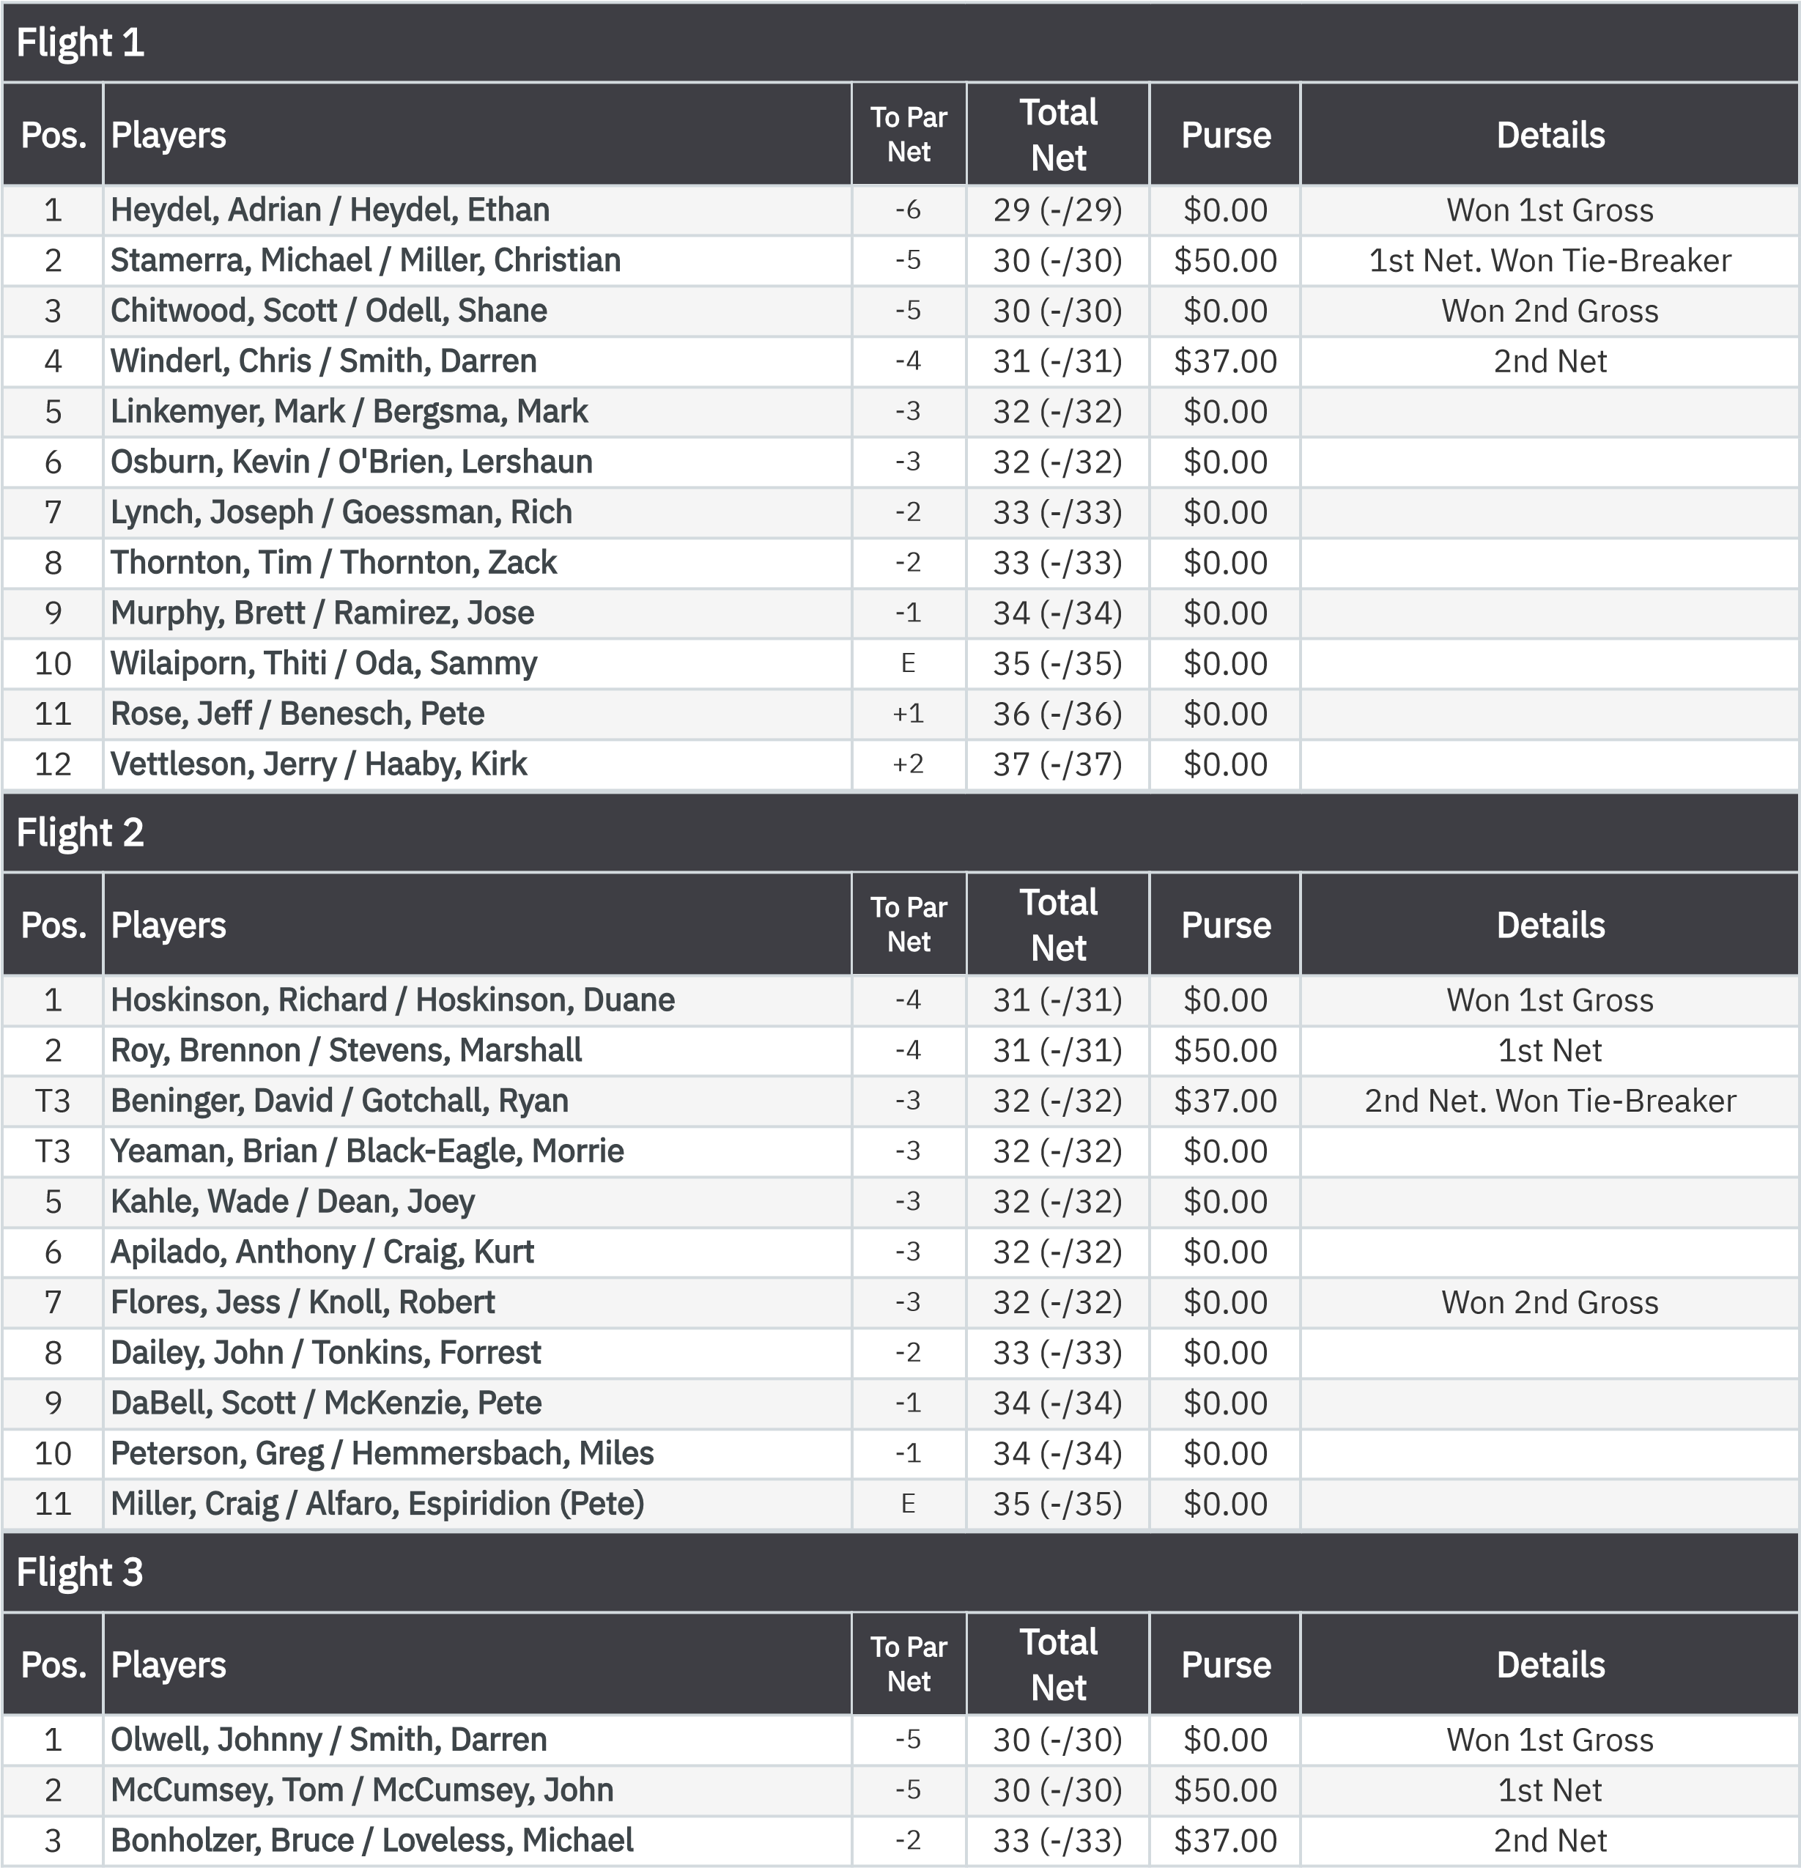
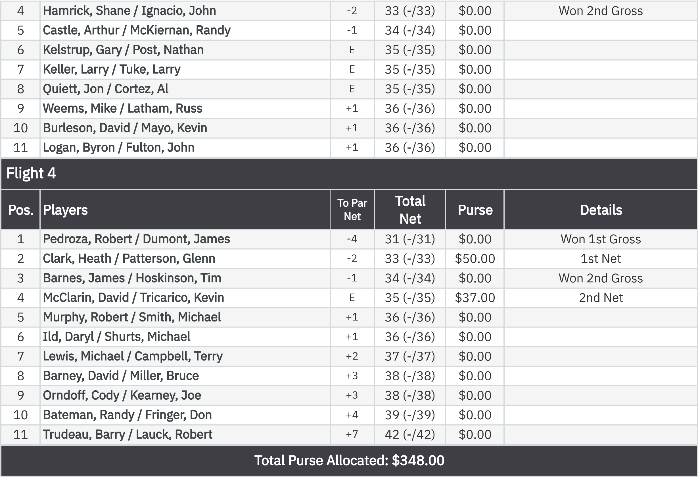
KP - Hole 13
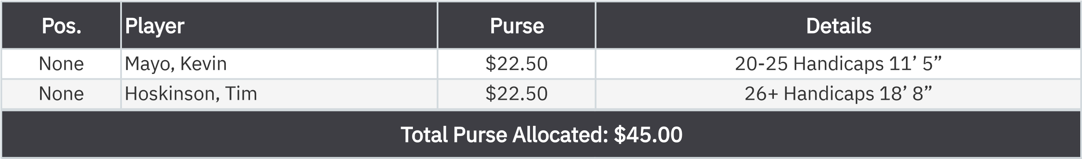
KP - Hole 16
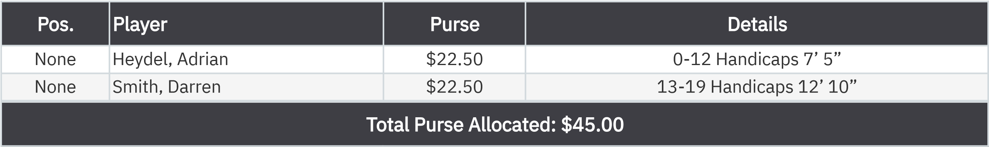
50-50 RHMC Scholarship Fund

.

s
None
Hamrick, Shane
$45.00

:
.

