2-Man Best Ball Back Nine (Gross)
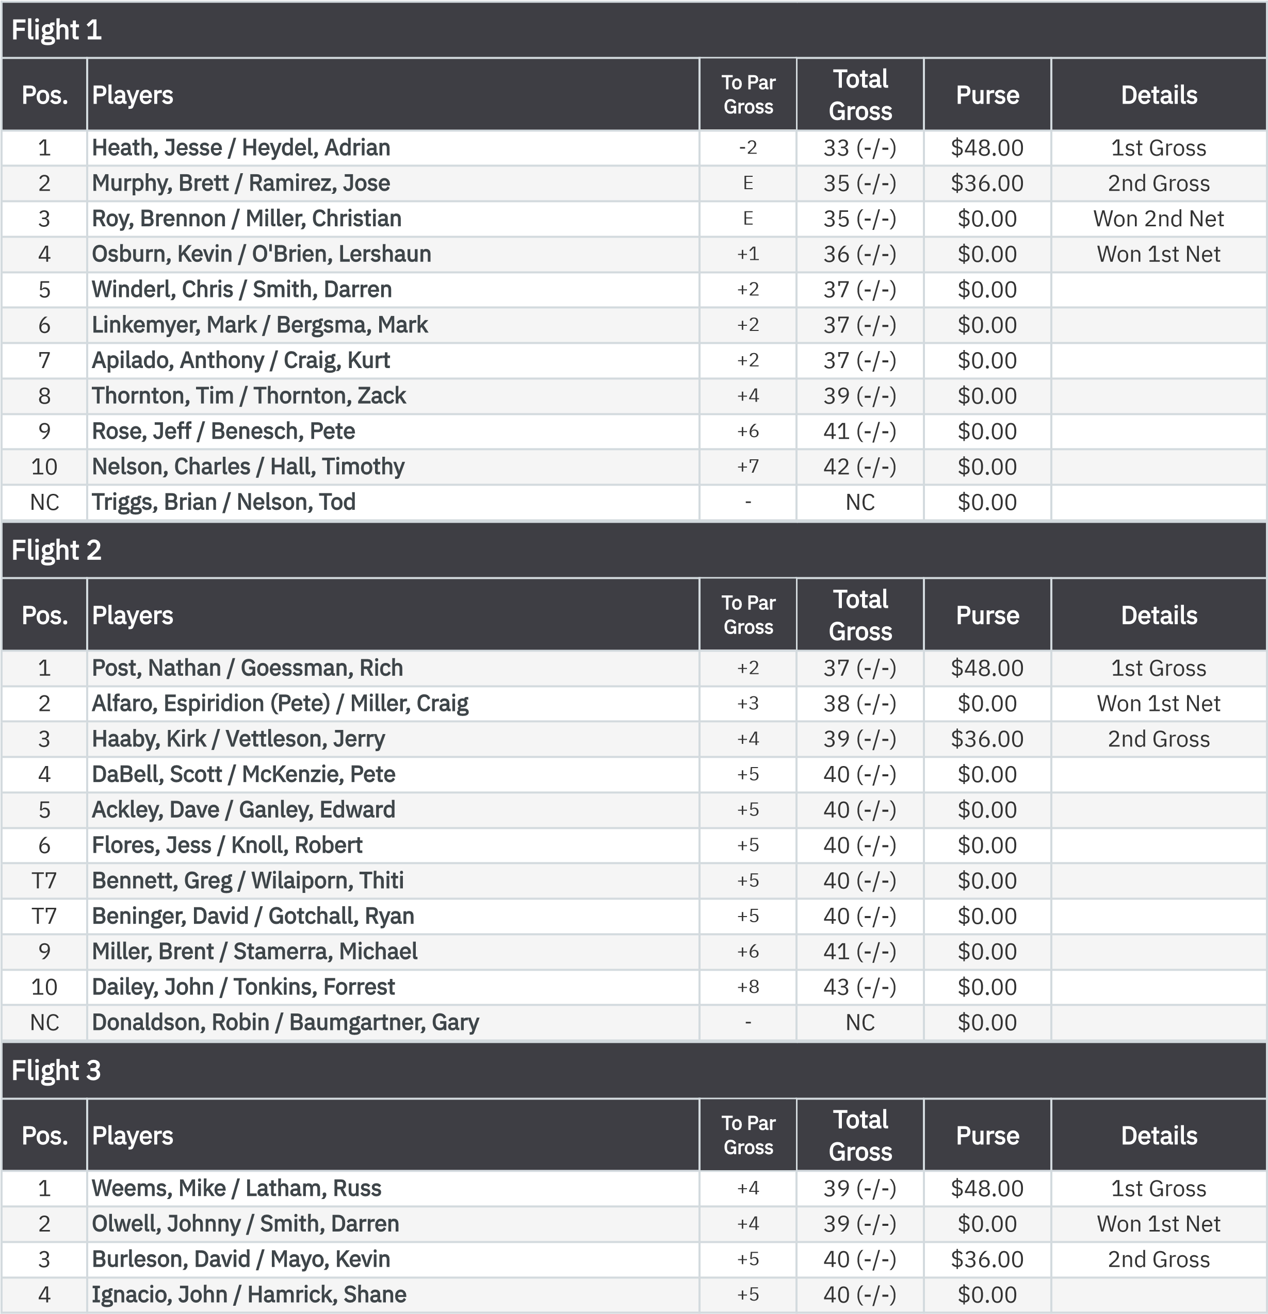
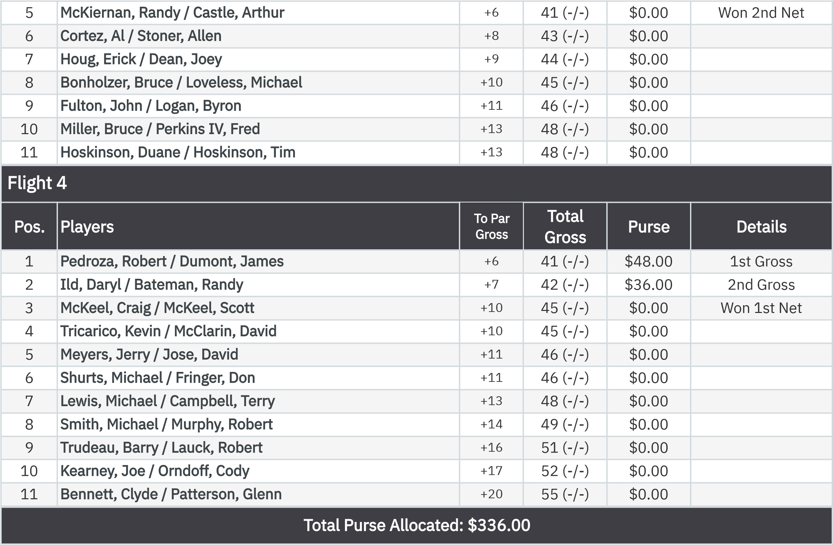
2-Man Best Ball Back Nine (Net)
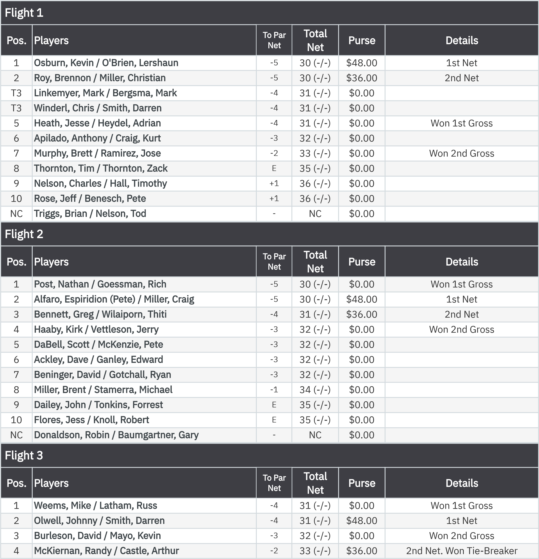
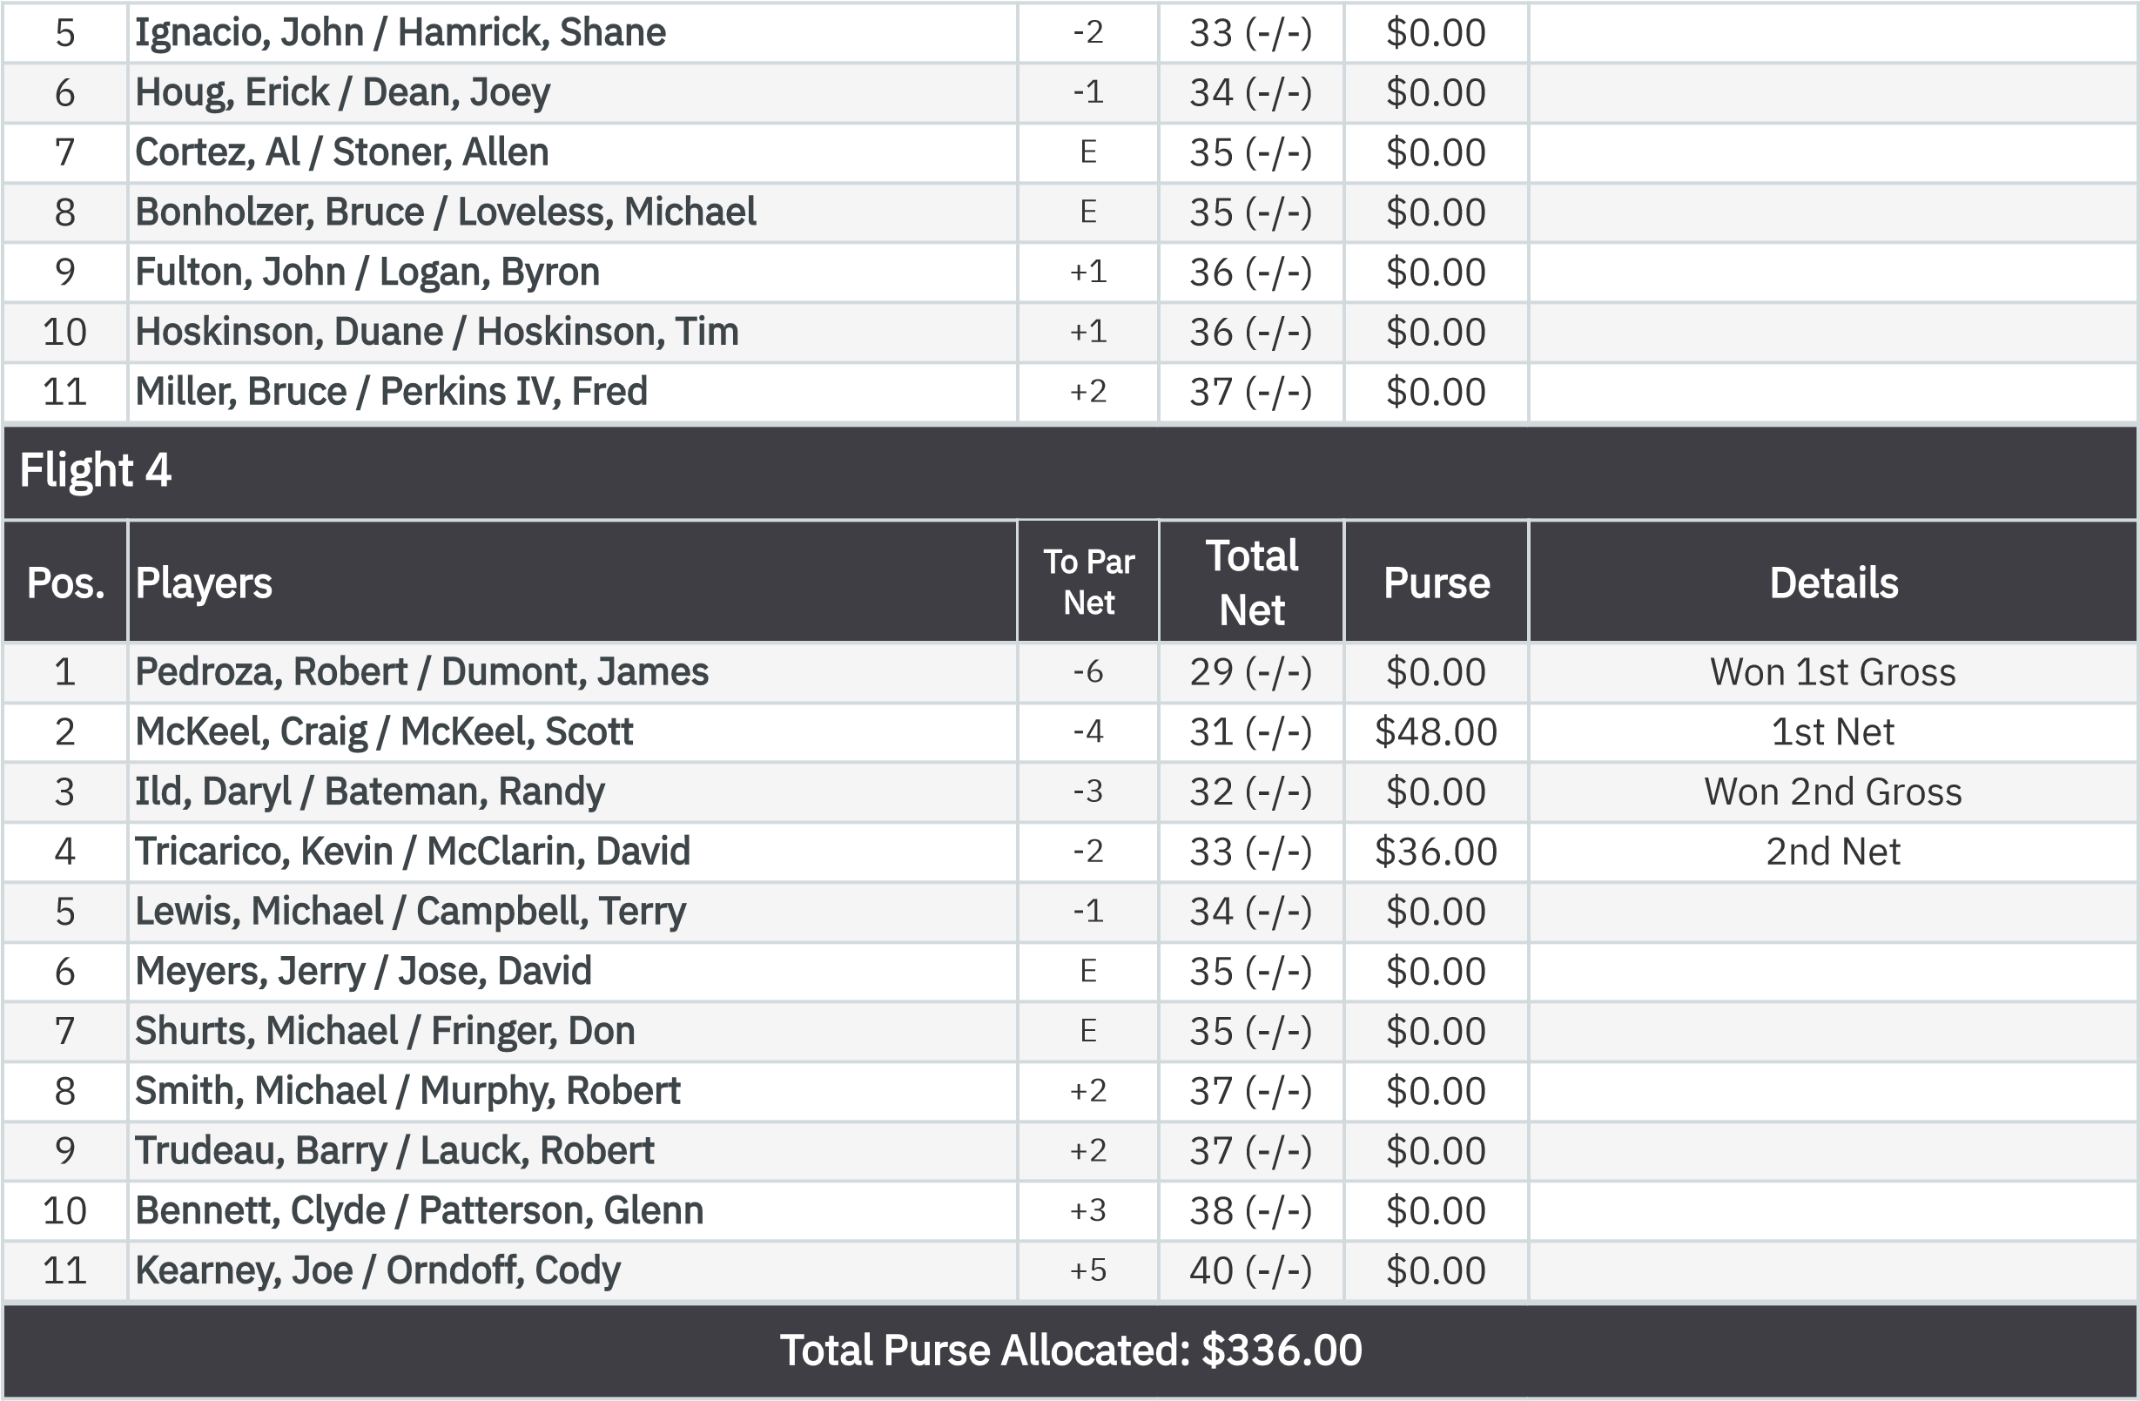
KP - Hole 13

.

None
Pedroza, Robert
$29.30
20-25
Handicaps 6’ 6”

:

KP - Hole 16
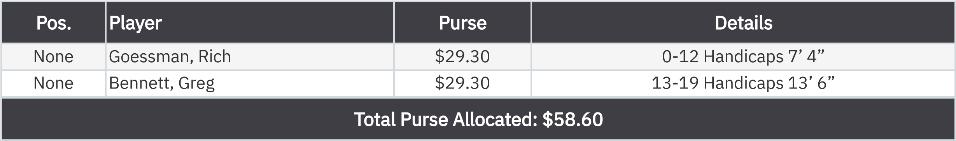
50-50 RHMC Scholarship Fund

.

None
Bennett, Greg
$44.00

:

