Stroke Play Front Nine (Gross)
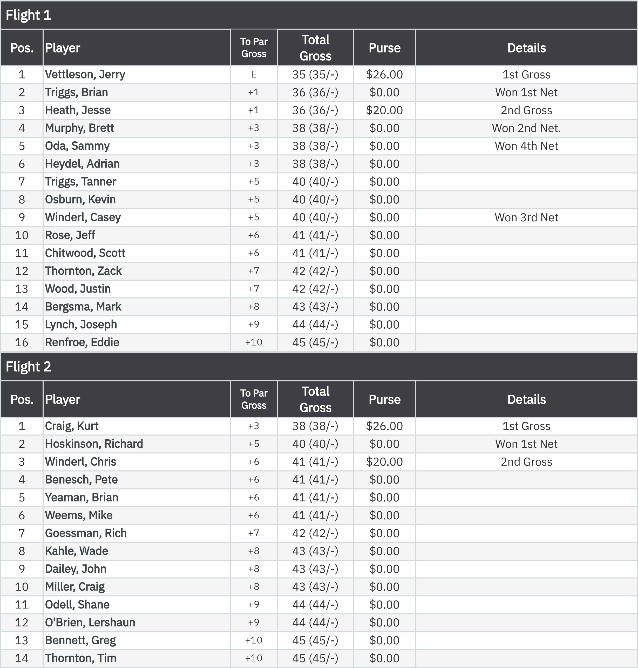
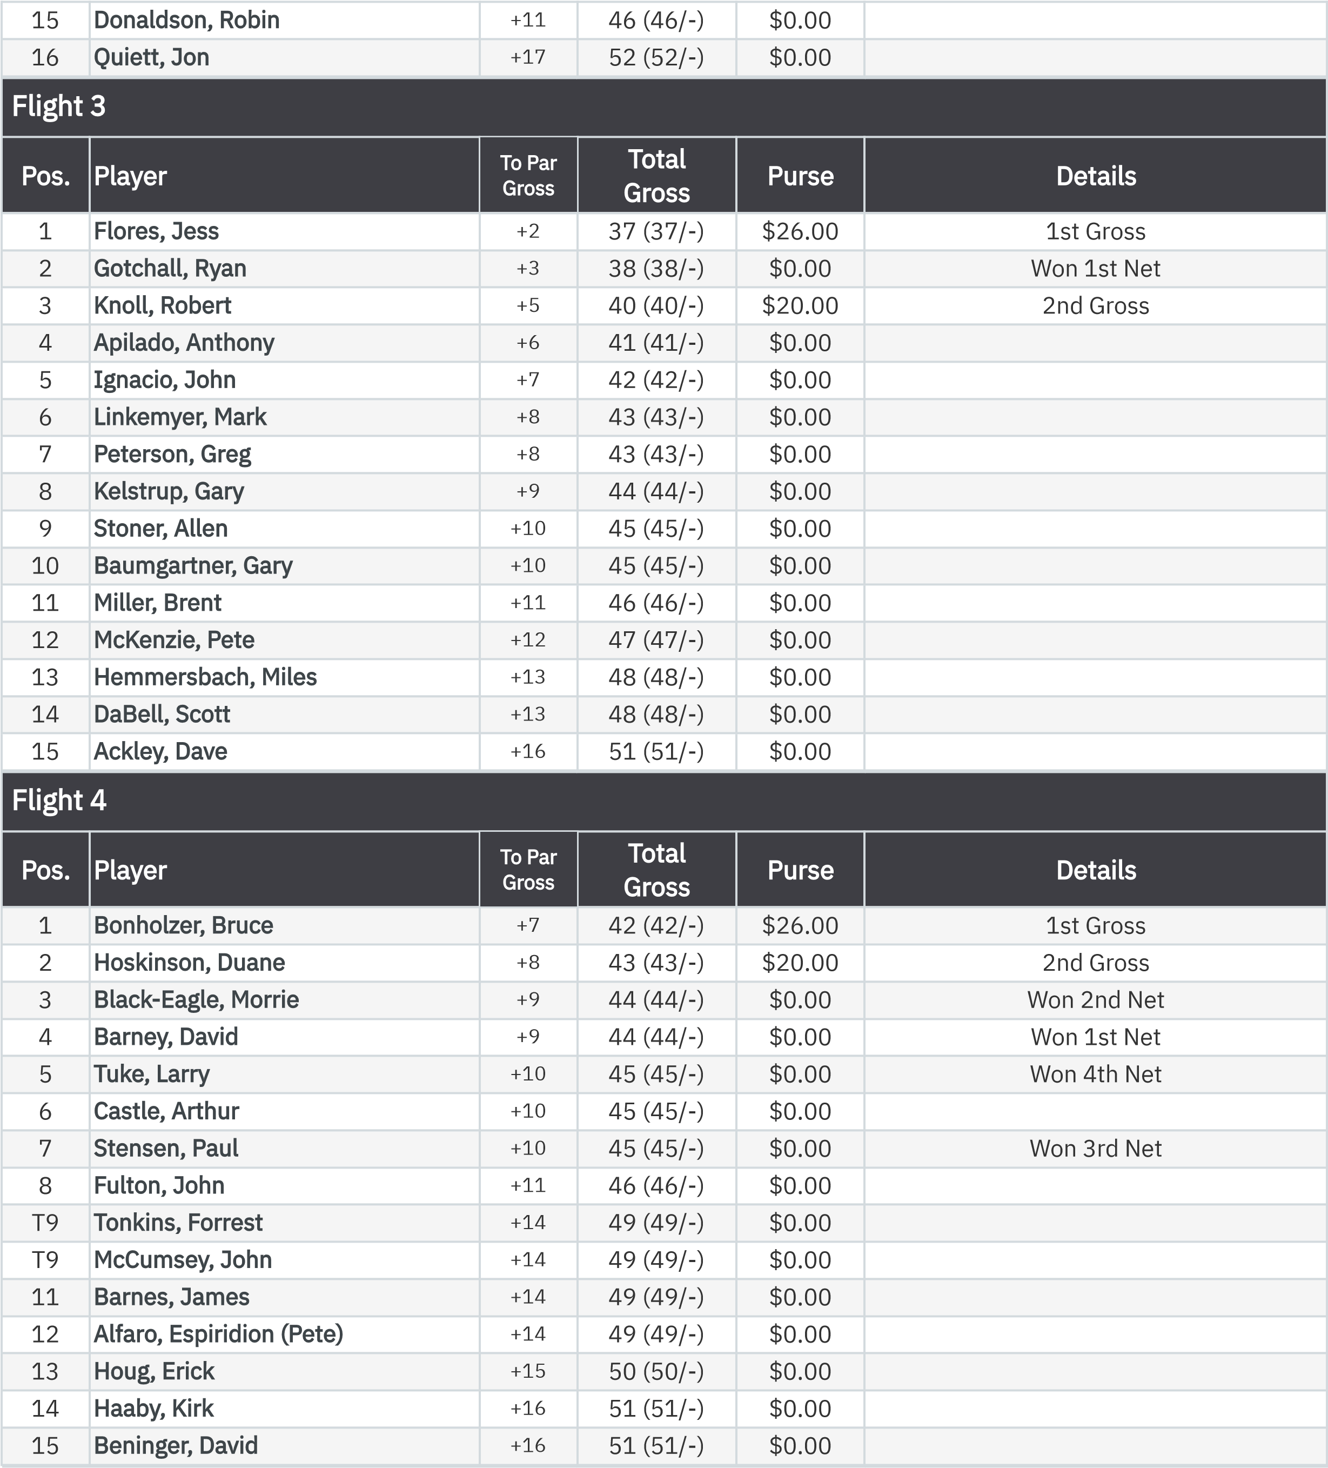
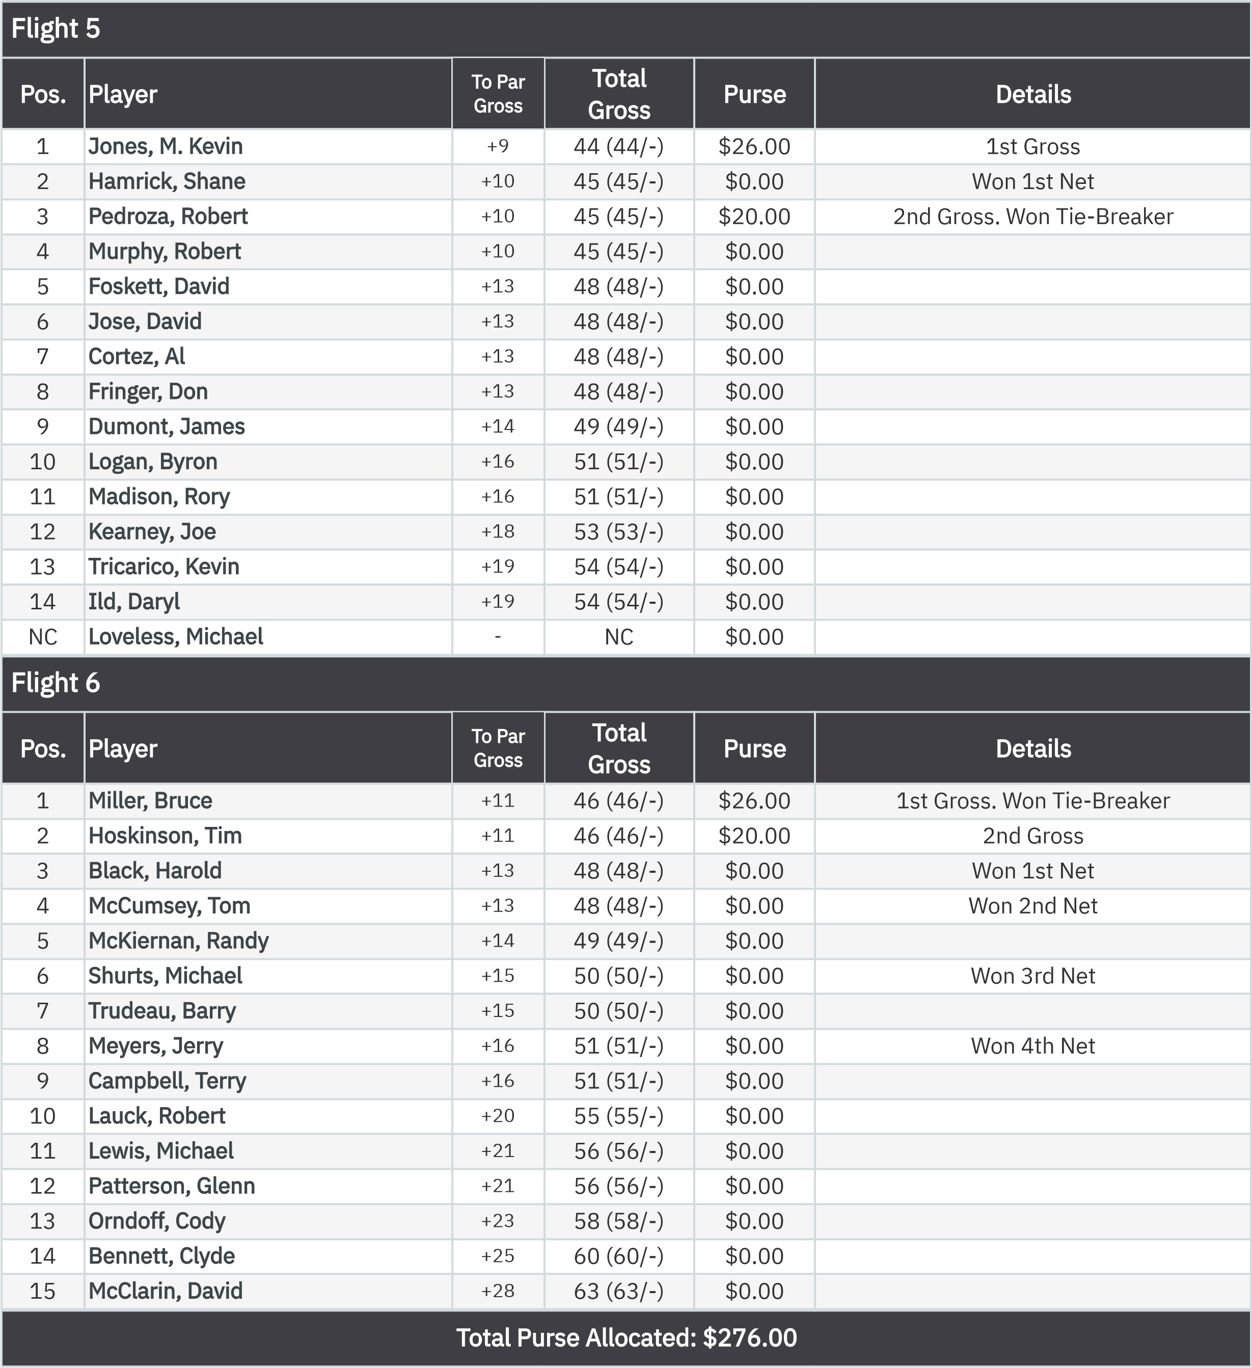
Stroke Play Front Nine (Net)
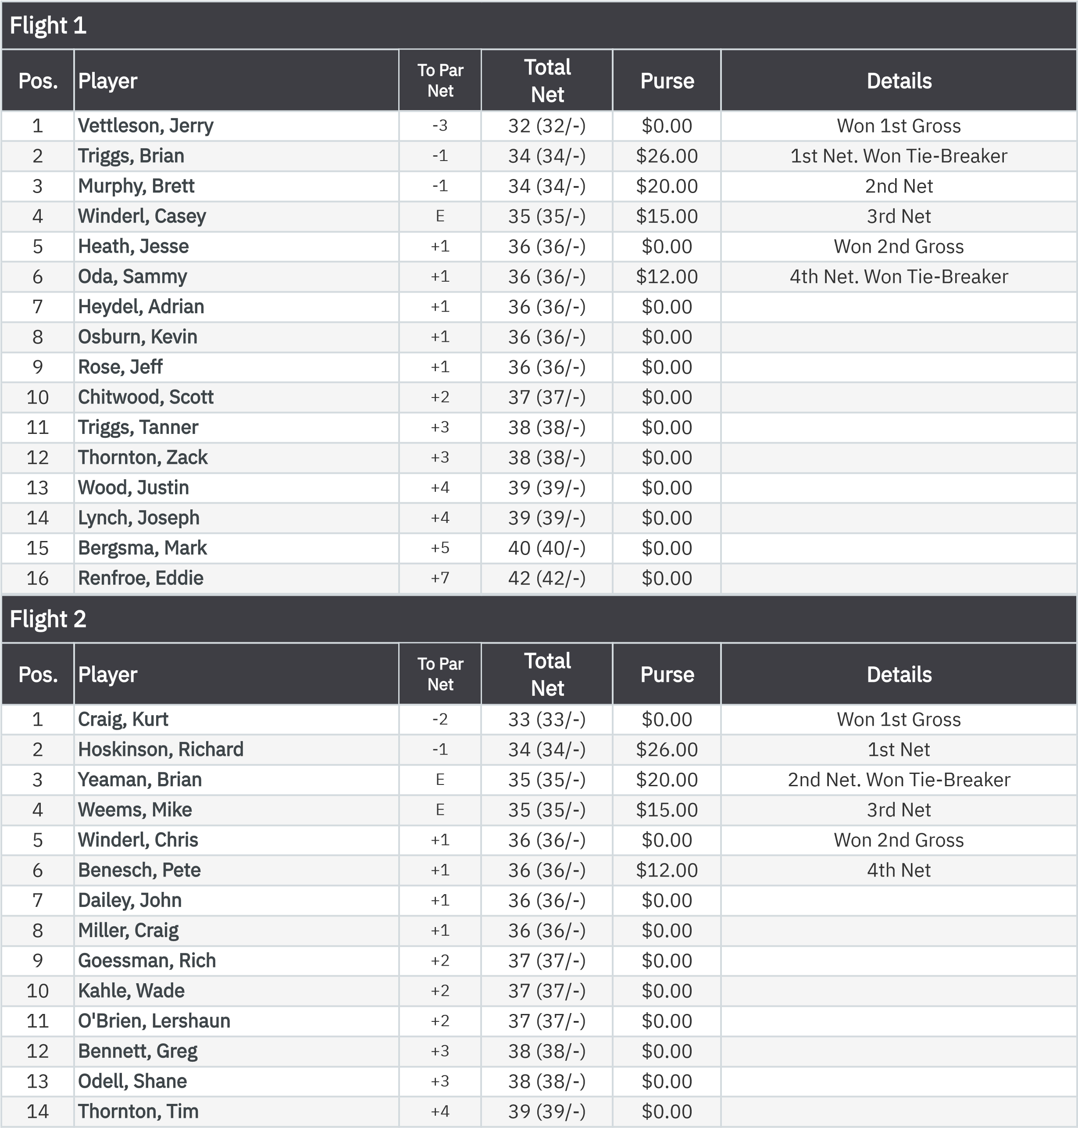
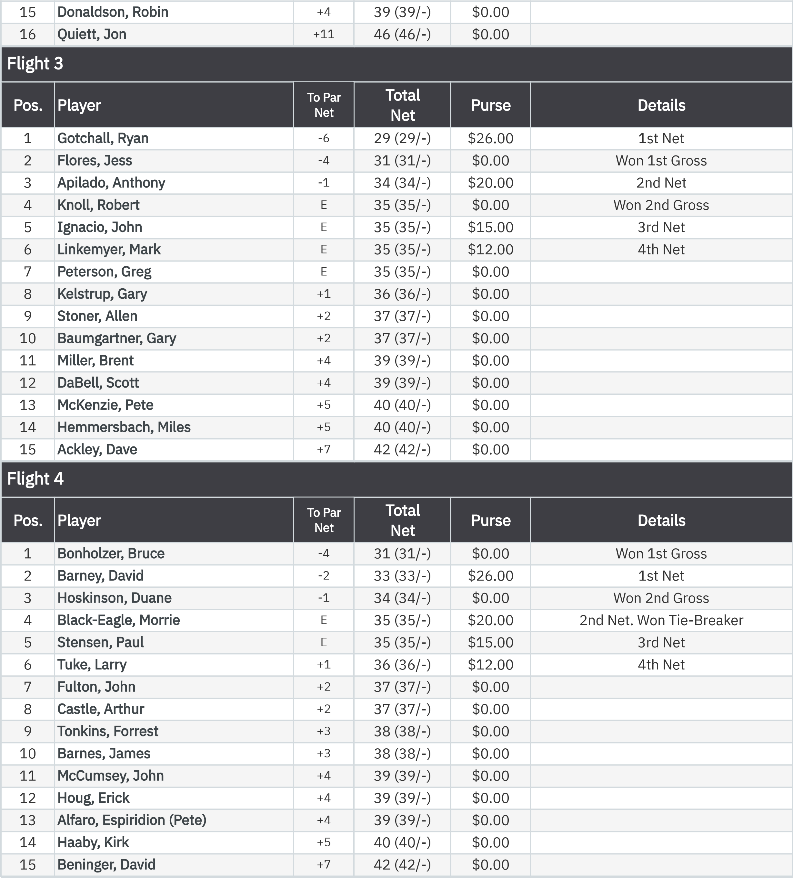
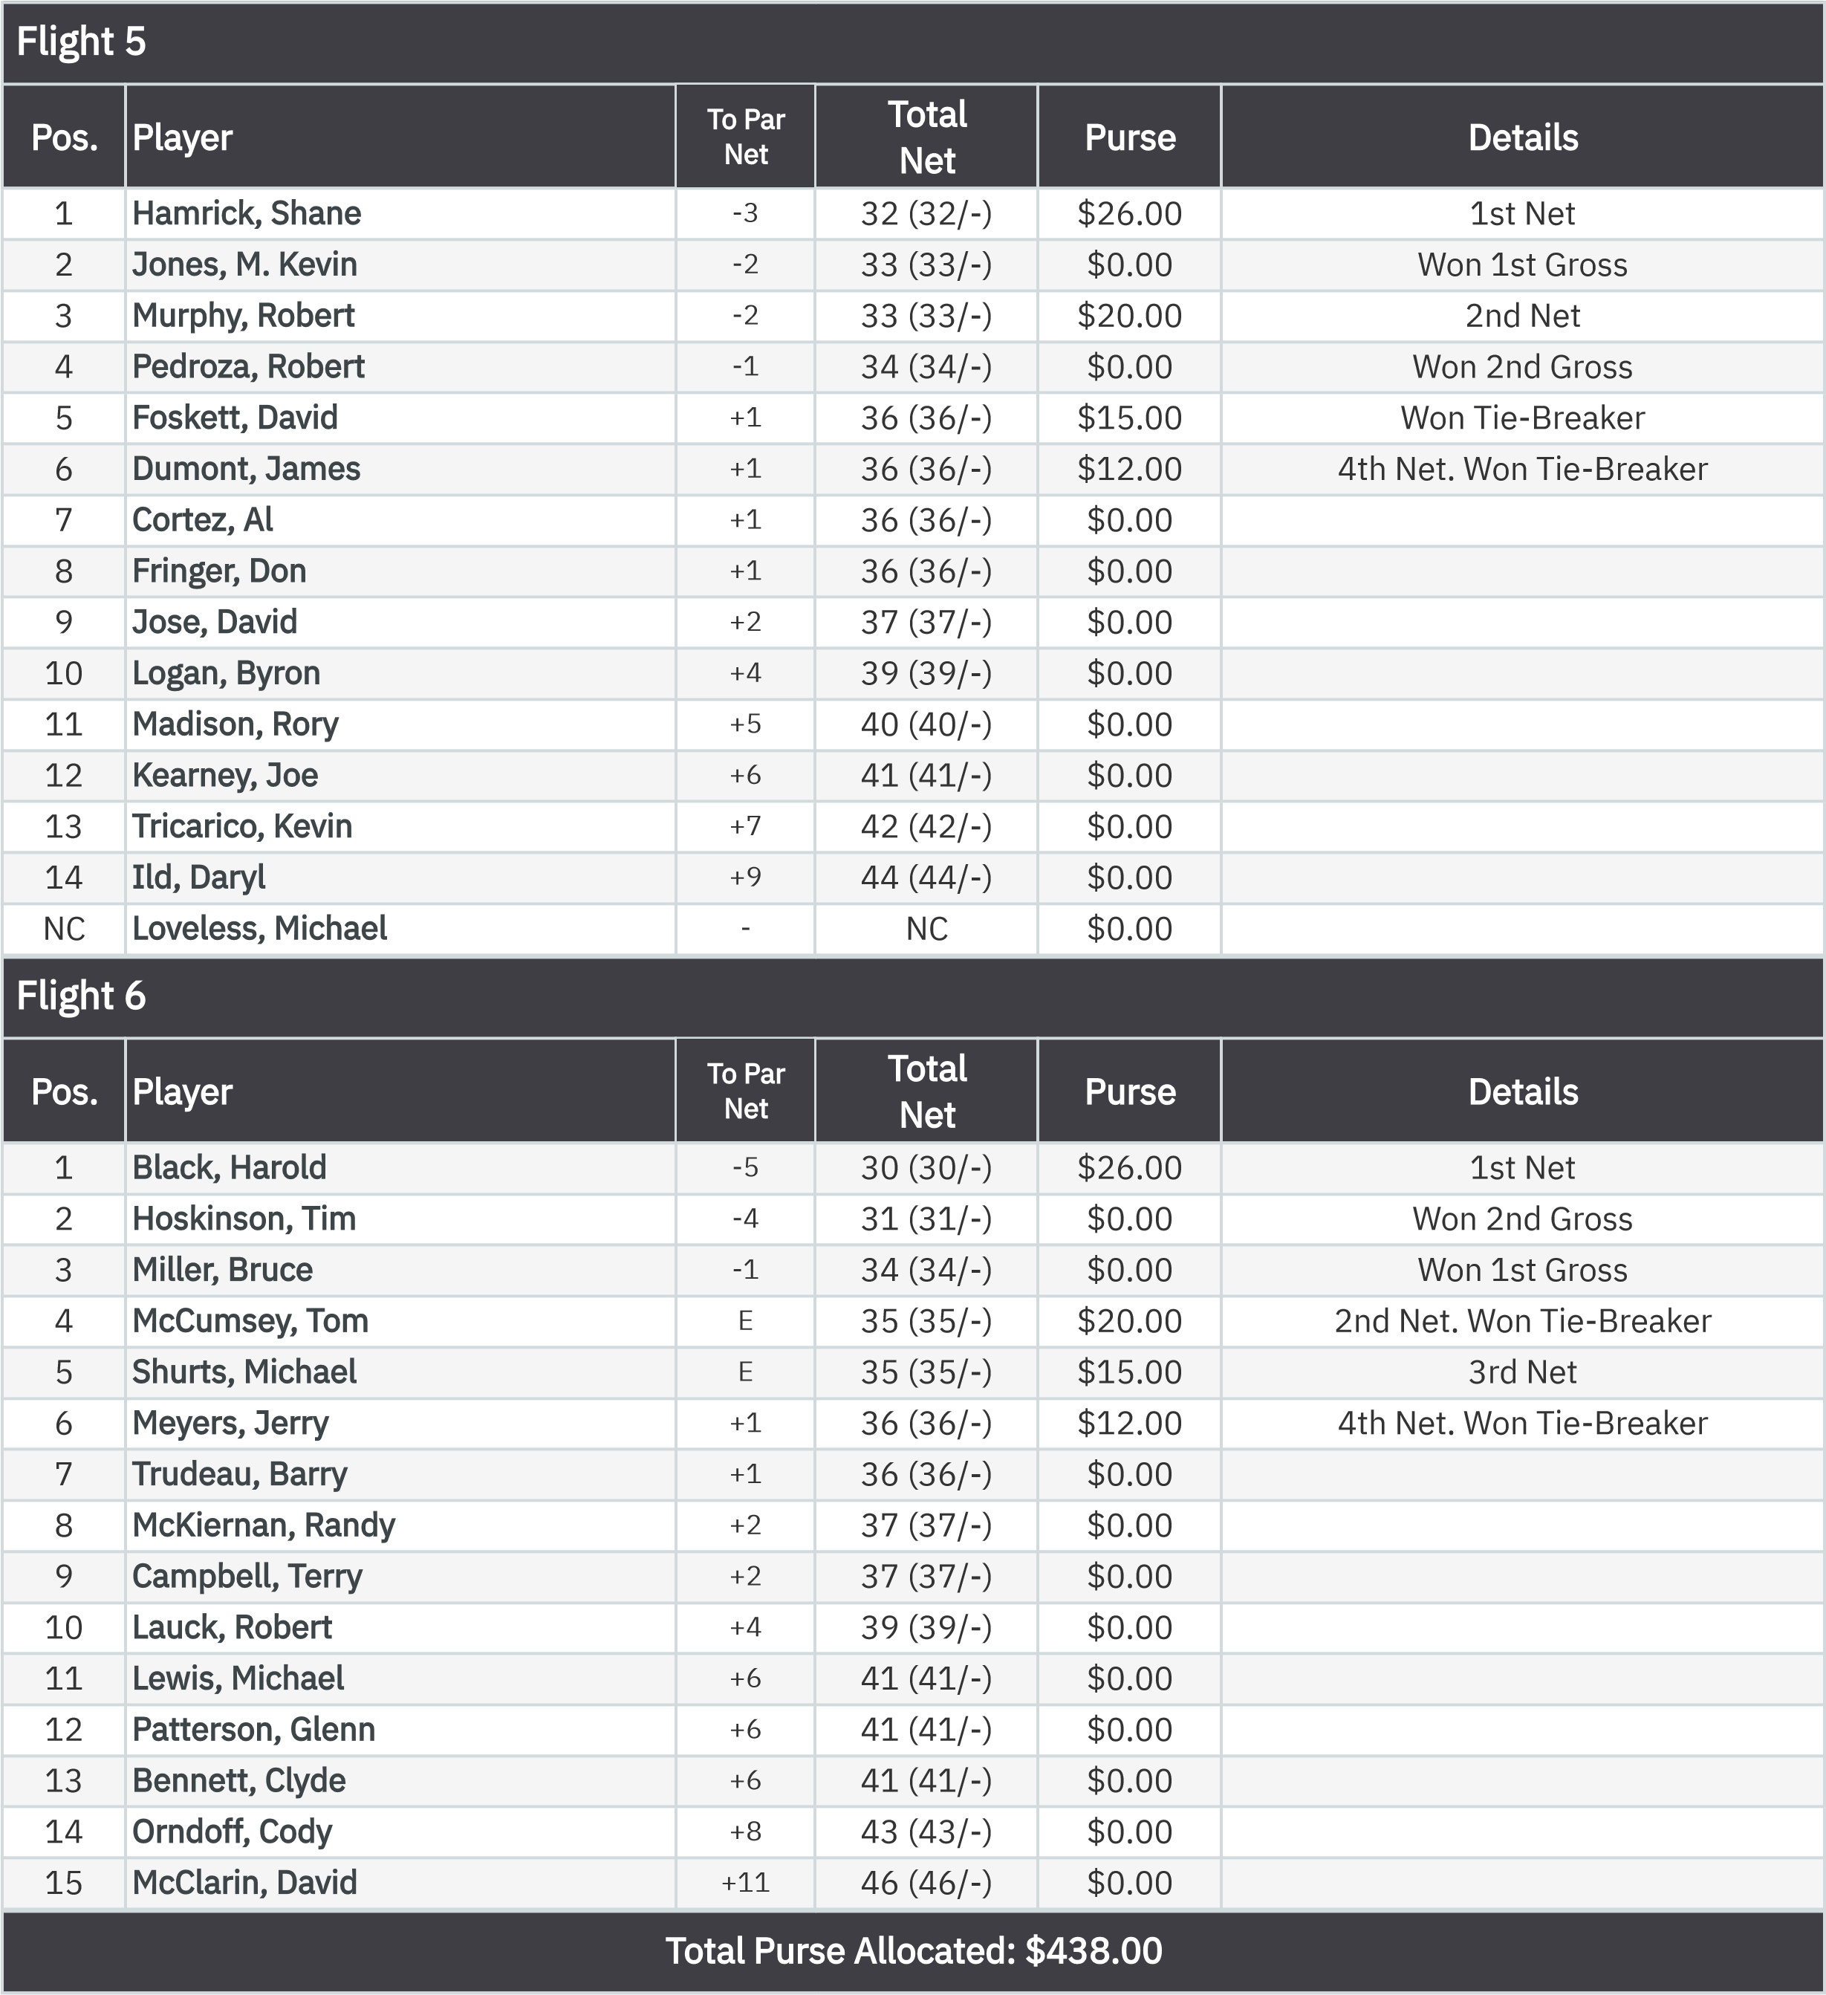
KP - Hole 4
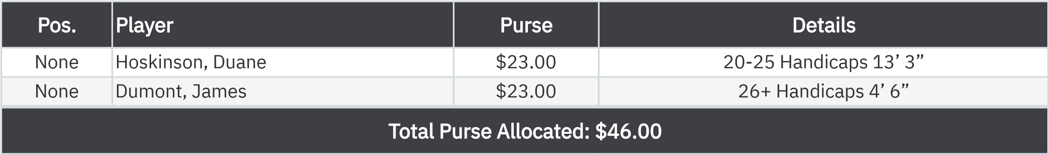
KP - Hole 9
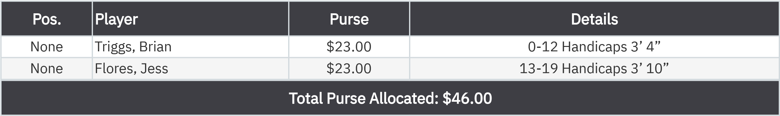
50-50 RHMC Scholarship Fund
.

r
None
Murphy, Brett
$46.00
:

