2-Man Combined Score Front Nine (Gross)
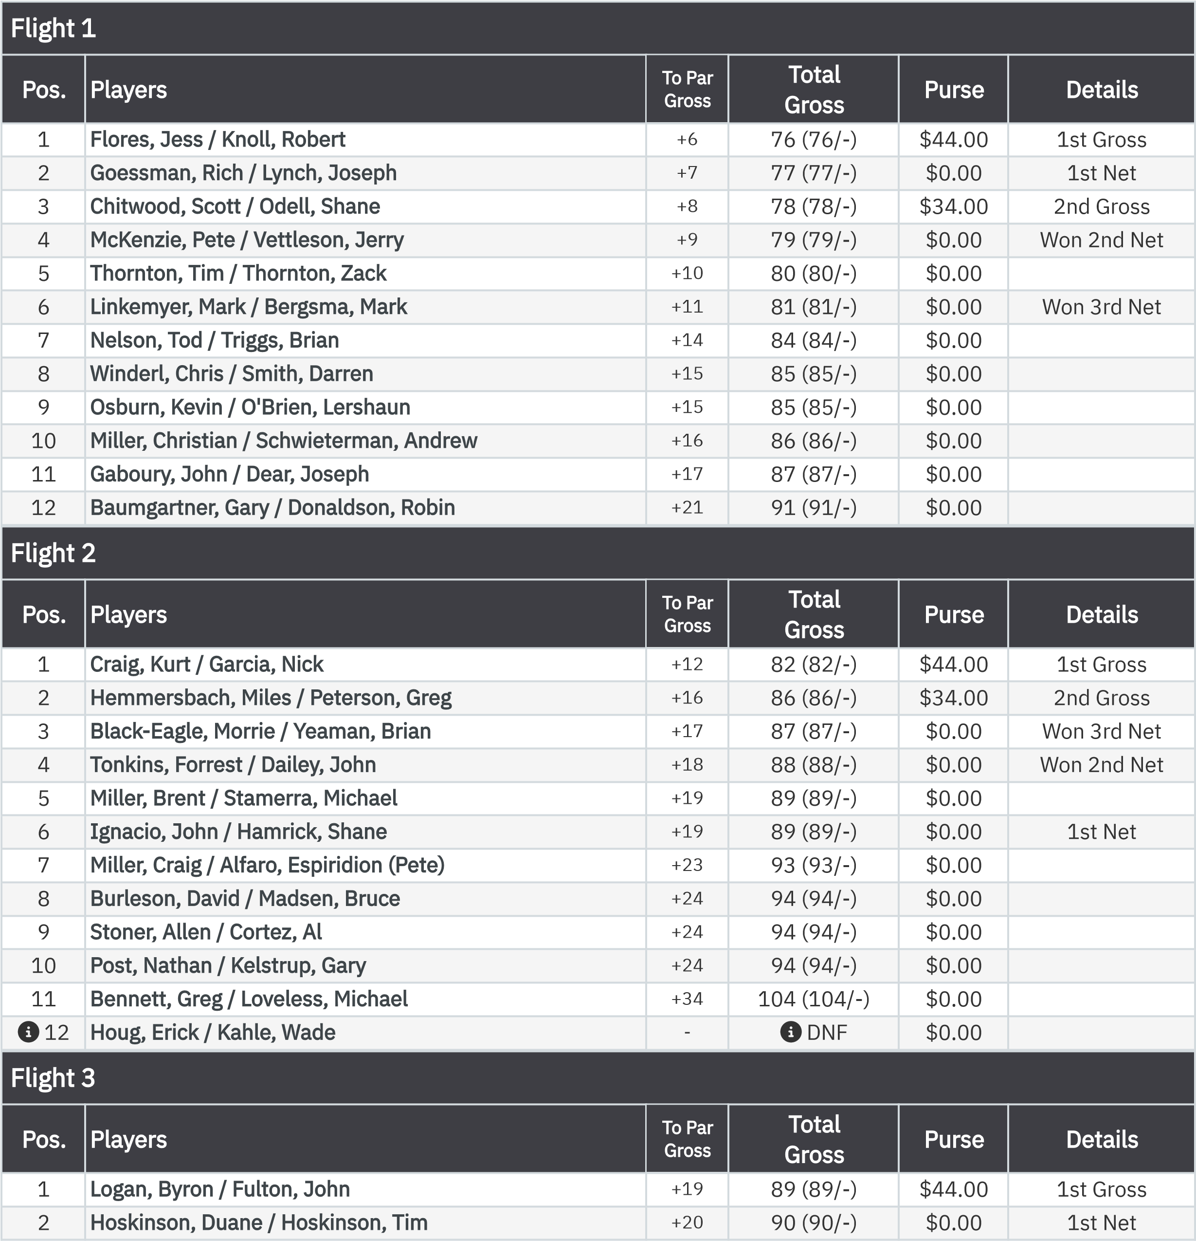
July 15, 2026
2-Man Combined Score (15Jul2026) Leaderboard
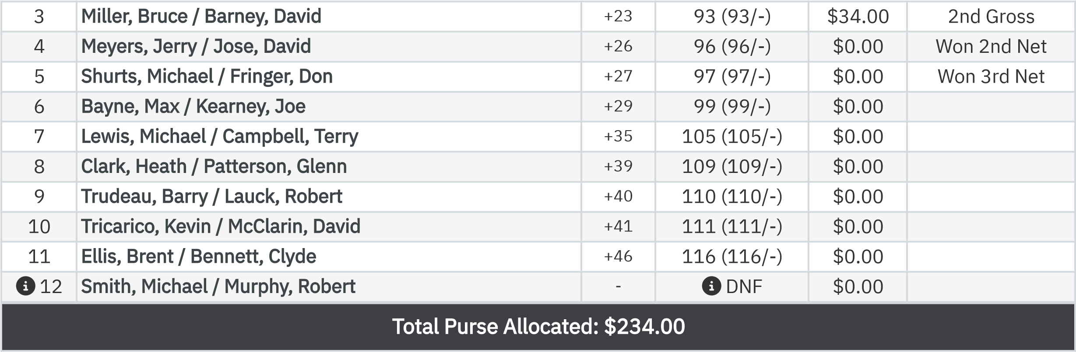

2-Man Combined Score Front Nine (Net)
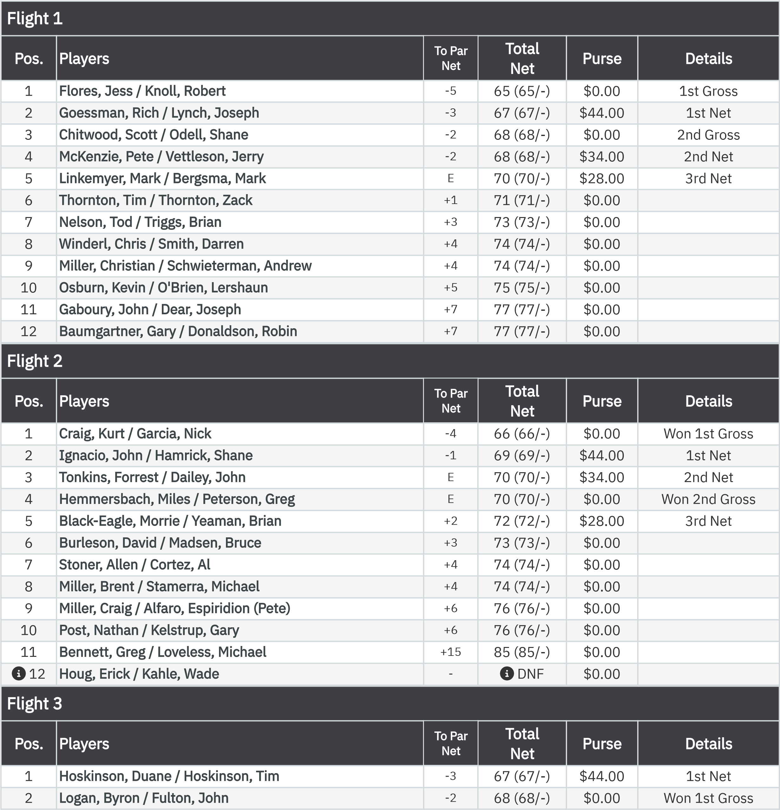
July 15, 2026
2-Man Combined Score (15Jul2026) Leaderboard
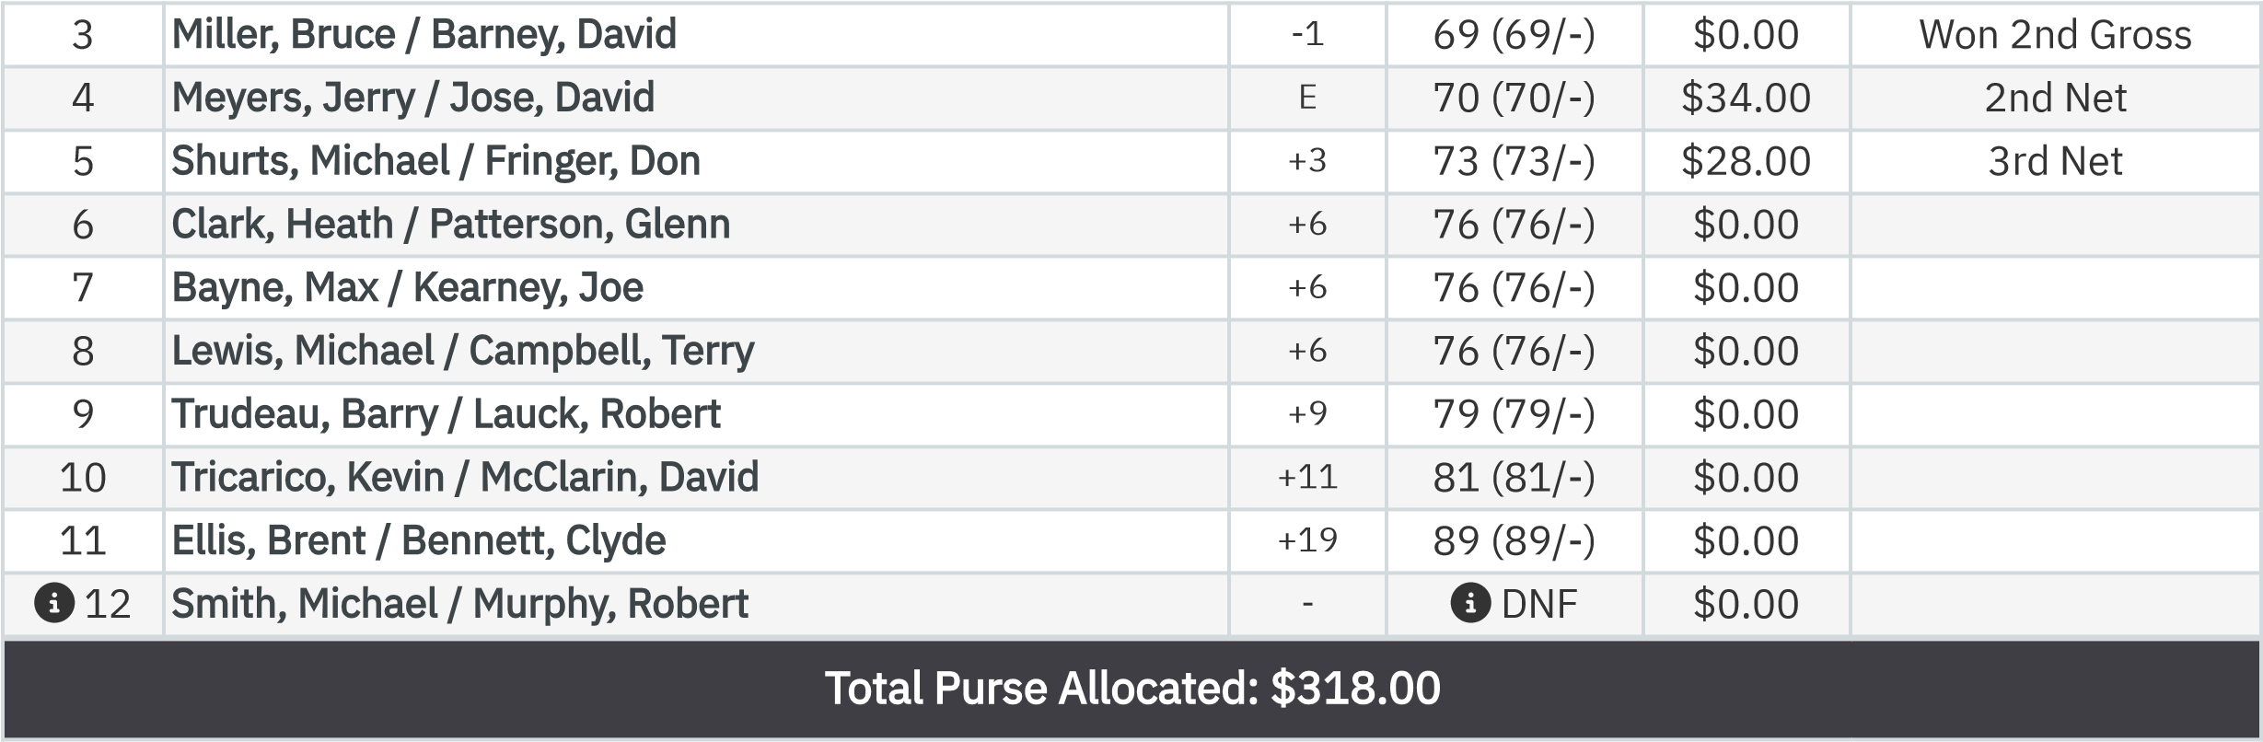

KP - Hole 4
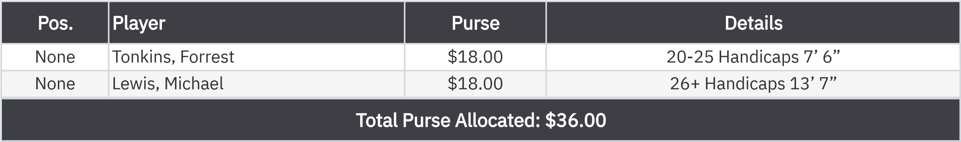

KP - Hole 9
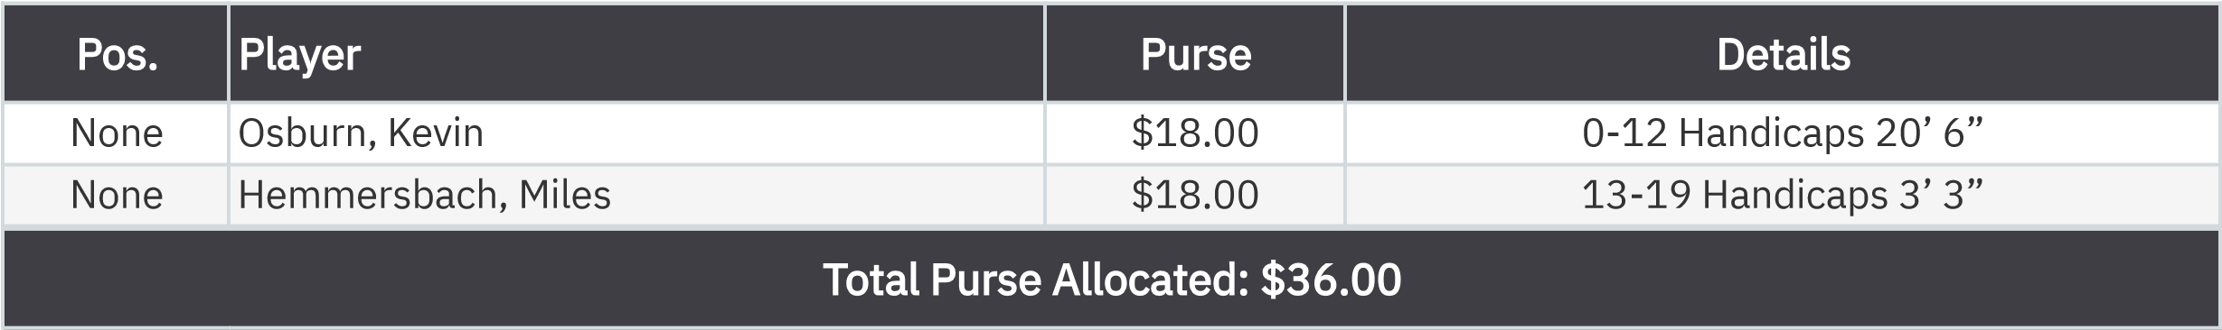

50-50 RHMC Scholarship Fund

.

None
Miller, Christian
$36.00
50
/50 Winner
:

