2-Man Scramble Back Nine (Gross)
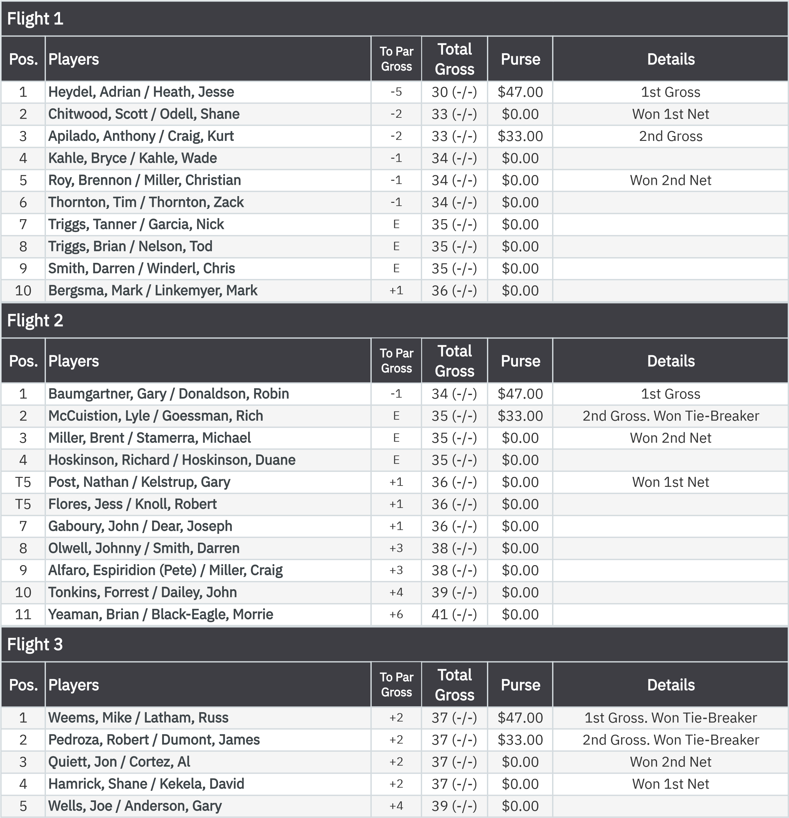
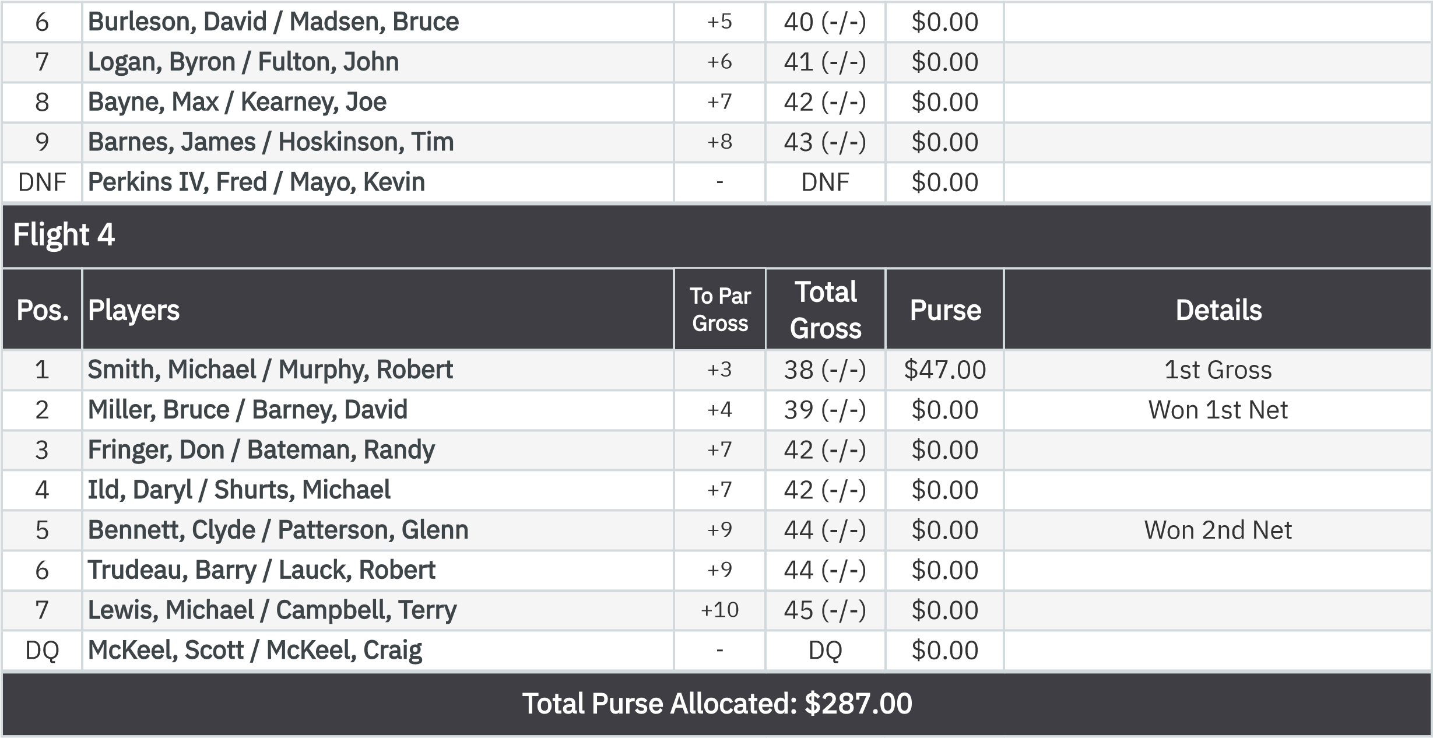
2-Man Scramble Back Nine (Net)
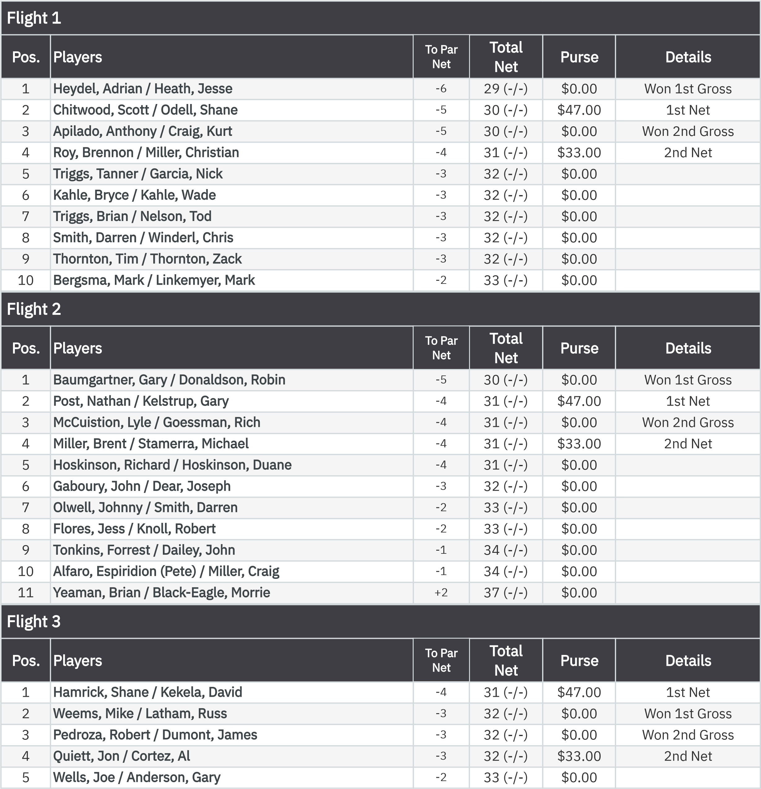
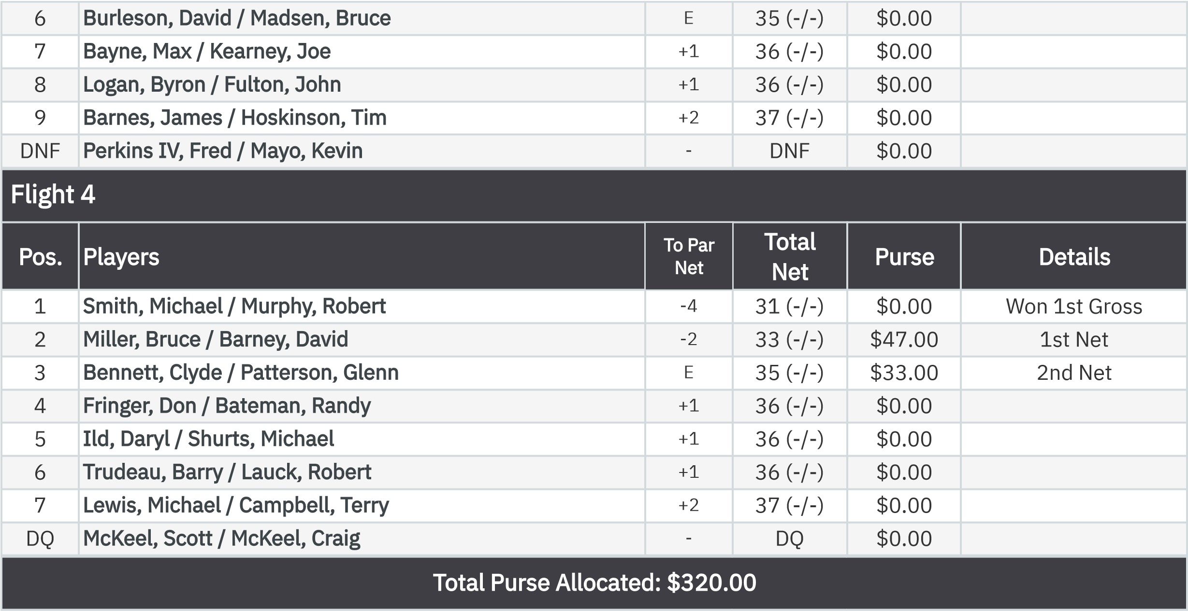
KP - Hole 13

r

None
Gaboury, John
$19.50
None
Miller, Bruce
$19.50

:

KP - Hole 16
.

er

None
Flores, Jess
$19.50
None
Heath, Jesse
$19.50

:

50-50 RHMC Scholarship Fund

.

None
Lewis, Michael
$39.00

